Community Development Investments & Property Trends Tool
The following document outlines the data and workflow used to create the Community Development Investments & Property Trends Tool. The map shows an aggregation of estimated market values and improvements of Hennepin County parcel data from tax year 2005 through 2019 along with Community Works program investments, and transit corridors.
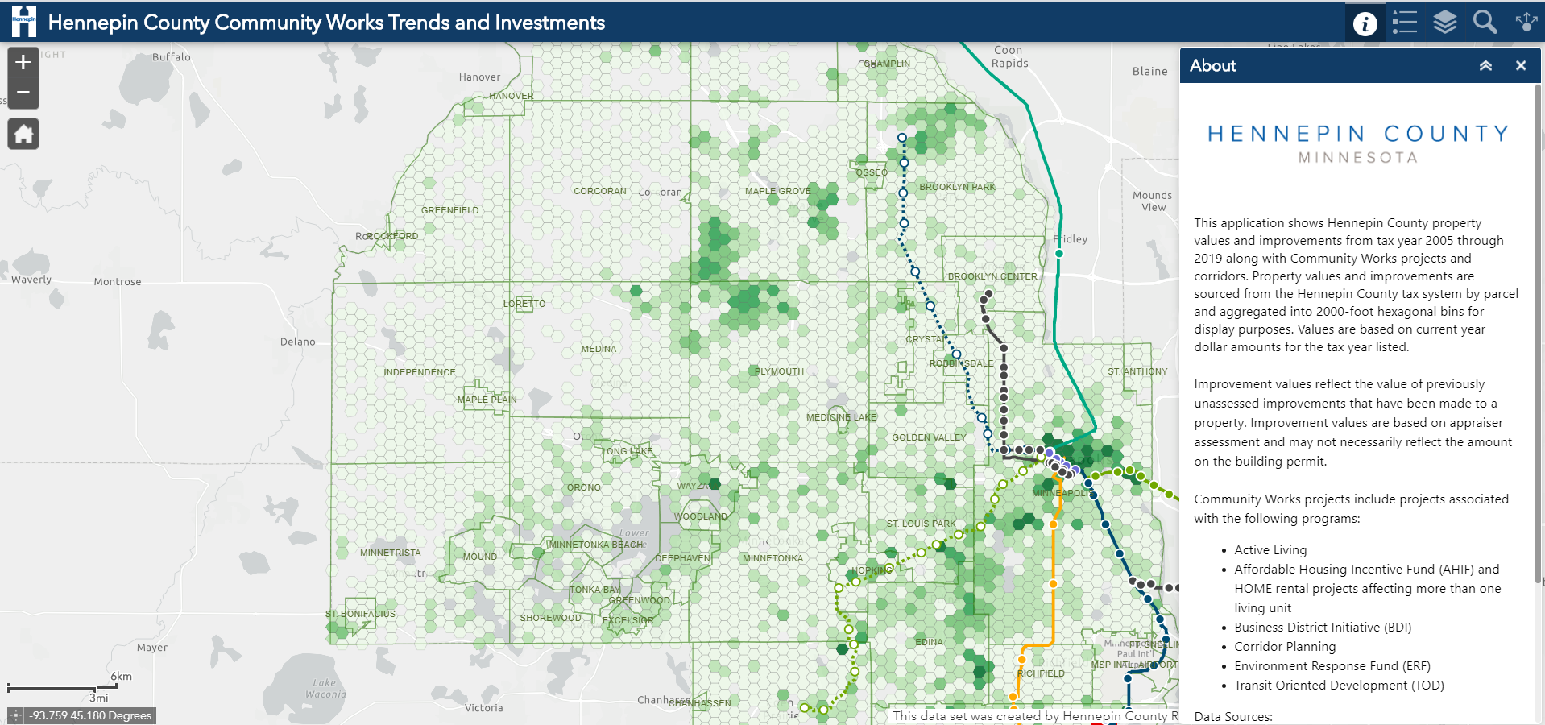

Goals
The primary purpose of this tool is to show where Hennepin County Community Works is investing in the County and changes in property values over time.
The data displayed in the map can be categorized into three main categories:
- Total market value and total improvement data (2005-2019)
- Hennepin County Community Works program investments
- Transitways and transit stations

Definitions
Community Works program investments: The map currently display data related to Community Works program investments. These are defined as investments associated with the following programs:
- Active Living
- Affordable Housing Incentive Fund (AHIF) rental projects
- HOME rental projects
- Business District Initiative (BDI)
- Corridor Planning
- Environment Response Fund (ERF)
Total Improvement Value: The aggregated improvement value for all parcels located within 2000-foot hexagonal bins. Improvement value reflects the value of previously unassessed improvements that have been made to a property, including the building and site between January 2nd of the prior and current assessment year. Improvement values capture new construction and updates to existing buildings. Improvement values are based on appraiser assessment and may not necessarily reflect the amount on the building permit.
Example: A new building is constructed on a vacant parcel. The improvement value reflects the cost of constructing the building and associated improvements to the land, excluding landscaping.
Total Market Value: The aggregated estimated market value (EMV) for all parcels located within 2000-foot hexagonal bins. Each year’s “property value” reflects the EMV in January of that year, which reflects the value assessed at the end of the previous year. Data are collected by the Hennepin County Assessor’s office.
Transitways: Includes existing and planned light rail (LRT) transit, bus rapid transit (BRT), commuter rail, and arterial bus rapid transit (aBRT) lines and stations.

About the data
Tax data
Hennepin County tax parcel data has been collected and digitized annually by the Hennepin County Tax Assessor’s office since 2005. The tax parcel datasets used for this analysis contains the following fields:
- PID (Property Identification)
- Address
- City
- ZIP
- Property type
- Land EMV (Estimated Market Value)
- Building EMV (Estimated Market Value)
- Total EMV (Estimated Market Value)
- Total Tax
- Improvement Value
Program Investment data
Project locations are sourced from Hennepin County Community Works and Hennepin County Environment and Energy. For more information about each program, see below.
- Active Living
- Affordable Housing Incentive Fund (AHIF) rental projects
- HOME rental projects
- Business District Initiative (BDI)
- Corridor Planning
- Environment Response Fund (ERF)
AHIF and HOME rentals where total units were 10 or less were removed from the map in order to remove single-family homes/duplexes and show multi-family developments only.
Transit data
The web map shows completed and planned light rail transit lines (LRT) and Bus Rapid Transit (BRT) lines, along with station areas (half mile buffer around transit station). Transit data is sourced from Metro Transit - MN Geospatial Commons.

Methodology
How was the data processed?
Three layers in the map, Total Improvement Value 2005-2019, Total Market Value Change 2005-2019, and Total Market Value Percent Change 2005-2019 were generated from Hennepin County tax parcel data and visualized in the map using hexagonal binning, a common data visualization technique. In order to visualize the Hennepin County tax parcel data in this manner, the parcel dataset for each year were imported into a file geodatabase used for processing and a hexagon grid covering entire Hennepin County was created. A python script was then run to the generate a point at the center (centroid) of each parcel. These parcels points were then counted and aggregated to the hexagon bin they fell within using a spatial join.
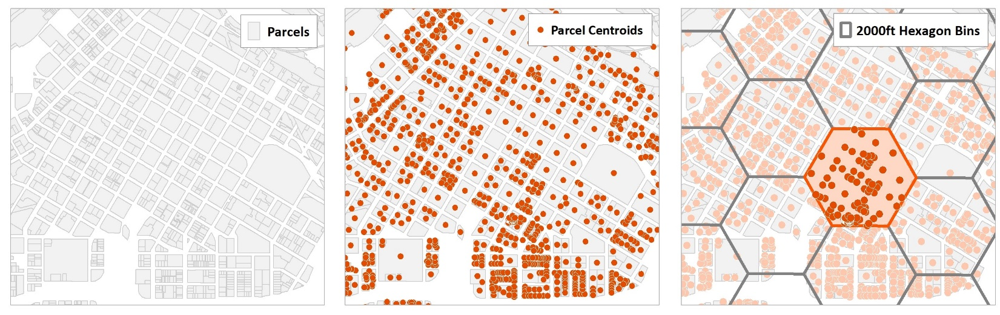

Why were hexagons used to visualize property data?
In 2019 alone, Hennepin County’s parcel dataset contained over 430,000 parcels. To effectively and expediently display parcel data from 2005 to 2019, it was necessary to convert these parcels to points and aggregate to a standard unit of geography, a hexagon. An additional benefit of standardizing the units of geography results in a way to more uniformly and accurately visualize countywide data trends. Hexagons, like squares, are a commonly used shape for binning/aggregating point data. A hexagon that is 2000 ft wide was the smallest unit of measure that could be used to capture the dataset.

The color shown on the hexagons is representative of the intensity of a data measurement. The toolbar of the GIS application shows what units of measure the colors represent for each data layer.
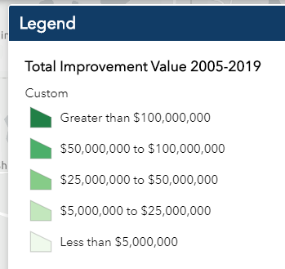
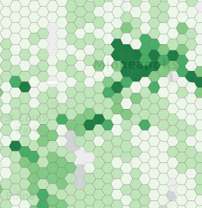
What software was used?
Analysis and data processing was completed using ArcMap (10.6.1) by ESRI.

Contact
Hennepin GIS
gis.info@hennepin.us

