Promotional materials for Hennepin County’s Stop Food Waste Challenge

About the challenge
About 40% of food is wasted somewhere along the supply chain. In Hennepin County, enough edible food is thrown away each year to fill Target Field 1.5 times! Food waste costs individuals and families a significant amount of money and wastes resources that goes into producing and transporting food. Taking steps to reduce food waste is one of the most effective actions people can take to reduce waste and address climate change.
Hennepin County’s Stop Food Waste Challenge, hennepinfoodwaste.ecochallenge.org, will help participants learn more about food waste and improve skills in cooking, planning, shopping, and storage. The challenge has more than 40 actions to choose from in five categories. Participants get email updates with resources and tips for taking action, access to reducing food waste webinars, and opportunities to connect and share with others. Participants can create or join a team to take the challenge along with their family, friends, or neighbors. The online Stop Food Waste Challenge is powered by EcoChallenge.

Contact
For more information about the Stop Food Waste Challenge, contact:
Amy Maas, Waste Reduction and Recycling Specialist, Amy.Maas@hennepin.us

Help spread the word and encourage others to join
Some ways that you can help spread the word about the Stop Food Waste Challenge and encourage others to join:
- Use the sample social media posts and graphics to share on your social media channels. These are editable so you can customize the message.
- Use the sample newsletter article to share on an organization’s website or in newsletters. These are editable so you can customize the length or message.
- Become a Stop Food Waste Challenge partner – details about partnership are on page 3.
- Follow and reshare messages posted on the Hennepin County Environment and Energy social media channels: Hennepin Environment on Facebook, hennepinenvironment on Instagram, and @hennepinenviro on Twitter. Use #StopFoodWaste
- Invite people you know directly using the sample email message below
- Create a team or join an existing team and invite people you know – your friends, family, neighbors, colleagues, etc. – to join you. Your teammates will keep each other motivated and accountable. Invitations can be sent through the EcoChallenge website.

Media kits for specific audiences
This media kit is intended to reach general audiences. Media kits are also available if you are reaching out to the following specific audiences:
- Young adults (DOCX)
- Families with children (DOCX)
- Older adults with no children in the home (DOCX)
Download these media kits at hennepinfoodwaste.ecochallenge.org/about/resources

Become a 2022 Stop Food Waste Challenge Partner
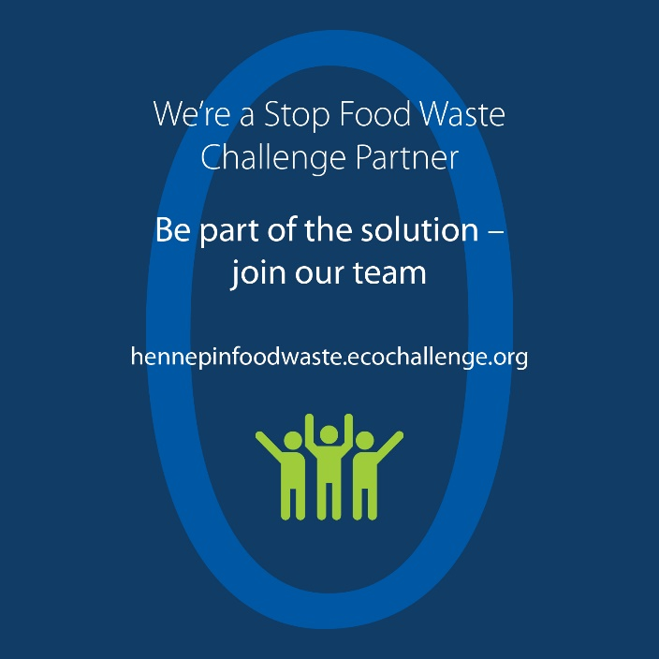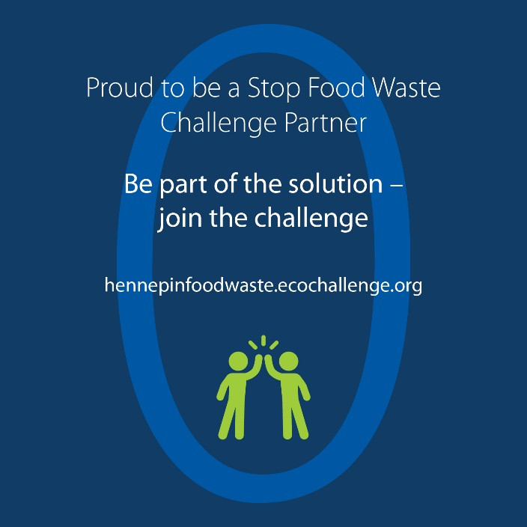
Hennepin County is working to reduce food waste as part of achieving our zero waste and climate action goals. As part of this effort, Hennepin County offers the Stop Food Waste Challenge to engage residents in learning easy, practical skills that will help prevent wasted food, save money, and create a healthier environment. Taking steps to reduce food waste is one of the most important actions we can take to address climate change.
But we can’t do it alone!
For the upcoming Stop Food Waste Challenge, which will run in August 2022, Hennepin County is seeking partners to help increase promotion, recruitment, and engagement for the challenge.
All partners will have their logo displayed on the challenge website, gain access to promotional materials, and get various recognition and cross-promotion during the challenge. There is no cost to becoming a partner.

Partnership opportunities include:
- Expanding our reach by promoting the challenge to your audiences.
- Strengthening engagement in the challenge by creating teams of colleagues, friends, and neighbors who motivate and hold each other accountable.
- Increase our impact by offering educational events on food waste prevention topics.
See the Stop Food Waste Challenge partnership guide (PDF) for details on partnership opportunities, and fill out the partnership form to become a 2022 Stop Food Waste Challenge partner.

Resources for partners
- Download partner social media graphics above (right click on image and select save as picture)
- Download partner posters to help promote the challenge:
  - Join our Stop Food Waste Challenge team 8.5 x 11 (PDF)
  - Proud to be a Stop Food Waste Challenge Partner 8.5 x 11 (PDF)
  - Be part of the solution – join the Stop Food Waste Challenge 8.5 x 11 (PDF)
- Download the half page Stop Food Waste Challenge flyer (PDF) for promotions at in-person events
- All resources and graphics can also be downloaded from the resources page on the EcoChallenge site here: hennepinfoodwaste.ecochallenge.org/about/resources

Sample newsletter article – long

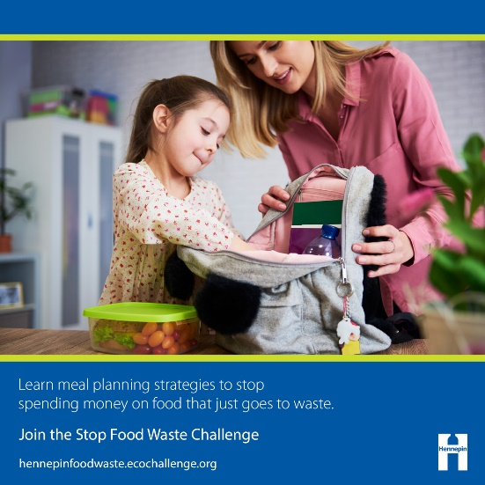
Create meals, not waste: Join Hennepin County’s Stop Food Waste Challenge
We love food, which leaves us wondering: why do we let so much of it go to waste? About 40% of food is wasted somewhere along the supply chain, and you may be surprised to learn that much of that food waste happens at home.
Food waste costs each of us a significant amount of money, not to mention the resources that go into producing and transporting our food. Here in Hennepin County, we throw away enough edible food each year to fill Target Field 1.5 times!

Improve your food-waste-fighting skills with the Stop Food Waste Challenge
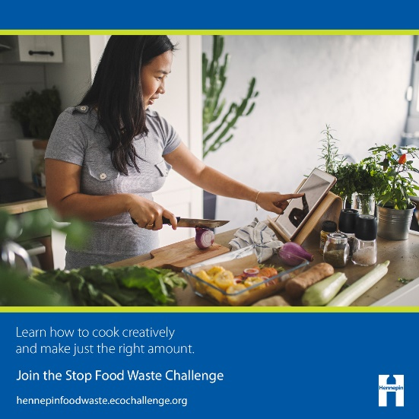
Learning skills like creating a meal plan, buying just what you need at the grocery store, cooking creatively, and properly storing food can have a big impact on reducing the amount of food in your home that goes to waste.
Join Hennepin County’s online Stop Food Waste Challenge to learn easy, practical skills that will help you stop wasting food, put more money in your pocket, and create a healthier environment. Even better, taking steps to reduce food waste is one of the most important actions we can take to address climate change.

How the challenge works
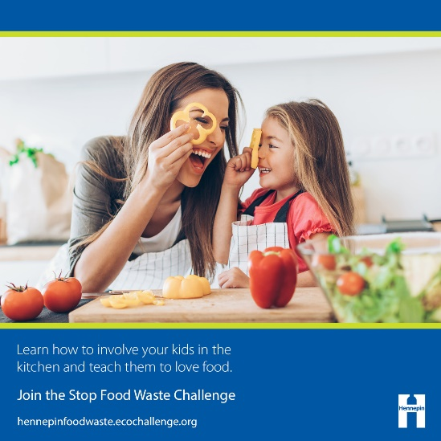
When you join the challenge, you can commit to taking actions that will have the most impact in your household – the challenge has more than 40 actions to choose from in five categories.
The first step is to sign up, create your profile, and join or start a team. Then, browse the categories and actions, check off the actions you already take, and select up to five one-time actions and five daily actions to make progress on during the four-week challenge.
It's recommended that everyone starts with tracking their food waste for one week – it’s the best way to learn what’s going to waste in your household and identify ways to prevent it.
Once the challenge starts, you will report what actions you take, see the impact of your actions add up, and connect with others. Participants will get email updates with resources and tips for taking action and opportunities to attend workshops and events hosted by Stop Food waste Challenge partners.
The challenge goes from August 1 through August 31. Join the challenge now at hennepinfoodwaste.ecochallenge.org.

Sample newsletter article – short

Create meals, not waste: Join Hennepin County’s Stop Food Waste Challenge
We love food, which leaves us wondering: why do we let so much of it go to waste? About 40% of food is wasted somewhere along the supply chain, and you may be surprised to learn that much of that food waste happens at home.

Improve your food-waste-fighting skills with the Stop Food Waste Challenge
Learning skills like creating a meal plan, buying just what you need at the grocery store, cooking creatively, and properly storing food can have a big impact on reducing the amount of food in your home that goes to waste.
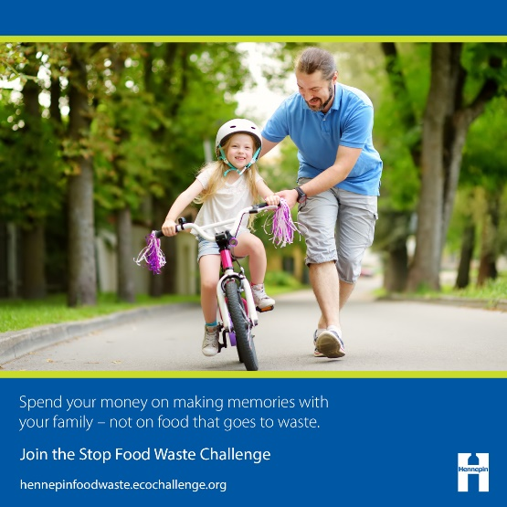
Join Hennepin County’s online Stop Food Waste Challenge at hennepinfoodwaste.ecochallenge.org to learn easy, practical skills that will help you stop wasting food, put more money in your pocket, and create a healthier environment.

How the challenge works
The challenge goes from August 1 through August 31. Create your profile, join or start a team, then browse the categories and actions. Select up to five one-time actions and five daily actions to make progress on during the four-week challenge. It’s recommended that everyone starts with tracking their food waste for one week – it’s the best way to learn what’s going to waste in your household and identify ways to prevent it.
During the challenge, you will get email updates with resources and tips for taking action, access to workshops and events hosted by Stop Food waste Challenge partners, and opportunities to connect with others.

Sample email message
Subject: Join me in taking the Stop Food Waste Challenge!
Dear [name],
I love food, which leaves me wondering: why do we let so much of it go to waste? About 40% of food is wasted somewhere along the supply chain, and I was surprised to learn that much of that food waste happens at home. Here in Hennepin County, we throw away enough edible food each year to fill Target Field 1.5 times!
If you’re like me, staying on top of my busy schedule makes it hard to keep track of the food I buy and create a meal plan and stick to it. I’m concerned about reducing food waste because of its significant costs – each of us spend a lot of money each year on food that just ends up going to waste, not to mention the resources that goes into producing and transporting our food. I’m excited about reducing food waste because of the opportunity to have an impact. Taking steps to reduce food waste is one of the most effective actions we can take to create less waste and address climate change.
[Edit the message above or insert a personal message – why is this important to you, why do you think this person would be interested in joining, etc.]
That’s why I’m committing to taking steps to reduce the amount of food waste I generate with Hennepin County’s Stop Food Waste Challenge, and I hope you will join me!
I’m interested to see what I learn by tracking my food waste and reflecting on why it went to waste, and I’m excited to learn skills like creating a meal plan, buying just what I need at the grocery store, cooking creatively, and properly storing food. Taking these steps will help me stop wasting food, put more money in my pocket, and create a healthier environment.
With the challenge, you can focus on the actions that will have the biggest impact for your household. The challenge has more than 40 actions to choose from in five categories. You can check off the actions you already take, then select up to five one-time actions and five daily actions to make progress on during the 4-week challenge. During the challenge, you will get email updates with resources and tips for taking action, access to workshops and events hosted by Stop Food waste Challenge partners, and opportunities to connect with others.
Join the challenge now at hennepinfoodwaste.ecochallenge.org. The challenge runs August 1 through August 31.
Sincerely,
[your name]

Social media posts
Suggested hashtags: #StopFoodWaste #ZeroWaste
To use images and graphics: right click on image and select save as picture. All images include alt text.

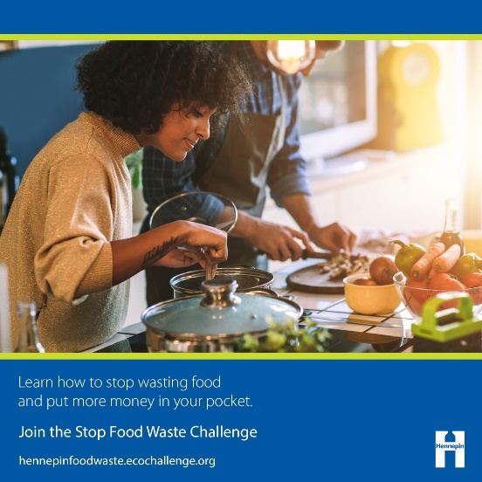
Message theme: Stop throwing food (and money) away
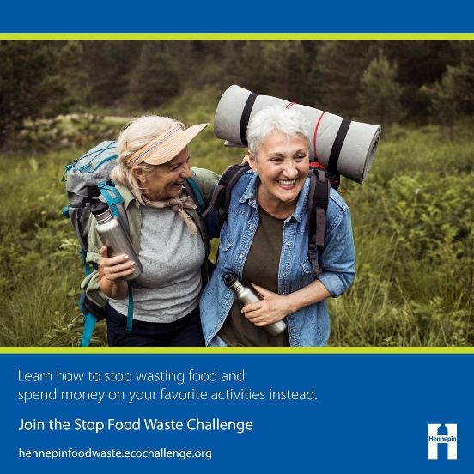
Facebook:
Whether you’re planning for expenses like classes, school supplies, or family activities or you’re saving for college, the next vacation, or retirement, you would never just throw money in the trash. But when you let good food go to waste, that’s exactly what you’re doing. The average person spends nearly $500 every year on food they’ll never eat and just end up throwing away. The cost of those rotten apples, leftovers that never got eaten, and questionable half carton of milk all adds up. Take the Stop Food Waste Challenge to learn easy, practical skills that will help you stop wasting food and put more money in your pocket. hennepinfoodwaste.ecochallenge.org
Twitter:
If you’re on a budget, you’d never throw money in the trash, but when you let food go to waste, that’s exactly what you’re doing. Learn to stop wasting food and put money back in your pocket with the Stop Food Waste Challenge. hennepinfoodwaste.ecochallenge.org #StopFoodWaste
Instagram:
Whether you’re planning for expenses like classes, school supplies, or family activities or you’re saving for college, the next vacation, or retirement, you would never just throw money in the trash. But when you let good food go to waste, that’s exactly what you’re doing. The average person spends nearly $500 on food they’ll never eat and just end up throwing away. The cost of those rotten apples, leftovers that never got eaten, and questionable half carton of milk all adds up. Take the Stop Food Waste Challenge to learn easy, practical skills that will help you stop wasting food and put more money in your pocket. hennepinfoodwaste.ecochallenge.org #StopFoodWaste #ZeroWaste #HennepinZeroWaste #HennepinCounty

Message theme: Managing busy schedule, creating a meal plan
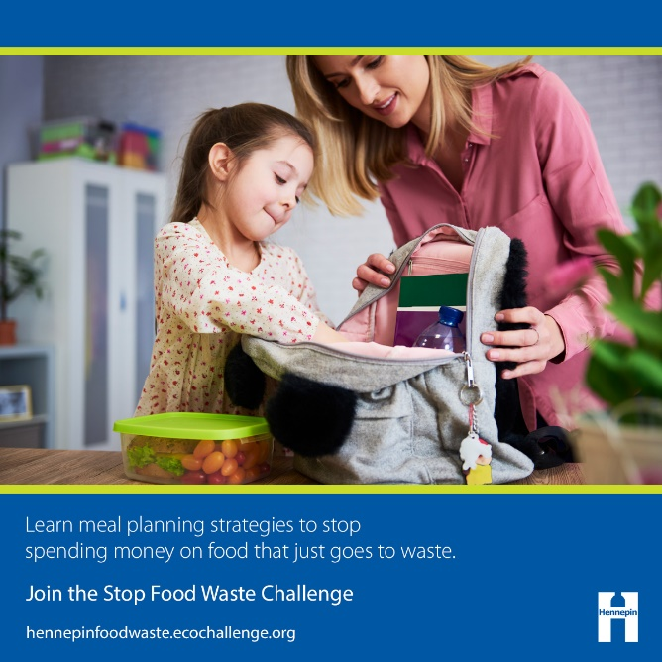
Facebook:
Between homework, job schedules, evening activities, visits with family, and dinners with friends, it’s hard enough to stay on top of your schedule. It’s even harder to make a meal plan and stick to it. The cost of that lettuce you intended to use for salads, the leftovers that got lost in the fridge, and the milk you bought just in case all adds up. Take the Stop Food Waste Challenge and learn meal planning strategies that will help you stop spending money on food that just goes to waste. hennepinfoodwaste.ecochallenge.org
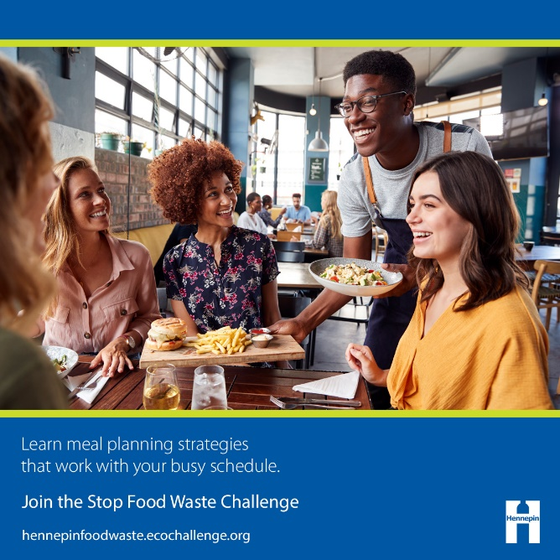
Twitter:
Do busy job schedules, evening activities, and dinners out cause your food at home to spoil before you can eat it? Learn how to meal plan in the Stop Food Waste Challenge and stop spending money on food that just goes to waste. hennepinfoodwaste.ecochallenge.org #StopFoodWaste
Instagram:
Between homework, job schedules, evening activities, visits with family, and dinners with friends, it’s hard enough to stay on top of your schedule. It’s even harder to make a meal plan and stick to it. The cost of that lettuce you intended to use for salads, the leftovers that got lost in the fridge, and the milk you bought just in case all adds up. Take the Stop Food Waste Challenge and learn meal planning strategies that will help you stop spending money on food that just goes to waste. hennepinfoodwaste.ecochallenge.org #StopFoodWaste #ZeroWaste #HennepinZeroWaste #HennepinCounty

Message theme: Involving kids in meal planning, cooking, and growing food
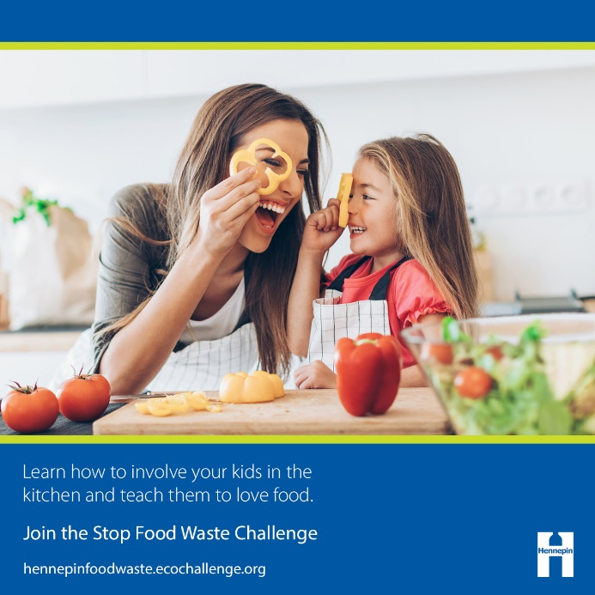
Facebook:
Getting kids to love food and eat healthy often means a lot of food goes to waste along the way. Involving children in the process of meal planning, cooking, and growing food makes it more likely they’ll eat the food that’s served and instill good values around food and healthy eating. But that’s easier said than done. Get tips and resources for teaching your kids to love food instead of wasting it by involving them in the kitchen and garden. Join the Stop Food Waste Challenge. hennepinfoodwaste.ecochallenge.org
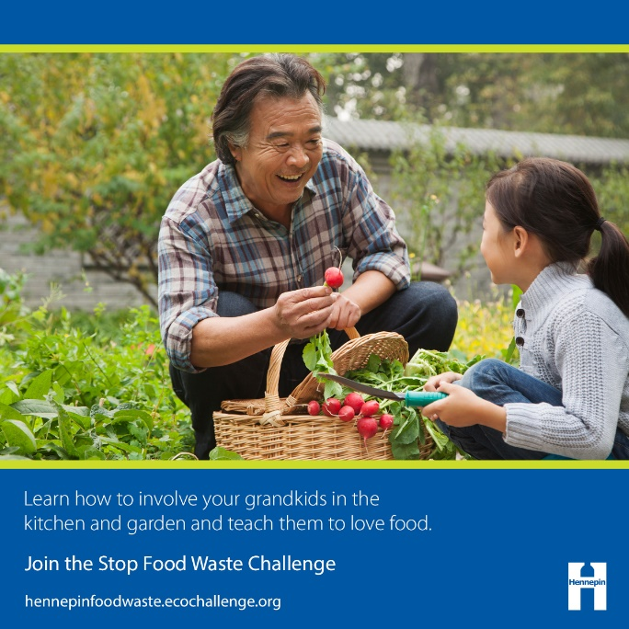
Twitter:
Involving kids in the kitchen and garden instills good values around food and makes it more likely they’ll eat what's served. Get tips for teaching your kids to love food instead of wasting it. Join the Stop Food Waste Challenge. hennepinfoodwaste.ecochallenge.org #StopFoodWaste
Instagram:
Getting kids to love food and eat healthy often means a lot of food goes to waste along the way. Involving children in the process of meal planning, cooking, and growing food makes it more likely they’ll eat the food that’s served and instill good values around food and healthy eating. But that’s easier said than done. Get tips and resources for teaching your kids to love food instead of wasting it by involving them in the kitchen and garden. Join the Stop Food Waste Challenge. hennepinfoodwaste.ecochallenge.org #StopFoodWaste #ZeroWaste #HennepinZeroWaste #HennepinCounty

Message theme: Learning how to buy and make the right amount
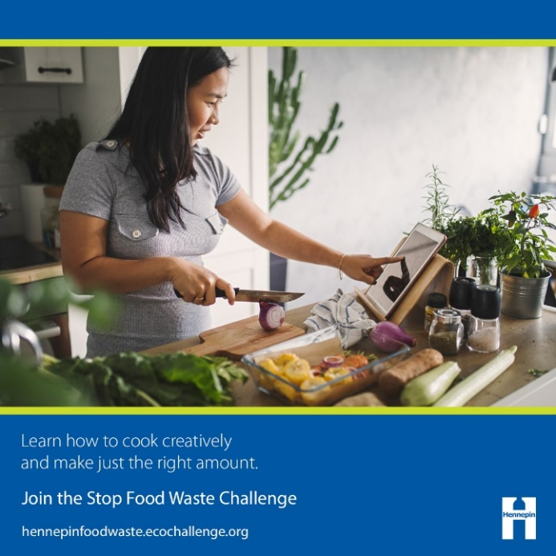
Facebook:
If you’re cooking for a small household, you may often find yourself buying or making more food than you can eat. Food that spoils and leftovers that go to waste cost you money and wastes the resources that went into growing and transporting your food. Learn strategies for buying and making just the right amount of food for your household and cooking creatively to use up extra ingredients by joining the Stop Food Waste Challenge. hennepinfoodwaste.ecochallenge.org
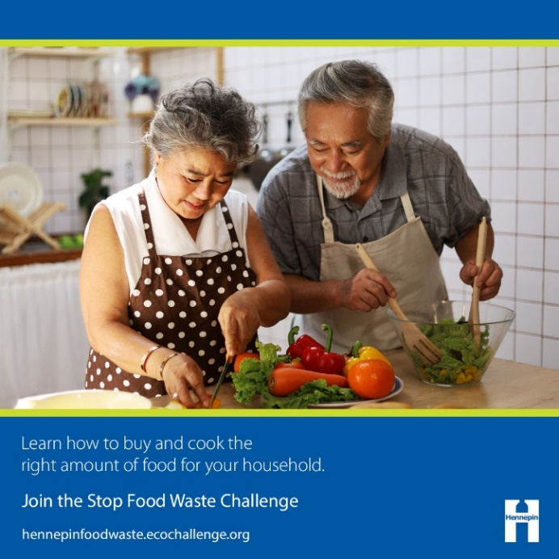
Twitter:
Cooking for a small household often means buying more food than you can eat, which wastes money and resources. Learn strategies for making just the right amount of food for your household by joining the Stop Food Waste Challenge. hennepinfoodwaste.ecochallenge.org #StopFoodWaste
Instagram:
If you’re cooking for a small household, you may often find yourself buying or making more food than you can eat. Food that spoils and leftovers that go to waste cost you money and wastes the resources that went into growing and transporting your food. Learn strategies for buying and making just the right amount of food for your household and cooking creatively to use up extra ingredients by joining the Stop Food Waste Challenge. hennepinfoodwaste.ecochallenge.org #StopFoodWaste #ZeroWaste #HennepinZeroWaste #HennepinCounty

Message theme: Reducing food waste to address climate change
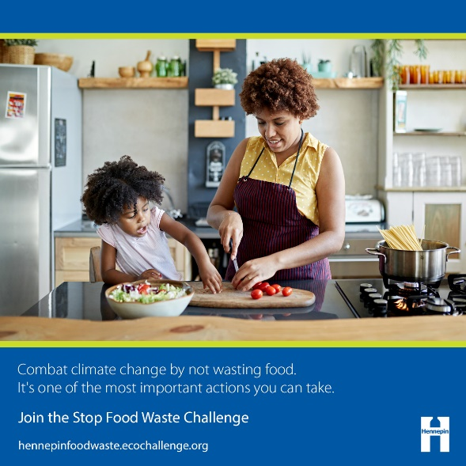
Facebook:
We care about creating a better community for ourselves and future generations, which is why we want to take action on climate change. Did you know that reducing the amount of food that goes to waste is one of the most important actions we can take to address climate change? It may come as a surprise, but if food waste was a country, it would be the third highest emitter of greenhouse gases after the U.S. and China. If you care about reducing greenhouse gas emissions, you should care about reducing food waste! Combat climate change by joining the Stop Food Waste Challenge and leave a healthy environment for future generations. hennepinfoodwaste.ecochallenge.org
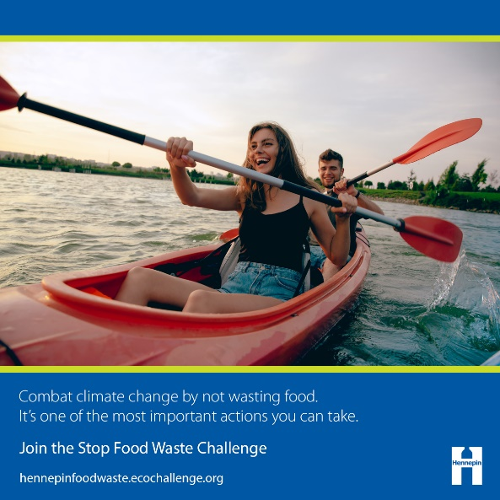
Twitter:
If you care about taking action on climate change and leaving a healthy environment for future generations, you should care about reducing food waste! Combat climate change by joining the Stop Food Waste Challenge. hennepinfoodwaste.ecochallenge.org #StopFoodWaste
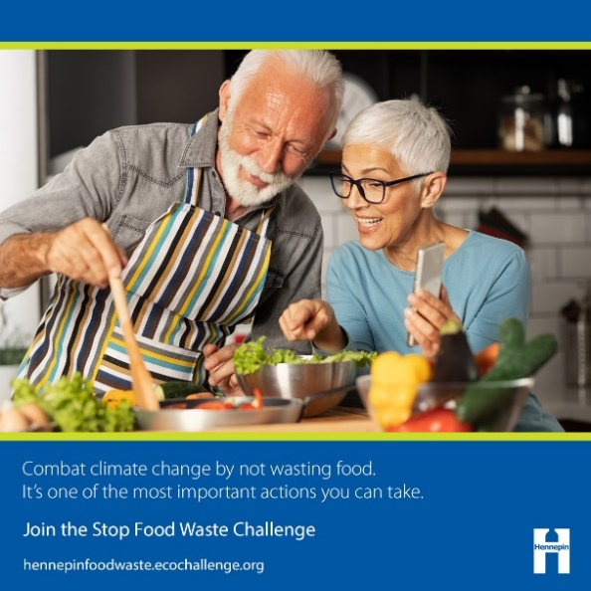
Instagram:
We care about creating a better community for ourselves and future generations, which is why we want to take action on climate change. Did you know that reducing the amount of food that goes to waste is one of the most important actions we can take to address climate change? It may come as a surprise, but if food waste was a country, it would be the third highest emitter of greenhouse gases after the U.S. and China. If you care about reducing greenhouse gas emissions, you should care about reducing food waste! Combat climate change by joining the Stop Food Waste Challenge and leave a healthy environment for future generations. hennepinfoodwaste.ecochallenge.org #StopFoodWaste #ZeroWaste #HennepinZeroWaste #HennepinCounty

