Salvage Crawl media kit

About Hennepin County’s Salvage Crawl
This May, Hennepin County is hosting a Salvage Crawl, where people are enticed to buy used—rather than new--building materials for home remodeling projects.

How to participate
Visit participating salvage retailers from May 1 to 31, 2024 to be entered into a drawing to win one of five prizes. Find a list of retailers and interactive map at hennepin.us/salvage. When you go shopping, look for Hennepin County’s Salvage Crawl poster near the checkout counter at each retailer location and scan the QR code to enter your information for a chance to win.

Resources to promote the Salvage Crawl
We need your help to make it a success. Share content from the Salvage Crawl Media Kit with your audiences! Ways to educate the public about the Salvage Crawl:
- Use the sample newsletter article and social media post to share on your organization’s website, newsletters, and social media channels. They are editable so you can customize the length or message.
- Follow and reshare messages posted on the Hennepin County Environment and Energy social media channels: Hennepin Environment on Facebook, Hennepin Environment on Instagram, and @hennepinenviro on X/Twitter.
- Share the information and resources available at www.hennepin.us/salvage
- Find an interactive map of participating retailers at hennepin.us/salvage

Contact
For more information about the Salvage Crawl, contact:
- Olivia Cashman, Hennepin County construction and demolition specialist, olivia.cashman@hennepin.us
- Christina Schmitt, Hennepin County Environment and Energy communications, christina.schmitt@hennepin.us

Newsletter article
Note: To use images: right click on image and select save as picture.
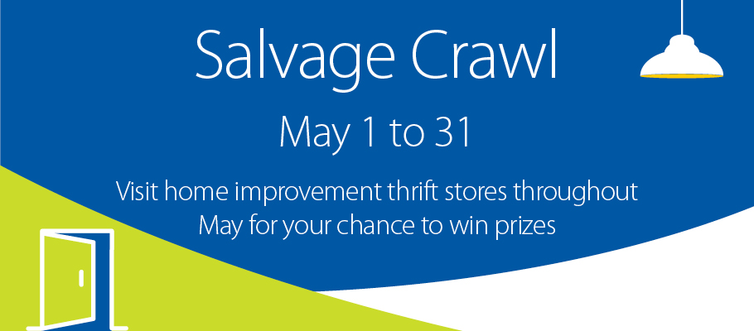

Support reuse and small businesses during Hennepin County’s Salvage Crawl
This May, participate in Hennepin County’s Salvage Crawl and get to know home improvement thrift stores in the Twin Cities. Salvage retailers offer a wide variety of building materials, hardware, tools, and other home improvement items. From old growth lumber to vintage light fixtures and everything in between, you’ll be sure to find both inspiration and quality materials for your next project.

How to participate
Visit participating salvage retailers from May 1 to 31, 2024 to be entered into a drawing to win one of five prizes. Find a list of retailers below. When you go shopping, look for Hennepin County’s Salvage Crawl poster near the checkout counter at each retailer location and scan the QR code to enter your information for a chance to win.

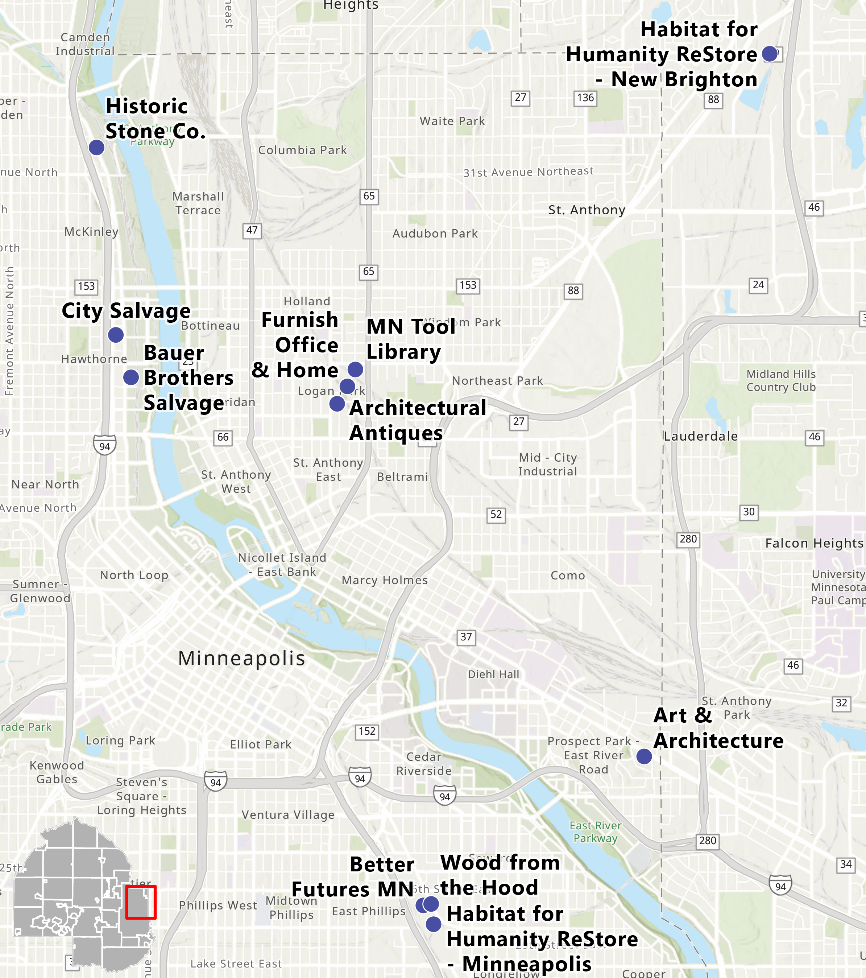
Participating retailers
Architectural Antiques
1330 Quincy St NE, Minneapolis, MN 55413
612-332-8344

Art & Architecture
3338 University Ave SE, Minneapolis, MN 55414
612-904-1776

Bauer Brothers Salvage
2432 N 2nd St, Minneapolis, MN 55411
612-521-9492

Better Futures MN
2620 Minnehaha Ave, Minneapolis, MN 55406
612-351-8657

City Salvage
2800 N Washington Ave, Minneapolis, MN 55413
612-627-9107

Furnish Office & Home
850 NE 15th Ave, Minneapolis, MN 55413
612-789-3322

Habitat for Humanity ReStore - Minneapolis
2700 Minnehaha Ave, Minneapolis, MN 55406
612-588-3820

Habitat for Humanity ReStore - New Brighton
510 County Rd D W, New Brighton, MN 55112
612-588-3820

Historic Stone Co
3940 N Washington Ave, Minneapolis, MN 55412
651-641-1234

MN Tool Library
1620 NE Central Ave #126, Minneapolis, MN 55413
612-440-8665

Wood from the Hood
2616 Minnehaha Ave, Minneapolis, MN 55406
612-581-0252

Prizes
First place (one available): $100 gift card to a participating retailer

Second place (four available): $50 gift card to a participating retailer OR one-year basic individual membership to the Minnesota Tool Library ($55 value)

Surprise prizes will also be given throughout the Salvage Crawl so watch for more details!

Social media post
Suggested hashtags: #SalvageCrawl #HennepinCountySalvageCrawl #Reuse #SmallBusiness #NationalHomeImprovementMonth
To use image: right click on image and select save as picture.
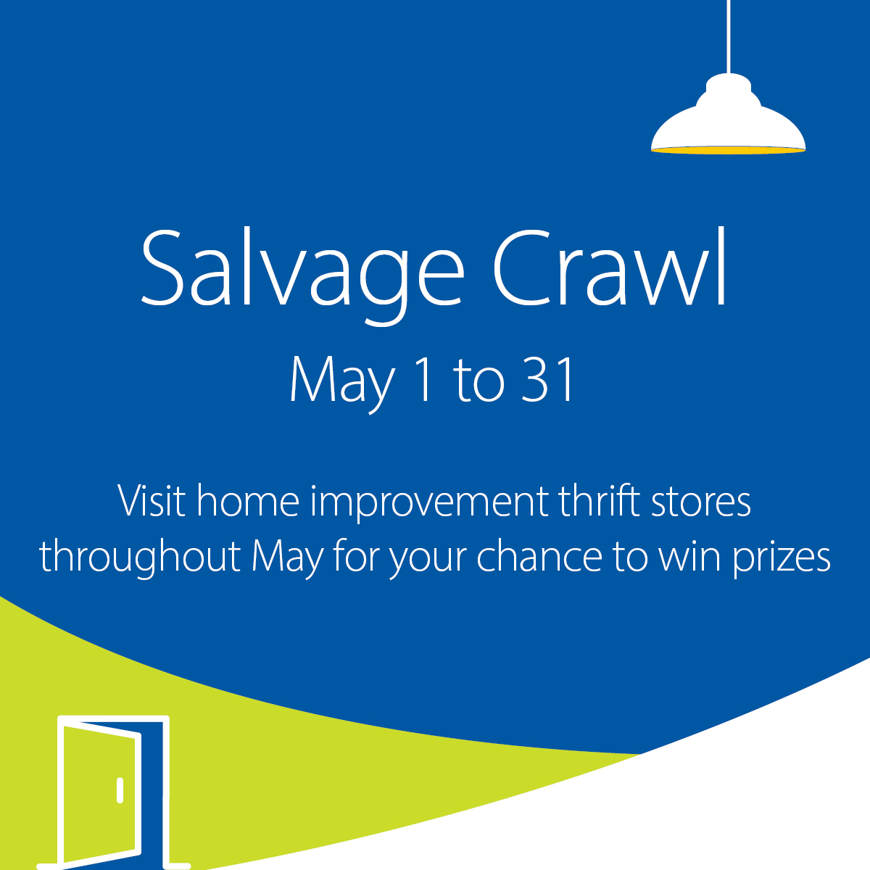
Caption: The greenest building material is one that already exists. Visit salvage retailers throughout the month of May for your chance to win prizes. hennepin.us/salvage

