College of American Pathologists Residents Forum

Standardized Application for Pathology Fellowships

Applicant Name
Last name | First | Middle

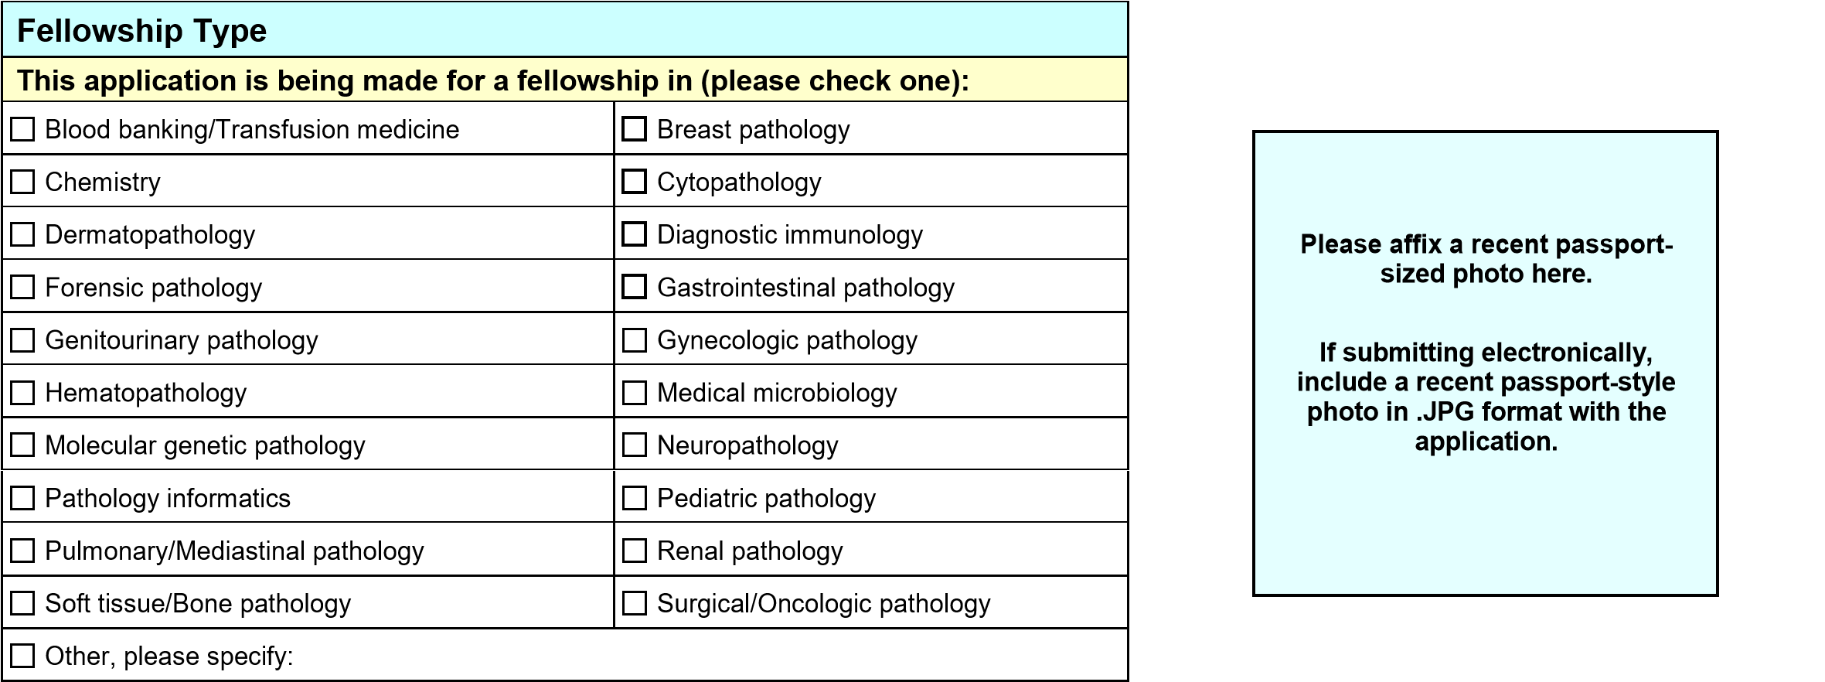

Training period for which applying: | Start date | Finish date

Personal Data
Other names used:
Present Address
Street |  | City |  | State |  | ZIP / Postal code
Permanent Address
Street |  | City |  | State |  | ZIP / Postal code
Telephone
Home | Work |  | Mobile |  | Fax
E-mail:
Citizenship
Country of citizenship |  |  | Visa status

Education |  |  | (Please enclose transcripts)
(Mo/Yr) | to | (Mo/Yr) | (Undergraduate School) | (Major) | (Degree)
(Mo/Yr) | to | (Mo/Yr) | (Graduate School, if applicable) | (Major) | (Degree)
(Mo/Yr) | to | (Mo/Yr) | (Medical School) | (Country) | (Degree)
(Mo/Yr) | to | (Mo/Yr) | (Residency) |  | (AP, CP, AP/CP, other)
(Mo/Yr) | to | (Mo/Yr) | (Other GME, if applicable) |  | Area of training
(Mo/Yr) | to | (Mo/Yr) | (Other GME, if applicable) |  | Area of training

Other Experience
In chronological order, list other educational experiences, jobs, military service or training that is not accounted for above.
(Mo/Yr) | to | (Mo/Yr)
(Mo/Yr) | to | (Mo/Yr)
(Mo/Yr) | to | (Mo/Yr)

National Boards
Please indicate national board examination dates and results received.
USMLE Step 1 |  | USMLE Step 2 |  |  |  |  |  |  |  | USMLE Step 3
Date passed | Score (optional) | CK - Date passed | Score (optional) |  |  | CS - Date passed |  |  | Score (optional) | Date passed | Score (optional)
For graduates of international medical schools, are you ECFMG-certified? |  |  |  |  | Yes |  |  | No If yes, provide certificate number and date granted.
ECFMG Certificate Number |  |  |  |  |  | Date ECFMG Certificate Granted  (MM-YYYY)
COMLEX Level 1 |  | COMLEX Level 2 |  |  |  |  |  |  |  | COMLEX Level 3
Date passed | Score (optional) | CE - Date passed | Score (optional) |  |  | PE - Date passed |  |  | Score (optional) | Date passed | Score (optional)

Medical Licensure
Please list any states in which you hold a license to practice medicine. Please provide a license number. If an application is pending in a state, please write “pending.”
(State) | (Date Issued) | (Medical License Number) | (Active?)
 |  |  |  |  | Yes |  | No
(State #2) | (Date Issued) | (Medical License Number) | (Active?)  Yes No
Have you ever been reprimanded, or had your license suspended or revoked in any of these states? |  | Yes (If so, please explain in an attached sheet.) No
Have you ever been named in (and/or had a judgment against you) in a medical malpractice legal suit? |  | Yes (If so, please explain in an attached sheet.) No

Board Certification
Please indicate any areas of board certification.
Board | Area of Certification | Date of Certification
Honors, Awards, Publications, Presentations, Memberships, Leadership/Research Experience
Please list on attached application forms or include this information in your CV.

Letters of Recommendation and/or References
Please list the individuals who will write your letters of recommendation. At least three are required.
Reference #1
Name |  | Title
Institution

Address | City |  | State | ZIP / Postal Code
Telephone |  | Email
Reference #2
Name |  | Title
Institution

Address | City |  | State | ZIP / Postal Code
Telephone |  | Email
Reference #3
Name |  | Title
Institution

Address | City |  | State | ZIP / Postal Code
Telephone |  | Email
Reference #4 (optional)
Name |  | Title
Institution

Address | City |  | State | ZIP / Postal Code
Telephone |  | Email

Signature (may omit if submitting electronically)
I hereby certify that all of the information on this application is accurate, complete, and current to the best of my knowledge, and that this application is being made for serious consideration of training in the Pathology Fellowship indicated. I understand that accepting more than one fellowship position constitutes a violation of professional ethics and may result in the forfeiture of all positions.
Signature | Date

Honors and Awards (if explicitly listed on CV, include highlights here with reference to location on CV)

Publications and Presentations (if explicitly listed on CV, include highlights here with reference to location on CV)

Memberships and Leadership/Research Experience (if explicitly listed on CV, include highlights here with reference to location on CV)

Residents Forum Suggested Timeline for Application
Beginning two-and-a-half years before the proposed start of a fellowship for which the application is being made, the following timeline is recommended:
December 1 Deadline for receipt of the completed Residents Forum Standardized Application and all supporting documentation (letters of recommendation, transcripts, etc.)
March 1 Deadline for program to make offers to applicants

Application Packet Check-list
✓ Completed Standardized Fellowship Application Form with Signature
✓ Updated Curriculum Vitae (CV)
✓ Included cover letter and/or personal statement
✓ Checked with the fellowship director or coordinator whether there are other items that should be included
✓ Transcript from schools
✓ Included photo

