Setting up Digital Signature – “Click to Sign”

These instructions are for setting up a digital signature in Windows 10 / Adobe Acrobat DC.
This type of signature is for internal forms signed by a worker.
After the form is signed the signature will look similar to this:
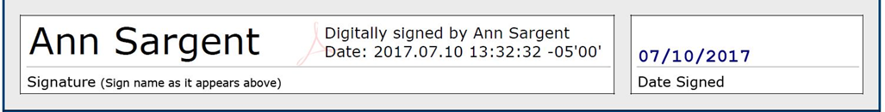

- Open a form that has eSignature enabled.

- Click on the Red Tab by the signature line:
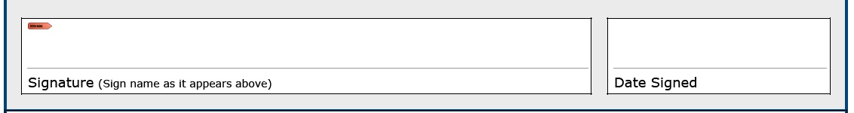

- You will get a pop-up message that “Digital ID Configuration Required.”
Select “Configure Digital ID.”
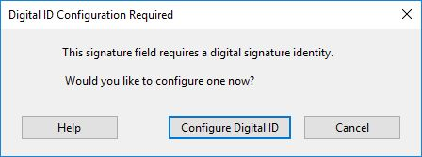

- Select “Create a new Digital ID,” then click “Continue.” t th t
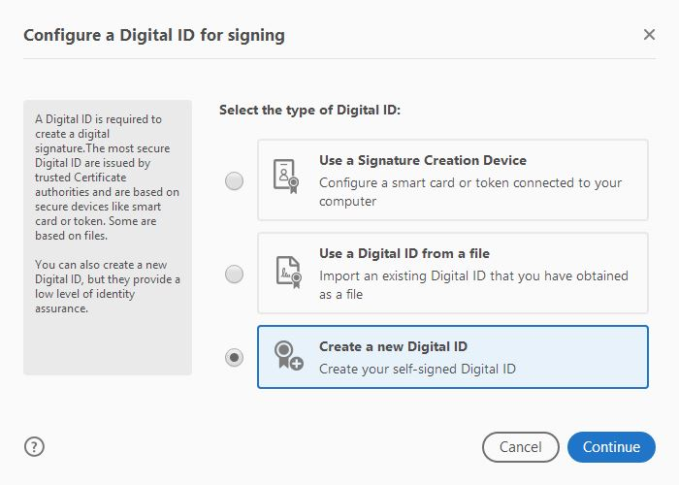

Select “Save to File,” then “Continue.”
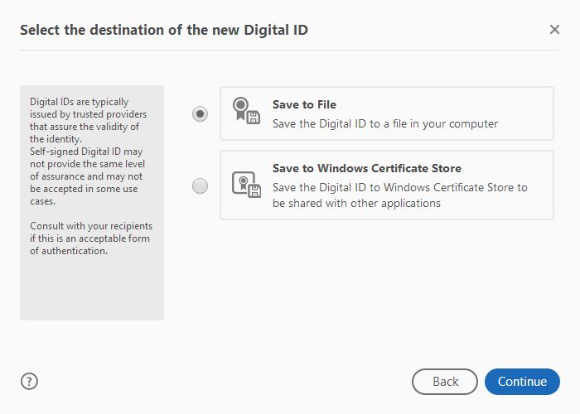

- Enter your name, unit, organization (i.e., Hennepin County) and Hennepin County email and click “Continue.”
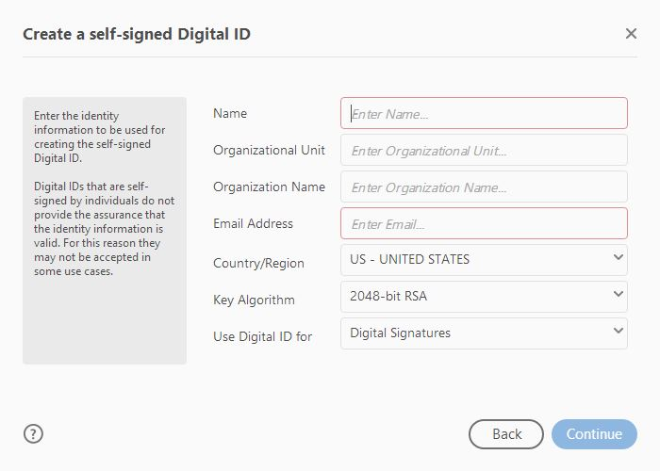

- Enter a password and confirm the password. Click “Save.”
Important Note: You must remember this password for future use, or you will need to re-do the process.
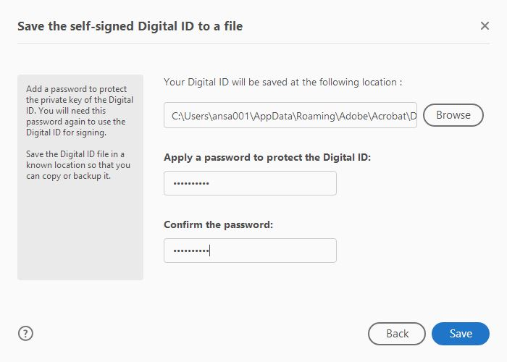

- You have now created a Digital ID. Click “Continue” to use it to sign your document.
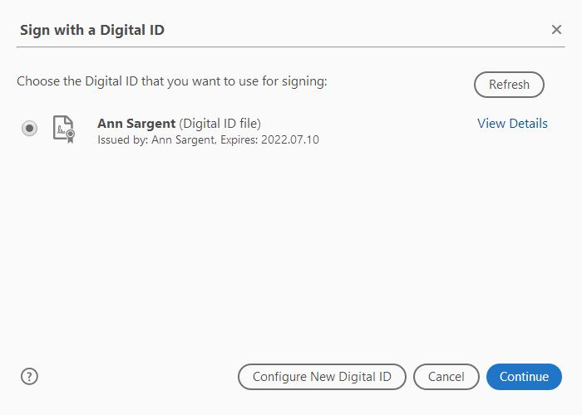

- Enter your password and click “Sign.” The document will then be signed.
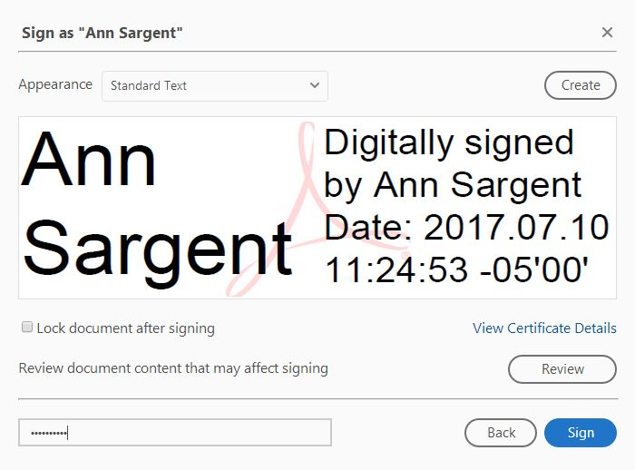

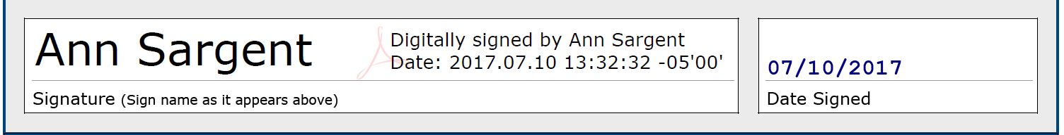

- Going forward, when you sign a form, you will just enter your password and click sign.
- If you get this dialog box when you click in the signature area to sign, select “Adobe Default Security.”
“Topaz.GemSignPlus” is used with signature pads, especially when clients need to sign.
