Organization: 2 ◻◻◻◻

Today’s date:
◻◻/◻◻/◻◻◻◻
MO DAY YEAR

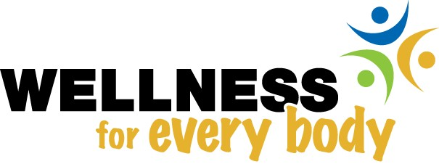

Baseline Survey

Hennepin County Mental Health Center

HEB survey, ver 1, p1 of 7

The survey begins with some questions about your experience here at this center.

- How long have you been coming to the Hennepin County Mental Health Center?
  - ◻ Less than 6 months
  - ◻ Between 6 months and a year
  - ◻ More than a year

- In the past month, how many times have you been here?
- ◻ 1 or 2 times
- ◻ Between 3 and 5 times
- ◻ Between 6 and 10 times
- ◻ More than 10 times

- Has the staff here ever asked you about:

- the foods that you eat?
- ◻ No
- ◻ Yes
- ◻ I don’t remember

how much exercise you get?
- ◻ No
- ◻ Yes
- ◻ I don’t remember

whether you smoke or use tobacco?
- ◻ No
- ◻ Yes
- ◻ I don’t remember

- Has the staff here at the center ever talked with you about how you could eat more healthfully OR get more exercise OR quit smoking (if you smoke)? This could be as part of a class or just talking with you.

- ◻ No
If No, please go to question 5.

- ◻ Yes

4a. Which of these has the staff talked with you about? Please circle all that apply.
Eating Exercise Tobacco

4c. Do you like the way that the staff here provides information and help about eating more healthfully, exercising more or stopping using tobacco?

1 ◻ No Why not?
_______________________________

2 ◻ Yes _______________________________

- Would you like the staff here to provide more, less or about the same amount of information and help about:

- healthful eating?
- ◻ More
- ◻ About the same amount
- ◻ Less

being more physically active?
- ◻ More
- ◻ About the same amount
- ◻ Less

quitting or decreasing tobacco use?
0 ◻ I don’t smoke or use any other type of tobacco
- ◻ More
- ◻ About the same amount
- ◻ Less

The next section is about your health and what you do.

Eating

The next questions ask you how many servings of either fruits or vegetables that you eat per day. Please look at the diagrams and the food models to see what we mean by a serving.

- These pictures show that a serving of vegetables is a cup of salad greens, or a half cup of any other vegetables.

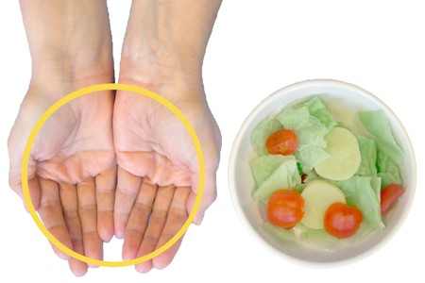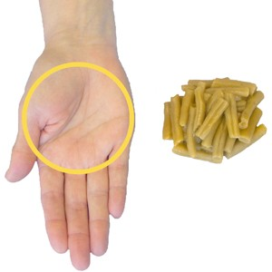

On a typical day in the past week, how many servings of vegetables did you eat? Please don’t count French fries.

_______ servings per day of vegetables

- These pictures show that a serving of fruit is a medium sized piece of fruit or a half cup of chopped, cut, or canned fruit, or 6 oz. (¾ cup) of 100% fruit juice.

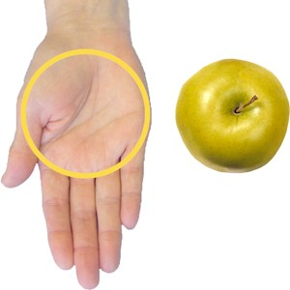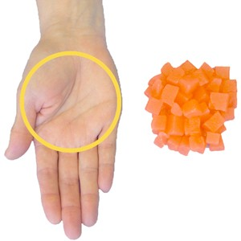

On a typical day in the past week, how many servings of fruit did you eat? Please remember to count 100% fruit juice.

_______ servings per day of fruit

- On a typical day in the past week, how many sweet drinks did you drink? Examples of sweet drinks are soda, juice drinks that are not 100% juice, coffee or tea with sugar added, and sports drinks. Please don’t count 100% juice.

_______ servings per day of sweet drinks

Physical Activity

- In the past week, what type of physical activity did you do? Check all that apply.
1 ◻ Walking
1 ◻ Running
1 ◻ Bicycling
1 ◻ Housework
1 ◻ Gardening
1 ◻ Yoga
1 ◻ Weight-lifting
1 ◻ Swimming
1 ◻ Some other type (what?): _________________________________________________

- In the past week, how many days did you do activities that made your heart beat faster or made you breathe harder? Examples are walking, bicycling, vacuuming, gardening, yoga and other exercises.

______ days in the past week

- During a typical day when you did activities that made your heart beat faster or made you breath harder, how many minutes did you do this?

______ minutes a day in a typical day when you did these activities

Tobacco Use

- Have you smoked a cigarette or a small cigar, even a puff, in the last seven days?

- ◻ No, I’ve never been a smoker.
If you don’t smoke (choice 1 or 2), skip to Question 13
- ◻ No, I used to smoke, but I quit.
- ◻ No, I smoke, but I haven’t smoked in the past seven days.
- ◻ Yes, I have smoked in the past seven days.
12a. Have you smoked cigarettes or small cigars? Check all that apply.
1 ◻ Cigarettes
1 ◻ Small cigars

12b. Have you smoked cigarettes or small cigars every day?
- ◻ No, just on some days
- ◻ Yes, every day

12c. About how many cigarettes and / or small cigars do you smoke in the typical day? Note: a pack usually has 20 cigarettes
_______ cigarettes or small cigars in a typical day

12d. In the last year, have you quit smoking for 24 hours or more?

- ◻ No
- ◻ Yes

12e. Are you seriously considering quitting smoking in the next 6 months?
- ◻ No
- ◻ Yes

- Have you used chewing tobacco or snuff at all during the last 7 days?
- ◻ No, not at all
- ◻ Yes

- Have you used any type of tobacco other than cigarettes, snuff or chewing tobacco in the past seven days?
- ◻ No

- ◻ Yes – What kind?
_____________________________________

- Have you used e-cigarettes in the past seven days?
- ◻ No
- ◻ Yes

Finally, we would like some background information about you. This information will help us describe (as a group) the people who participated in the survey.

- How important do you think eating healthfully is for your health? Would you say that it is very important, somewhat important or not important?
- ◻ Very important
- ◻ Somewhat important 3 ◻ Not important

- How important do you think getting enough exercise is for your health? Would you say that it is very important, somewhat important or not important?
- ◻ Very important
- ◻ Somewhat important 3 ◻ Not important

- How important do you think not using tobacco is for your health? Would you say that it is very important, somewhat important or not important?
- ◻ Very important
- ◻ Somewhat important 3 ◻ Not important

- What is your age?
______ years old

- Are you female or male?
1 ◻ Female
2 ◻ Male

That’s all! Thank you very much for taking the time to complete this survey.

Please give your survey to the interviewer.

