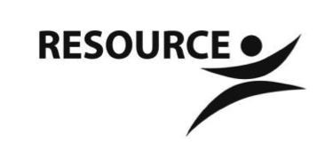
Northwest Community Support Program
7000 57th Ave N, Suite 100
Crystal, MN 55428

NWCSP Tobacco Use Policy

PURPOSE: Smoking and secondhand smoke are known to cause serious lung diseases, heart disease and cancer. NWCSP recognizes the hazards caused by tobacco use and exposure to secondhand tobacco smoke. Our policy to provide a tobacco-free environment for all staff, members and visitors was established to keep a safe and healthy meeting and work place, support those trying to quit tobacco use and promote positive health behaviors. This policy covers the smoking of any tobacco product and the use of oral tobacco products, “spit" tobacco and e-cigarettes.

WHAT WE WILL BE DOING:

- We will allow tobacco use only in a designated smoking area located outdoors at the northeast corner of the building near the bench at the entry to the parking lot. All materials used for smoking in designated smoking areas, including cigarette butts and matches, will be extinguished and disposed of in appropriate containers.
- We will support members and staff in their desire to quit smoking through education, information, support and existing resources within and outside of NWCSP.
- Staff will have opportunities for ongoing tobacco cessation education in order to feel more informed and able to assist those who are ready to quit using tobacco and motivate others who are considering quitting.
- Members will have opportunities for ongoing tobacco cessation education and assistance through programs provided at NWCSP including Healthy Living; Tobacco and you, individual health coaching, workshops and staff discussions/conversations.
- Non-mandatory tobacco-free days will be offered and encouraged on a monthly basis (or more often at staff and member discretion.) Staff will provide support, encouragement and activities that help members manage cravings.

WHAT WE WILL NOT BE DOING:

- NWCSP will not allow the use of tobacco products including cigarettes, e-cigarettes and “spit tobacco” within our facilities of at any time.
- Tobacco use will not be allowed during activities, rides and other events or opportunities provided by NWCSP off the grounds.
- We will not provide rides or stops during outings for people to purchase tobacco.
- We will not tolerate staff or members asking for cigarettes from visitors to NWCSP or any part of the premises or its’ grounds.

