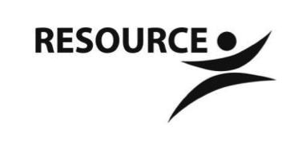
Northwest Community Support Program
7000 57th Ave N, Suite 100
Crystal, MN 55428

NWCSP Nutrition Policy

PURPOSE: To promote a culture at NWCSP that aligns with current Dietary Guidelines for Americans and SAMHSA’s wellness initiative by creating a nutritionally supportive environment that promotes foods and nutrients such as fruits, vegetables, whole grains, low-fat dairy products, and seafood.

WHAT WE WILL BE DOING:

- Promoting healthy lifestyle choices by offering nutritious options at NWCSP and serving mostly fruits, vegetables, whole grains, and low-fat dairy and meats at NWCSP events
- Offering monthly nutrition education opportunities that may include cooking classes, gardening, and information about healthy eating habits and shopping for healthy foods.
- Providing only coffee, water, tea and 100% juice when serving beverages
- Consuming treats no more than 1x/week, for example, small portions of cake for monthly birthday bingo event, and limiting foods containing sodium (salt), saturated fats, trans fats, cholesterol, added sugars, and refined grains
- In regard to cooking curriculum:
  - Focusing on healthy foods with nutritional benefit, focusing on using fruits, vegetables, whole grains, and low-fat dairy and meats
  - Using seasonal ingredients and produce from our own garden when possible
  - Preparing recipes that are easy to prepare with foods that are readily available and budget conscious
  - Teaching basic cooking and shopping skills and techniques

WHAT WE WILL NOT BE DOING:

- Selling soda, candy and processed snacks on NWCSP property
- Organizing outings or providing transportation to fast food establishments
- Providing sugar sweetened beverages and/or artificially sweetened beverages

