Tips about nutrient-rich foods and portion sizes

Eat more nutrient rich foods: Foods high in vitamins, minerals, fiber, water, and other nutrients:

Fruits and vegetables: Eat 5–9 servings a day.
- Use fresh, frozen, or canned (low in sodium, no added sugar)
- Drink 100% fruit juice (4-ounce portion) and low-sodium 100% vegetable juice
- Eat a variety of colorful fruits and vegetables each day
  - Examples: oranges, melons, berries, bananas, apples, leafy greens (spinach, Swiss chard, red leaf or romaine lettuce), tomatoes, carrots, peas, broccoli, cauliflower

Grains: Make half your servings whole grain.
- Look for 100% whole wheat or whole grain on the label
  - Examples: oatmeal, whole wheat, brown rice, quinoa

Lean protein: Eat 2-3 servings a day (about 6 ounces).
- Look for leaner cuts of meat such as loins (e.g., beef sirloin or pork tenderloin), 90/10 ground meat (90% lean and 10% fat), or fish or white meat poultry that is not fried
- Add plant proteins like nuts, nut butters, seeds, and beans (for example, kidney, garbanzo, navy, or black beans)

Dairy: Include 2-3 servings a day.
- Choose lower fat dairy products made with skim (fat free) or 1% milk
  - Not all servings need to be fluid milk
  - Examples: fat free or 1% milk; low fat yogurt or cottage cheese; low fat cheese

Eat fewer nutrient poor foods: Foods high in added sugar, fat, sodium, or calories that have few or no nutrients.
- Examples: cookies, cake, donuts, candy, chips, ice cream, hot dogs, bologna, bacon, sausage, sugar-sweetened beverages
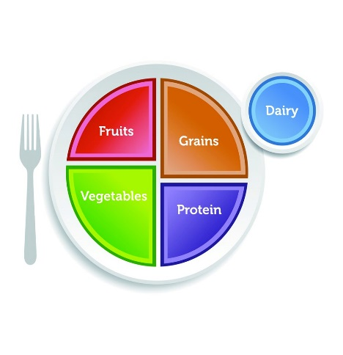
Portion sizes: How should my plate look?
- Use MyPlate (on right). It provides a guide for how much of each food group should make up your plate.
- Use your hand to determine portion sizes (see hand portion handout) or measuring cups and spoons.
- Use smaller plates and 8-ounce cups to keep portion sizes in check.

