Making a Healthier Pizza

Instead of: Try:

High-fat Meats Low-fat Meats
Pepperoni Low-fat pepperoni
Ham Canadian bacon
Regular Hamburger Extra lean ground beef/ground turkey
Sausage Flavored turkey sausage/soy crumbles Chopped chicken breast

White Flour Crust Whole Wheat or Whole Grain Crust
Regular Pizza Sauce Low-sodium Pizza Sauce
Extra Cheese Part Skim Mozzarella – spread thinly
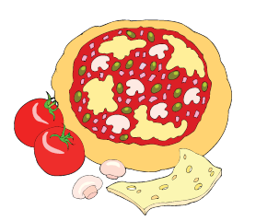
No Vegetables Vegetable/Fruit Options Green/yellow/red/orange bell peppers Roasted red pepper
Onions/green onions
Mushrooms Artichoke hearts Zucchini
Yellow summer squash Tomatoes/sun dried
Broccoli
Olives – black or green Egg plant
Pineapple

