Tips about fat, sodium, and sugar

Limit foods that have added sugars or syrups, such as:
- regular soft drinks, energy drinks, and sports drinks
- candy, cakes, cookies, donuts
Reading the ingredient label on processed foods can help to identify added sugars. Names for added sugars on food labels include:
- anhydrous dextrose malt syrup
- brown sugar maltose
- confectioner's powdered sugar maple syrup
- corn syrup molasses
- corn syrup solids nectars (e.g., peach or pear nectar)
- dextrose pancake syrup
- fructose raw sugar
- high-fructose corn syrup (HFCS) sucrose
- honey sugar
- invert sugar white granulated sugar
- lactose
You may also see other names used for added sugars. These include cane juice, evaporated corn sweetener, crystal dextrose, glucose, liquid fructose, sugar cane juice, and fruit nectar.

Limit foods with saturated fats such as:
- whole milk and butter
- processed meats: hotdogs, bologna, sausage, bacon
Replace saturated fats with unsaturated fats, such as canola or olive oil.
Avoid foods with trans fat (look on the food label to see if there is any trans fat ) and hydrogenated oils (see if the word hydrogenated is listed in the ingredients on the food label).
Limit foods high in sodium:
- frozen pizza
- canned soups
- hotdogs, sausage, bacon, bologna
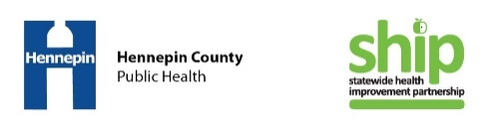
Read food labels. It’s the key to good health.

