

Land protection and restoration media kit


About land protection and restoration

Hennepin County works with residents and partner organizations to protect and restore habitat through conservation easements and habitat restoration projects. Hennepin County, in partnership with the Minnesota Land Trust, has received more than $4.5 million from the Lessard-Sams Outdoor Heritage Fund to acquire conservation easements on the best remaining natural areas in Hennepin County. Funding is also available for habitat restoration projects on protected properties.

Protecting and restoring natural areas provides many benefits. Natural areas help protect and improve air and water quality, provide wildlife habitat and recreation opportunities, and increase property values. They also recharge groundwater, slow stormwater runoff, and help control floods. Protecting land allows landowners to preserve what they value and leave a conservation legacy for future generations.

Resources to promote land protection and restoration
Ways to educate the public about land protection and restoration programs in Hennepin County:
- Use the sample newsletter article to share on your organization’s website or in your newsletters.
- Use the sample social media posts to share through your social media channels.
- Share the information and resources available at hennepin.us/land-protection
- Follow and reshare messages posted on the Hennepin County Environment and Energy social media channels: Hennepin Environment on Facebook, Hennepin Environment on Instagram, and @hennepinenviro on Twitter.

Contact
For more information about land protection and restoration in Hennepin County, contact:
Kristine Maurer, Natural Resources Specialist, Kristine.Maurer@hennepin.us, 612-348-6570
Emily McDonald, Environmental Educator, Emily.McDonald@hennepin.us

Sample newsletter article – conservation easements

Permanently protect your land and leave a conservation legacy

Funding and support available to establish conservation easements on valuable open spaces
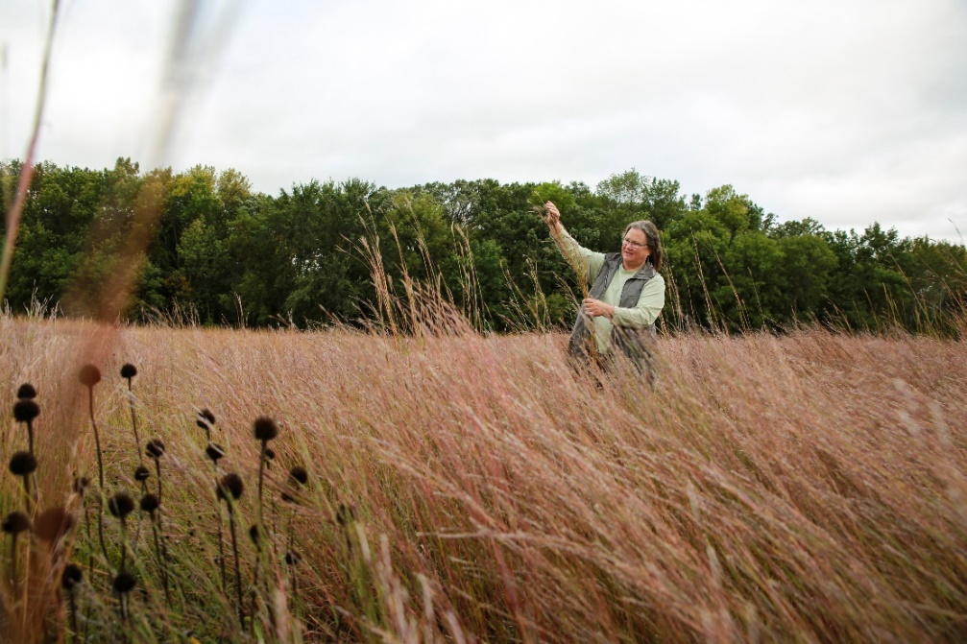
Your land likely holds special meaning to you and your family. A special pond, creek, forest, prairie, or wetland may hold family memories, offer a quiet refuge, or provide recreational activities like wildlife viewing, hiking, riding, hunting, and fishing. Your land also has tremendous value to wildlife and future generations, offering critical habitat for birds, pollinators, and mammals and supporting a healthy environment with clean air and water.
Hennepin County is working to protect 6,000 acres of natural areas and open space and partnering with landowners to protect their land is an important part of reaching that goal.
Landowners can be compensated for permanently protecting their property with a conservation easement, which is a set of development restrictions that a landowner voluntarily places on their property to permanently protect its natural resources.
Properties that may be a good fit for a conservation easement include those that contain rare plants or animals, are near to or encompass high quality habitat, or are at risk of being lost due to development. Though conservation easements may not be a good fit for all properties, the county also has funding and technical assistance available to landowners for habitat improvement projects.
Conservation easements ensure that landowners now, and in the future, can protect what they value about their land, such as the open space, views, rural character, wildlife habitat, mature forest, and more.
If you or someone you know is interested in learning more about establishing a conservation easement, visit hennepin.us/land-protection or contact Kristine Maurer at kristine.maurer@hennepin.us or 612-348-6570.

Sample newsletter article – habitat restoration and improvements

Improve habitat on your property

Funding and support available for habitat restoration and enhancement projects
Healthy forests, prairies, wetlands, bogs, and lakes provide habitat for diverse plant and wildlife species and offer many opportunities for recreation and connection to nature. If you’re interested in protecting land, water, habitat, or open space on property you own, Hennepin County may be able to help.
Hennepin County offers funding and assistance to improve habitat on permanently protected lands. Both private landowners and partner organizations are eligible to receive funding.

For partner organizations
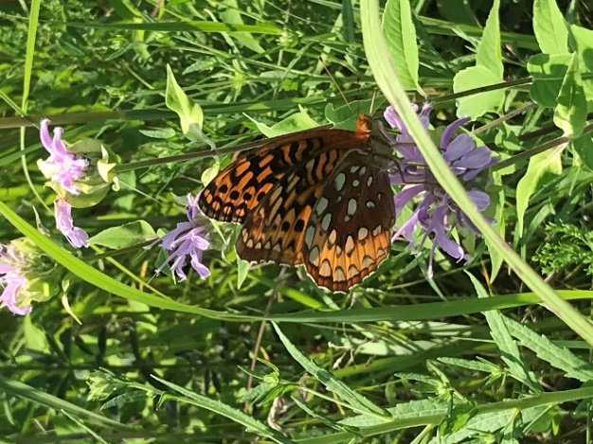
Partner organizations include cities, watershed organizations, state or federal agencies, tribes, park districts, or nonprofit entities with conservation easement or fee-title ownership of conservation lands and waters.
Complete the partner interest form to indicate your organization's interest in a habitat improvement project with Hennepin County.
To understand the process, see the habitat improvement process map for partners (PDF) and the description of each step (PDF).

For private landowners
Complete the private landowner interest form to indicate your interest in habitat improvement projects with Hennepin County.
To understand the process, see the habitat improvement process map for private landowners (PDF) and the description of each step (PDF).

Next steps and timeline
Potential habitat improvement projects are evaluated continuously as funds remain. Only properties that are permanently protected are eligible to receive financial assistance for habitat improvement. The process of implementing a habitat improvement project on permanently protected lands takes a few months to a year. Establishment and long-term maintenance of the investment could last multiple years.
For more information, visit hennepin.us/land-protection

Sample newsletter article – project feature

Conservation easement project feature: Protected habitat corridor in Independence
In order to permanently protect the old-growth maple-basswood forest, tamarack bog, wetlands, and grasslands on their property, a landowner in Independence worked with Hennepin County to establish a 13-acre conservation easement. Establishing the conservation easement protected important habitat for species in greatest need of protection, including monarchs and other unique wildlife, and gave the landowner access to resources to complete habitat improvement projects.

Easement establishment completes a protected corridor
This conservation easement in Independence lies just east of Lake Rebecca Park Reserve in an area rich with lakes and wetlands. The 13-acre easement, established in 2018, completed a corridor of protected habitat between Lake Rebecca Regional Park and Lake Sarah.
This corridor includes six separate easements covering 38 acres established one-by-one over the last 30 years. This series of adjacent easements demonstrates a long-term commitment by Hennepin County, the Minnesota Land Trust, and private landowners to build habitat complexes and create connectivity.

Restoring forest and prairie habitat
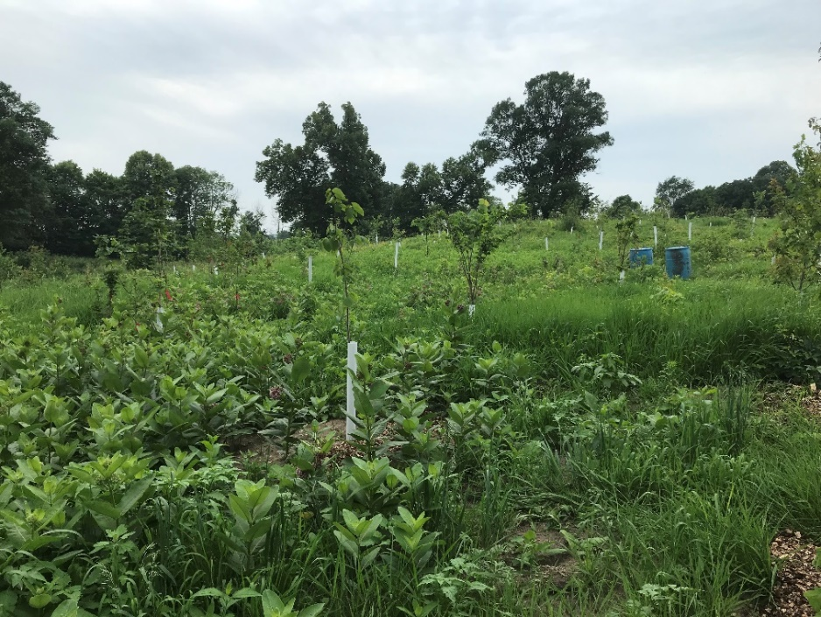
After the easement was established, 1,200 trees were planted on three and a half acres through a reforestation project. In addition, two acres of former farm field was planted with native flowers and grasses to restore upland tallgrass prairie. The prairie and forest restoration will provide improved habitat for pollinators, birds, and mammals as well as intercept nearly 2.5 million gallons of rainfall annually.
The reforestation was completed in partnership with the landowner, Hennepin County, Three Rivers Park District, and the Conservation Corps of Minnesota.
More information about this easement, including a time-lapse video of the reforestation project, along with information on establishing conservation easement is available at hennepin.us/land-protection.

Social media posts
To use images and graphics: right click on image and select Save as Picture.

Protect land with a conservation easement

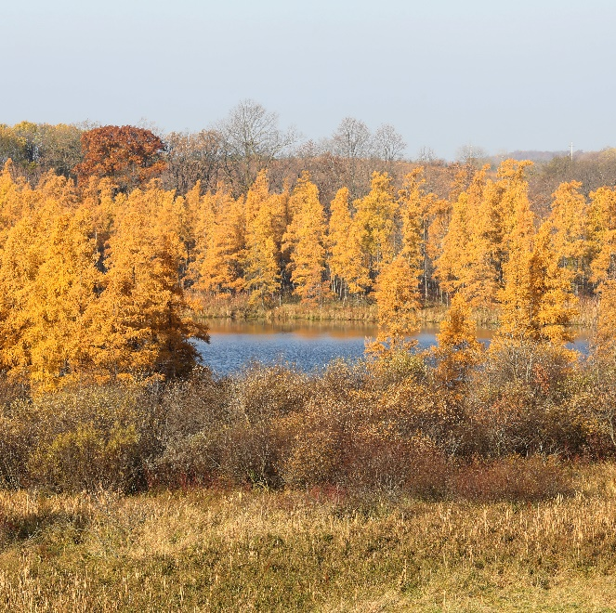
Post 1:
Facebook: Hennepin County is working to protect 6,000 acres of the best remaining natural areas and open spaces in the county. Partnering with landowners to permanently protect their land is an important part of reaching that goal. Conservation easements ensure that landowners now, and in the future, can protect what they value about their land, such as the open space, views, rural character, wildlife habitat, mature forest, and more. Learn more about how you can leave a conservation legacy: hennepin.us/land-protection

Twitter: Permanently protecting land through conservation easements is vital as Hennepin County seeks to protect at least 6,000 acres of the best remaining natural areas. Learn more about protecting your land and leaving a conservation legacy: hennepin.us/land-protection
Instagram: From lakes and rivers to forests and prairies, Hennepin County has an abundance of diverse landscapes and natural resources. These natural resources provide critical habitat for wildlife, protect water quality, offer recreational opportunities, and enhance our collective quality of life.
Hennepin County is working to protect 6,000 acres of the best remaining natural areas and open spaces in the county. Partnering with landowners to permanently protect their land and improve habitat on protected properties is an important part of reaching that goal. Conservation easements ensure that landowners now, and in the future, can protect open space, views, rural character, wildlife habitat, mature forest, and more.
<<Include a carousel of images featuring conservation easements>>

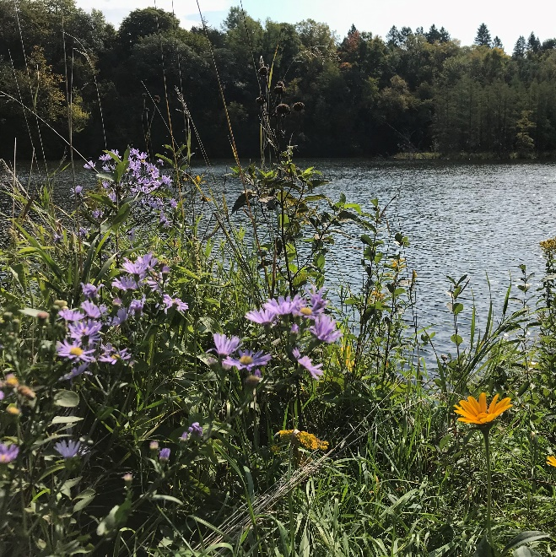
Post 2:
Facebook: Permanently protect your land with a conservation easement! Conservation easements ensure that landowners now, and in the future, can protect what they value about their land, such as the open space, views, rural character, wildlife habitat, mature forest, and more. Apply for funding and assistance: hennepin.us/land-protection
Twitter: Permanently protect your land with a conservation easement! Conservation easements ensure that landowners now, and in the future, can protect open space, views, rural character, wildlife habitat, mature forest, and more. Apply for funding and assistance: hennepin.us/land-protection

Improve habitat on your property

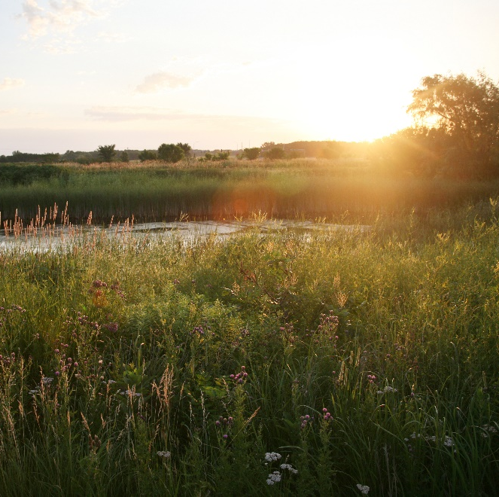
Post 1:
Facebook: Are you interested in restoring or enhancing habitat like forests, woodlands, prairie, or wetlands on your property? Hennepin County offers funding and assistance to improve habitat on permanently protected lands. Both private landowners and partner organizations are eligible to receive funding. Learn more and apply: hennepin.us/land-protection
Twitter: Are you interested in restoring habitat like forests, prairies, or wetlands on your property? Funding is available to improve habitat on permanently protected lands. Both private landowners and partner organizations are eligible. Learn more and apply: hennepin.us/land-protection

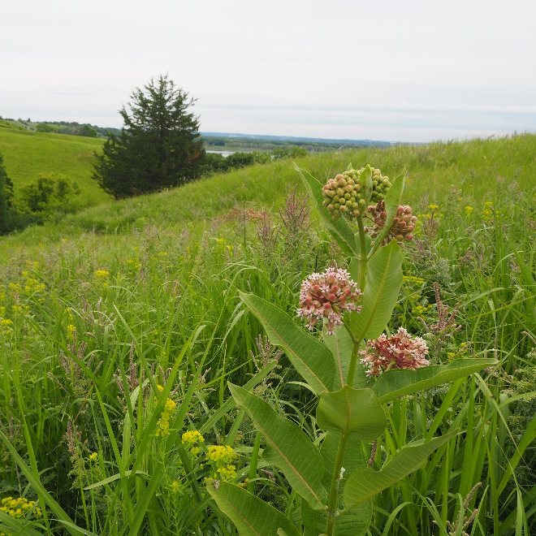
Post 2:
Facebook: Funding and assistance are available to improve habitat for wildlife on your property! From lakes and rivers to forests and prairies, Hennepin County has an abundance of diverse landscapes and natural resources. These natural resources provide critical habitat for wildlife, protect water quality, offer recreational opportunities, and enhance our collective quality of life. Both private landowners and partner organizations are eligible to apply for funding. Learn more and apply: hennepin.us/land-protection
Twitter: Funding and assistance are available to improve habitat for wildlife on your property! Both private landowners and partner organizations are eligible to apply for funding. Learn more and apply: hennepin.us/land-protection

Project features

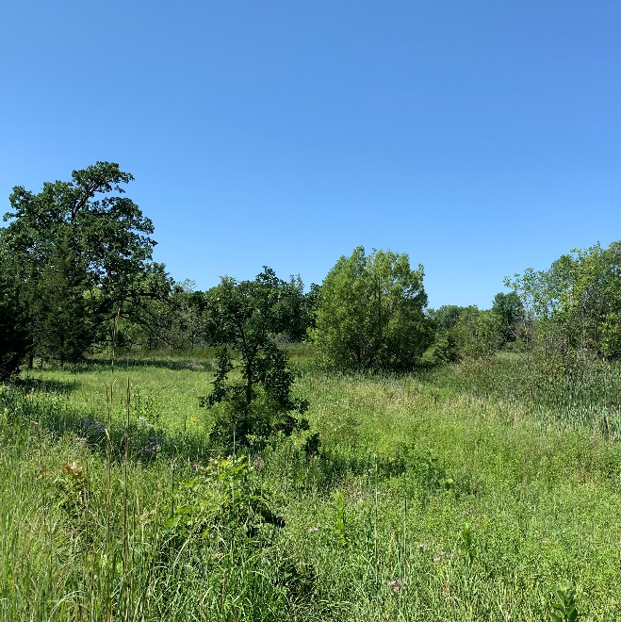
Post 1: Restored pastureland
Facebook: When the Clark's bought a 38-acre parcel of pastureland 25 years ago in western Hennepin County, their goal was to create a home for themselves while restoring the diverse and natural lands that had once thrived on the property. With a conservation easement, their decades of hard work will be protected forever. Read the Minnesota Land Trust's story: mnland.org/2020/09/03/protecting-the-waters-of-hennepin-county/
Twitter: The Clark’s goal was to create a home for themselves while restoring the diverse and natural lands on their property. With a conservation easement, their decades of hard work will be protected forever. mnland.org/2020/09/03/protecting-the-waters-of-hennepin-county/
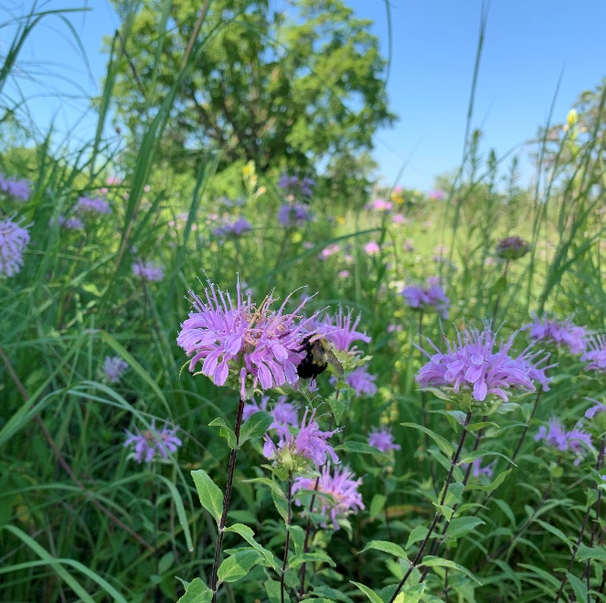
Instagram: When the Clark's bought a 38-acre parcel of pastureland 25 years ago in western Hennepin County, their goal was to create a home for themselves while restoring the diverse and natural lands that had once thrived on the property. With a conservation easement, their decades of hard work will be protected forever.
This property is part of a larger joint effort between Hennepin County and the Minnesota Land Trust to protect habitat within Hennepin County. Natural lands play an important role in filtering surface and groundwater, maintaining wildlife corridors, and creating opportunities for outdoor recreation.

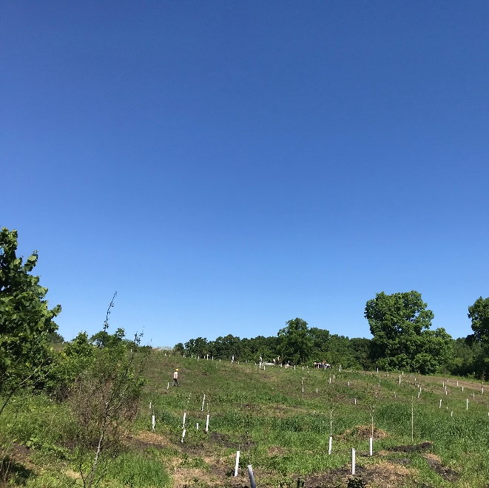
Post 2: Wetlands in Independence
Facebook: This property in Independence lies on the edge of the Twin Cities metro, in an area rich with lakes and wetlands. The 13-acre easement was one of the last remaining unprotected parcels in a habitat corridor connecting Lake Rebecca Regional Park to Lake Sarah. The easement contains old-growth maple-basswood forest, a tamarack bog, wetlands, and grasslands and provides important habitat to Trumpeter swans and other unique wildlife. Read the Minnesota Land Trust's story: mnland.org/2018/06/13/important-twin-cities-area-habitat-protected-forever/
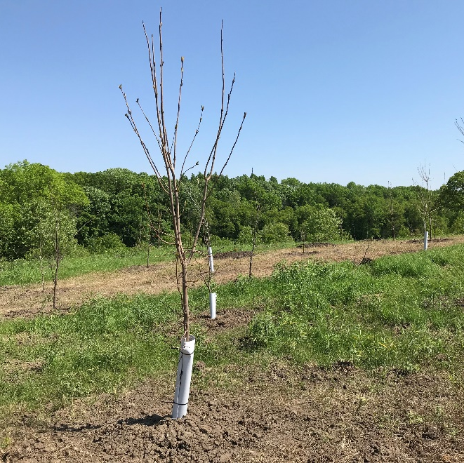
Twitter: This 13-acre easement contains old-growth maple-basswood forest, a tamarack bog, wetlands, and grasslands and provides important habitat to Trumpeter swans and other unique wildlife: mnland.org/2018/06/13/important-twin-cities-area-habitat-protected-forever/
Instagram: This property in Independence lies on the edge of the Twin Cities metro, in an area rich with lakes and wetlands. The 13-acre easement was one of the last remaining unprotected parcels in a habitat corridor connecting Lake Rebecca Regional Park to Lake Sarah. The easement contains old-growth maple-basswood forest, a tamarack bog, wetlands, and grasslands and provides important habitat to Trumpeter swans and other unique wildlife.
After the easement was established, a reforestation project planted 1,200 trees on 3.5 acres of former farm field. The reforestation will help reduce greenhouse gas emissions by sequestering an estimated 3,600 tons of carbon dioxide over the next 25 years and improve water quality by infiltrating nearly 2.5 million gallons of rainfall annually.

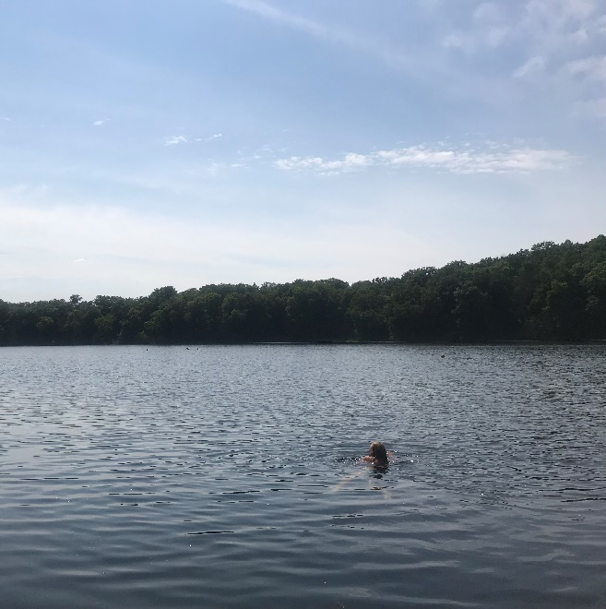
Post 3: Little Long Lake
Facebook: Little Long Lake in Minnetrista consistently has the best water quality in the metro area. Between existing conservation easements and property owned by the Three Rivers Park District, more than 550 acres of habitat are already permanently protected in this area. These habitats contain high-quality upland forest, ephemeral forest wetlands, wet meadows, marshland, and streams. Hennepin County and the Minnesota Land Trust have been working with landowners to protect and restore habitats adjacent to Little Long Lake to ensure the lake remains ideal for fishing and swimming forever. Learn more about land protection and restoration projects in Hennepin County: hennepin.us/land-protection
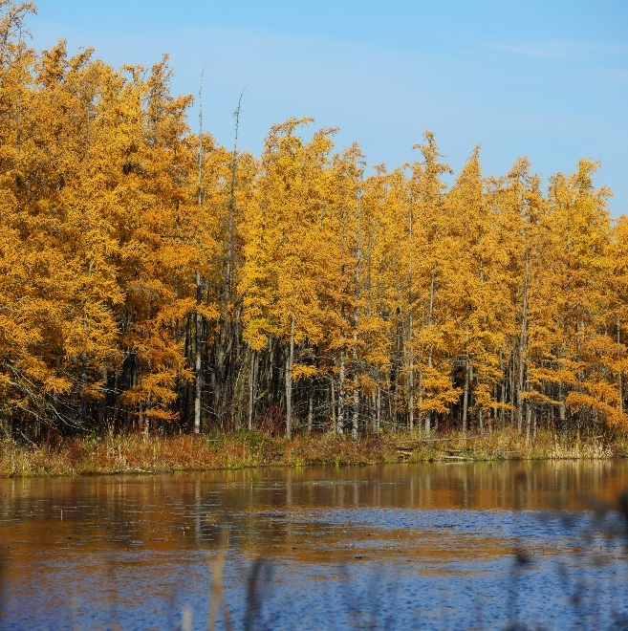
Twitter: Little Long Lake in Minnetrista consistently has the best water quality in the metro area. Protecting and restoring habitats adjacent to Little Long Lake ensures the lake remains ideal for fishing and swimming forever. hennepin.us/land-protection
Instagram: Little Long Lake in Minnetrista consistently has the best water quality in the metro area. Between existing conservation easements and property owned by the Three Rivers Park District, more than 550 acres of habitat are already permanently protected in this area. These habitats contain high-quality upland forest, ephemeral forest wetlands, wet meadows, marshland, and streams. Hennepin County and the Minnesota Land Trust have been working with landowners to protect and restore habitats adjacent to Little Long Lake to ensure the lake remains ideal for fishing and swimming forever.

