Hennepin County will now be utilizing electronic signature functionality on contracts. Contractors do not need any special software to sign county contracts electronically - you can even sign on a mobile device.

This guide gives step-by-step instructions on how to:
- Electronically sign a county contract (pages 1-5)
- Delegate your signature to another person in your organization (pages 5-6)

Signing a Contract

- You will receive an email that appears to be from Hennepin County Purchasing with the subject line: Please sign <Contract Description> - Contract <ID number>.
Note: the email is sent from the address 'echosign@echosign.com'. Do not reply to this email. If you have questions or issues, send an email to contracts@hennepin.us.

- Click the link in the email

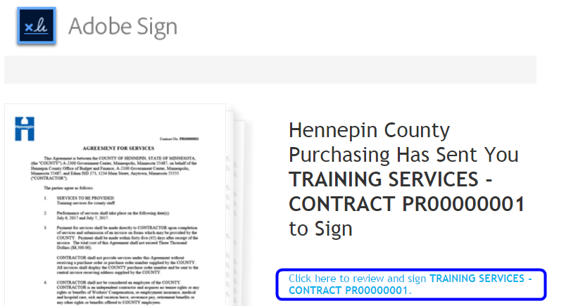

- The contract document will open in a web browser. Scroll to review the contract. To go directly to your signature block, click the Start button.

Note: Contract exhibits/attachments will be placed after the signature pages.

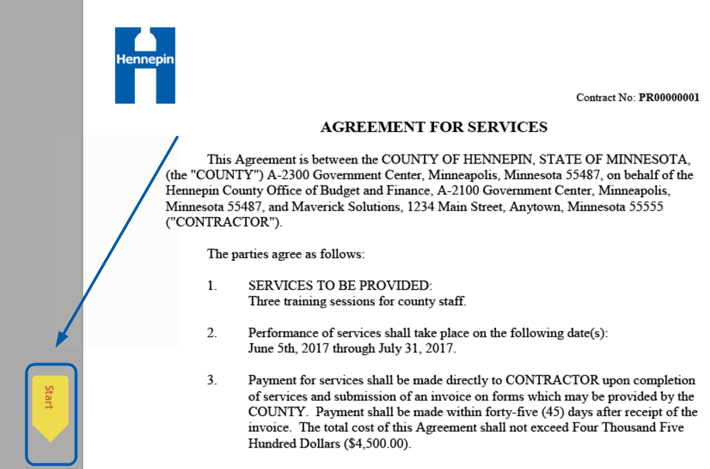

- Click in the box to sign

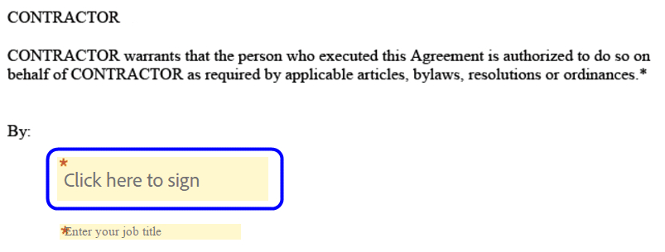

- You have three options for capturing your signature:
- Draw: Select the Draw icon, then draw your signature with your mouse (or your finger/stylus if you have a touch-screen device). Click the Clear link to clear your drawing and start over.

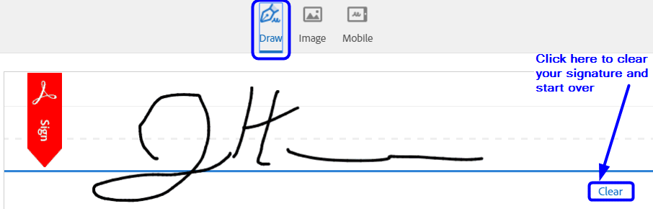

- Image: Click the Image icon, then click Select Image to upload an image of your signature. You will need to select an image file that is stored on your computer/device.

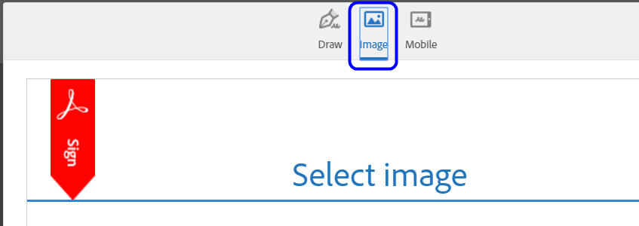

- Mobile: Click the Mobile icon if you are signing on a desktop or laptop computer and want to draw or take a picture of your signature on your mobile device. Enter your mobile number and click the Send button. It will send a text message to your mobile phone with a link. Select the link and draw your signature or click the Image icon to upload a photo of your signature. When you are done, your signature will appear on your computer.

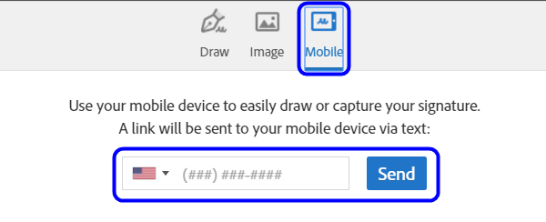

- Once you have captured your signature, enter your name in the text box and click the Apply button

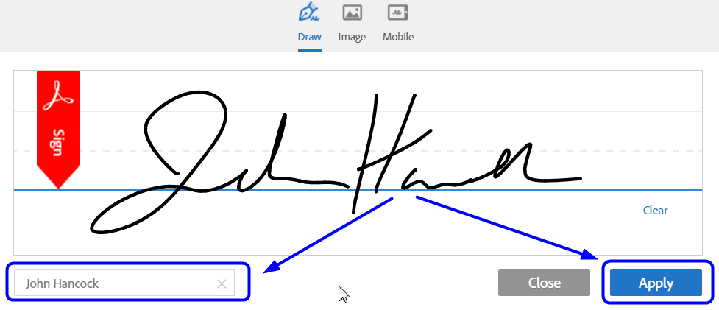

- Next, enter your Title

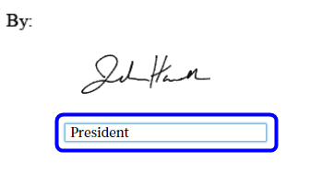

- Click the Click to Sign button

- You will see a message that you have successfully signed the document

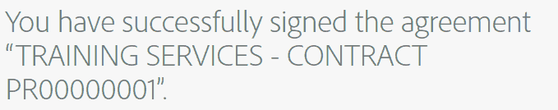

- When all signers have signed the document, you will receive an email from Adobe Sign with the subject line: <Contract description and ID> between Hennepin County, <other signers> is Signed and Filed! The email will include a PDF copy of the signed contract.

Delegating your signature

If your signature has been requested on a contract, you can delegate your signature to another person. This means that the person you delegate to will sign the contract instead of you. The person you delegate to must have the authority to sign contracts for your organization.

- When your signature is requested on a contract, you will receive an email that appears to be from Hennepin County Purchasing with the subject line: Please sign <Contract Description> - Contract <ID number>.

- Click the link to delegate in the last paragraph of the email

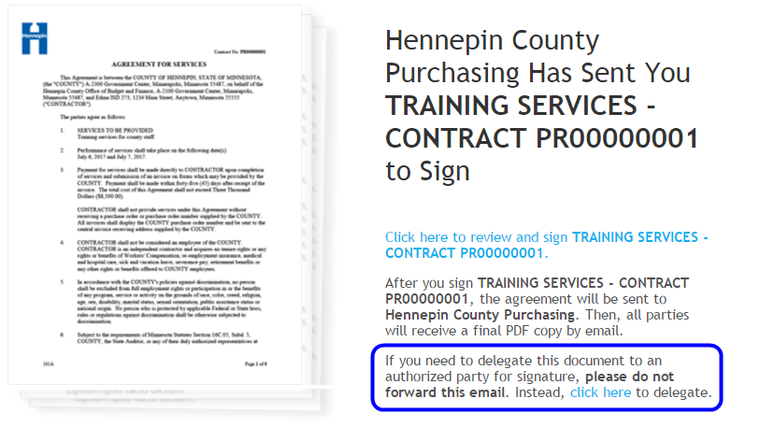

- Enter your delegate's email and a message, then click the Delegate button. Your delegate will receive an email notification that you have forwarded the contract to them to sign.

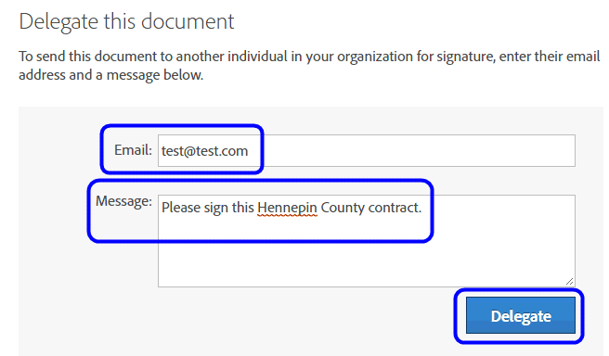

- When your delegate has signed the contract, you will receive an email notification. When all parties have signed the contract, you and your delegate will receive a confirmation and a PDF copy of the signed contract.

