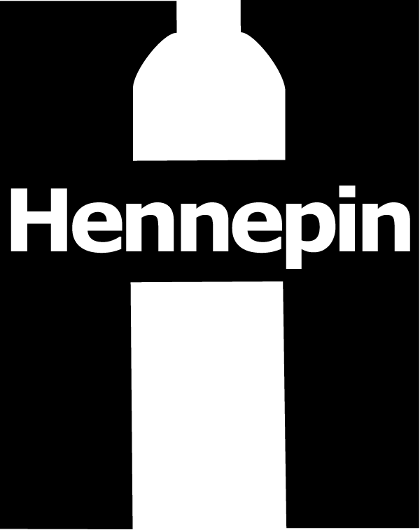 | Hennepin County Environment and Energy News  612-348-3777 • environment@hennepin.us www.hennepin.us/environmentaleducation  701 Fourth Ave. S., Suite 700, Minneapolis, MN 55415

Contact: Alisa Reckinger, Environment and Energy, 612-348-4788, alisa.reckinger@hennepin.us
Last updated: January 2016
Subject: Identifying and reducing household hazardous waste

Sample Newsletter Article

Identifying and reducing hazardous chemicals in your home
From cleaning to eliminating pests to unclogging drains, we use a variety of chemical products in our homes every day. According to the U.S. Environmental Protection Agency, only a fraction of registered chemicals have gone through complete testing for human health concerns. Some chemicals have immediate toxic effects. Others are toxic to our bodies only after repeated, long-term exposure. The following are several important steps you can take to protect your family and reduce harmful chemicals.

Learn how to read labels
When it comes to hazardous products, reading the label is the easiest way to identify one. Signal words help you determine how hazardous a product is. Look for signal words on labels and choose the least hazardous product for the job:
- Caution: Mild/moderate hazard
- Warning: Moderate hazard
- Danger: Extremely flammable, corrosive or highly toxic
- Poison: Highly toxic

Characteristic words are often used on labels to identify the type of hazard the product poses.
- Flammable/Combustible: The product can easily catch fire and support flame.
- Corrosive: “Corrosive,” “acid,” “caustic,” “lye,” “alkaline” or “causes burns to the skin” mean that the product can burn the skin or eyes. It can also eat away other materials that it comes into contact with.
- Toxic: “Poison” or “harmful if swallowed” mean that the product is poisonous and can be harmful or fatal if swallowed, inhaled or absorbed through the skin.
- Reactive: “Do not mix with ____” or “store separately from other products” means the product may react violently or produce toxic gas if combined with other substances.

Reduce and safely store hazardous chemicals in your home
- Remove your shoes at the entrance to your home so you don’t track chemicals from outside.
- Use pump spray products instead of aerosols as aerosol mist is more easily inhaled.
- Avoid chemical air fresheners and candles.
- Buy fewer household hazardous products by avoiding specialty cleaners, using multipurpose cleaners and using single-ingredient products like vinegar or baking soda for cleaning.
- Only buy the amount of product that you will use.
- Avoid chemical pesticides and herbicides.
- Keep products out of reach of children and animals.
- Never mix chemicals together (such as bleach and ammonia).
- Keep products away from heat, sparks, flames or other sources of ignition, and prevent products from freezing.
- Keep products in their original containers and make sure the label is legible.

Safely dispose of household hazardous waste
Hennepin County offers two permanent drop-off facilities and seasonal collection events for residents to properly dispose of household hazardous wastes for no charge. Learn more at www.hennepin.us/dropoffs or call 612-348-3777.

Sample Web Story

Identifying and reducing hazardous chemicals in your home
From cleaning to eliminating pests to unclogging drains, we use a variety of chemical products in our homes every day. According to the U.S. Environmental Protection Agency, only a fraction of registered chemicals have gone through complete testing for human health concerns. Some chemicals have immediate toxic effects. Others are toxic to our bodies only after repeated, long-term exposure.

The following are several important steps you can take to protect your family and reduce harmful chemicals:
- Learn how to read labels: It may seem like every product comes with a warning label these days, but when it comes to hazardous products, reading the label is the easiest way to identify one. Signal words (Caution, Warning, Danger and Poison) help you determine how hazardous a product is. Look for signal words on labels and choose the least hazardous product for the job. Caution is the least hazardous, poison is the most hazardous.
- Reduce hazardous chemicals in your home: Buy fewer household hazardous products by using multipurpose cleaners and using single-ingredient products like vinegar or baking soda, only buy the amount of product you will use, and avoid chemical air fresheners, pesticides and herbicides.
- Safely store products in your home: Keep product out of reach of children and animals, never mix chemicals together, keep products away from heat and flames, prevent products from freezing, and keep products in their original containers with legible labels.
- Safely dispose of household hazardous waste: Bring them to a Hennepin County drop-off facility or seasonal collection event.

Learn more at http://www.hennepin.us/dropoffs or call 612-348-3777

Sample Social Media Posts
Interact with Hennepin Environment on Facebook at www.facebook.com/hennepinenvironment and Twitter at www.twitter.com/hennepinenviro (@hennepinenviro).

Facebook:
Signal words (Caution, Warning, Danger and Poison) help you determine how hazardous a product is. Look for signal words on labels and choose the least hazardous product for the job. Learn more.

Protect your health and the environment by learning to read product labels, taking steps to reduce hazardous chemicals in your home, using and storing products safely, and properly disposing of chemicals. Learn more.

Buy fewer household hazardous products with multipurpose cleaners and using single-ingredient products like vinegar or baking soda, only buy the amount of product you will use, and avoid chemical air fresheners, pesticides and herbicides.

Reduce your chemical and hazardous waste by creating your own green cleaners with baking soda, vinegar and lemon juice. You’ll save money too!

Twitter:
Reduce your chemical and hazardous waste by creating your own green cleaners with baking soda, vinegar and lemon juice.

Protect your health by switching from aerosol containers to spray pump containers. Aerosols are more pressurized with lighter air which makes their chemicals easier to inhale.

Look for signal words on labels and choose the least hazardous product for the job. Learn more.

Additional Promotional Materials
Order printed copies of these materials at www.hennepin.us/literatureorderform.

- How to identify and reduce hazardous chemicals in your home
- Green Cleaning Recipes

