Recycling Exists campaign media kit

About the Recycling Exists campaign
Questions about what happens to recycling after it leaves our homes have been increasing over the years. Six metro counties are working together to restore trust in Minnesota's recycling system with this united message: In Minnesota, recycling exists.
The campaign highlights what happens to the different items we put in our recycling bins, including how they get sorted and processed and where they are sent to be made into new items. The campaign also includes information on what you can recycle, how to recycle right, and how recycling benefits the environment and economy.
The campaign delivers this information in a fun way by contrasting a group of mythical creatures – a unicorn, dragon, and merperson – who are distressed that everyone thinks they are a myth with a fact we can all agree on: recycling is real and it works.

Resources to promote Recycling Exists
- Use the sample newsletter article to share on your organization’s website or in your newsletters. This is editable so you can customize the length or message.
- Use the social media posts and graphics or videos (available to download at recyclingexists.com/resources) to share through your social media channels.
- Encourage people to visit www.RecyclingExists.com to learn more.
- Follow and reshare messages posted on the Hennepin County Environment and Energy social media channels: Hennepin Environment on Facebook, Hennepin Environment on Instagram, and @hennepinenviro on X/Twitter. Use the #Recycling, #RecyclingExists, #RecycleRight

Contact
For more information about the Recycling Exists campaign, contact Alisa Reckinger, Communications Specialist, alisa.reckinger@hennepin.us or Kaitlin Keller, Waste Reduction and Recycling Specialist, kaitlin.keller@hennepin.us

Sample newsletter article

Recycling is no fairytale in the Twin Cities
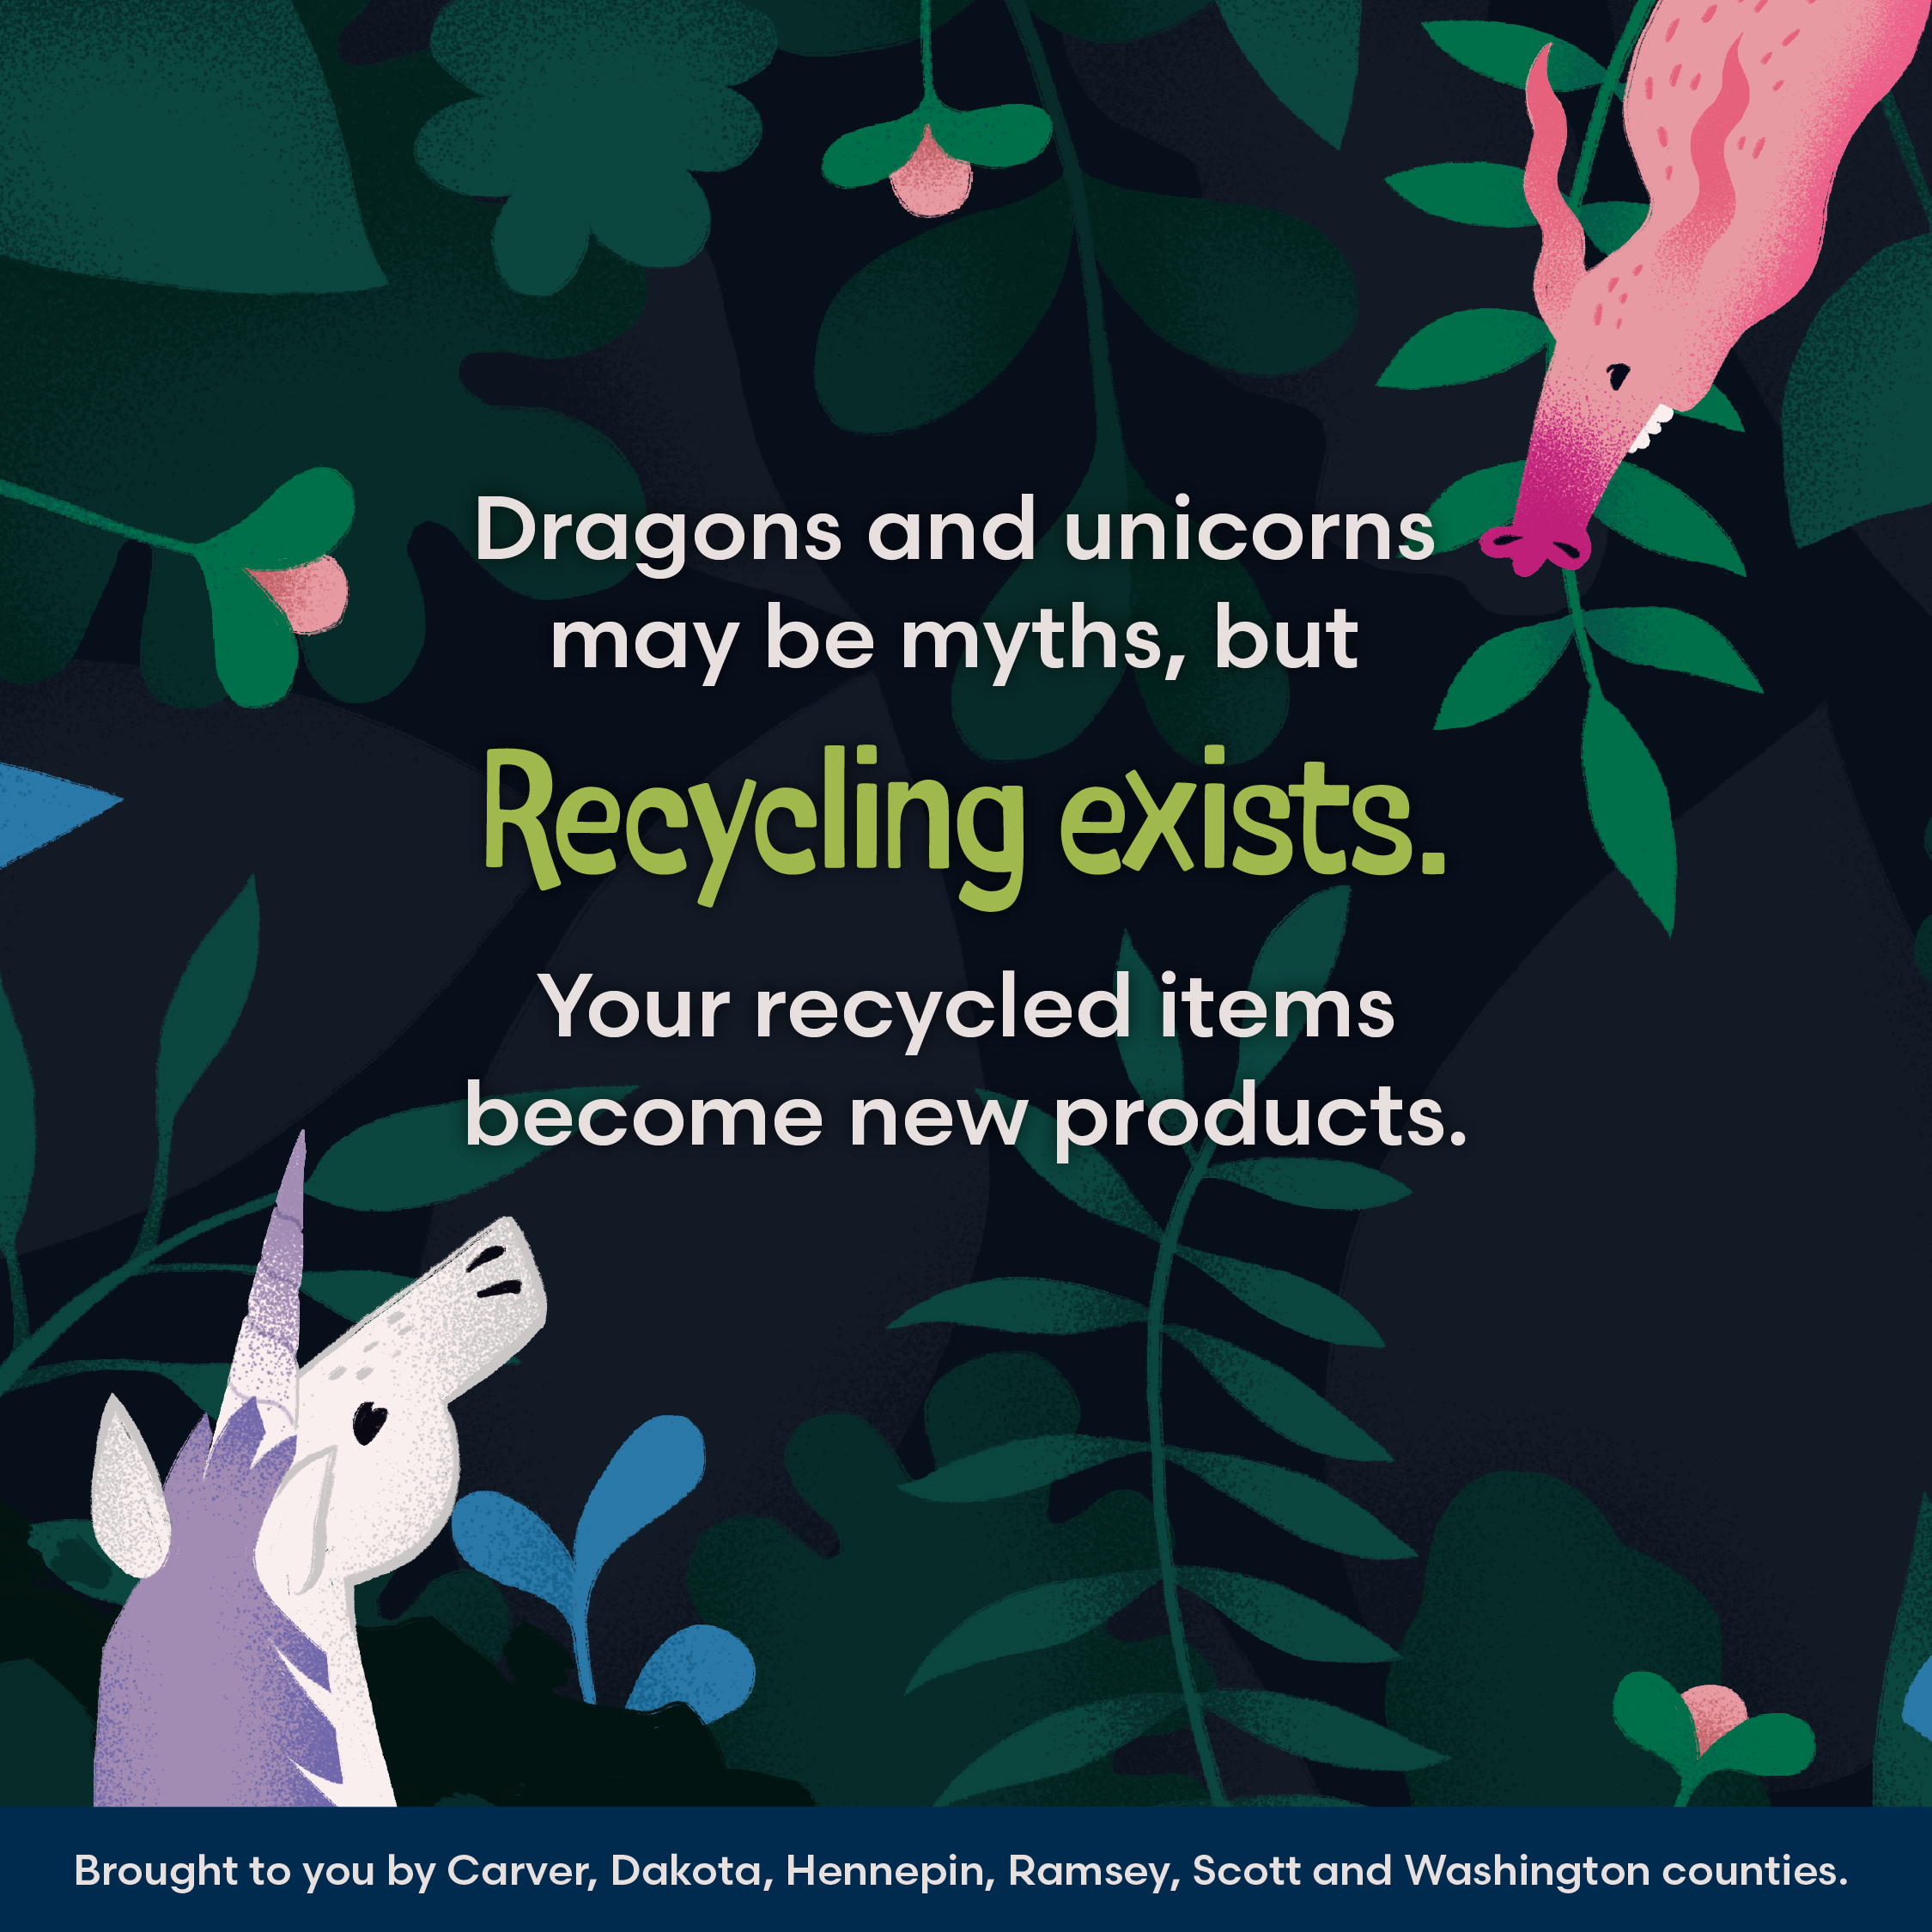
Do you wonder what really happens to recyclables when they leave your home? This has become an increasingly common question, which is why metro counties are working together to assure you that recycling is no myth. It’s real and it works here.
Minnesota and the Midwest are home to many recycling facilities that collect, sort, process, and manufacture items made from the bottles, boxes, and other containers we put our recycling bins.
Plastic milk and laundry detergent jugs are made into durable decking, fencing and landscaping products in Paynesville, and plastic drink bottles and produce containers are made into new plastic bottles in Wisconsin and Ohio.
Glass bottles and jars are sorted by color in Saint Paul, and the clear glass is sent to Shakopee to make bottles for drinks, pickles, salad dressing and more.
Recycled paper and cardboard are made into cereal and cracker boxes in Saint Paul, while recycled food cans are made into new products like wire, and parts for cars and appliances at facilities in the Midwest.
Our efforts to recycle and reduce waste save energy, protect resources and support local businesses and jobs. About 78,000 jobs in Minnesota are supported by the recycling industry.
You can be proud that recycling works in Minnesota. Learn more at RecyclingExists.com.

Social media posts
Suggested hashtags: #Recycling #RecyclingExists #RecycleRight
Graphics and videos can be downloaded at recyclingexists.com/resources, or right click on image and select save picture as.

General
It’s not a myth. Recycling works in the Twin Cities. The items you put in your cart get recycled when you recycle right.
Learn the real story behind recycling at RecyclingExists.com.

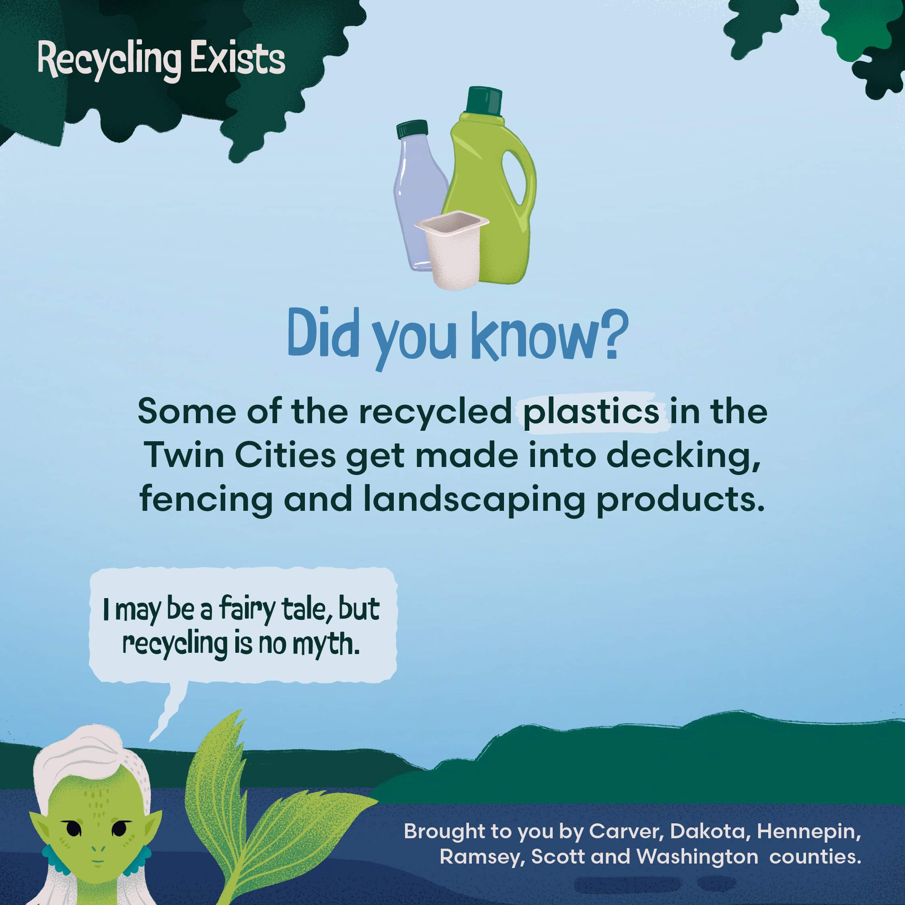
Plastic
It’s not a myth. Recycling works in the Twin Cities. Each year, over 30,000 tons of plastic is recycled here. Recycled milk jugs and detergent bottles get made into durable decking, fencing and landscaping products in Minnesota.
Learn the real story behind recycling at RecyclingExists.com.
Use caption with static graphic or vertical or horizontal video

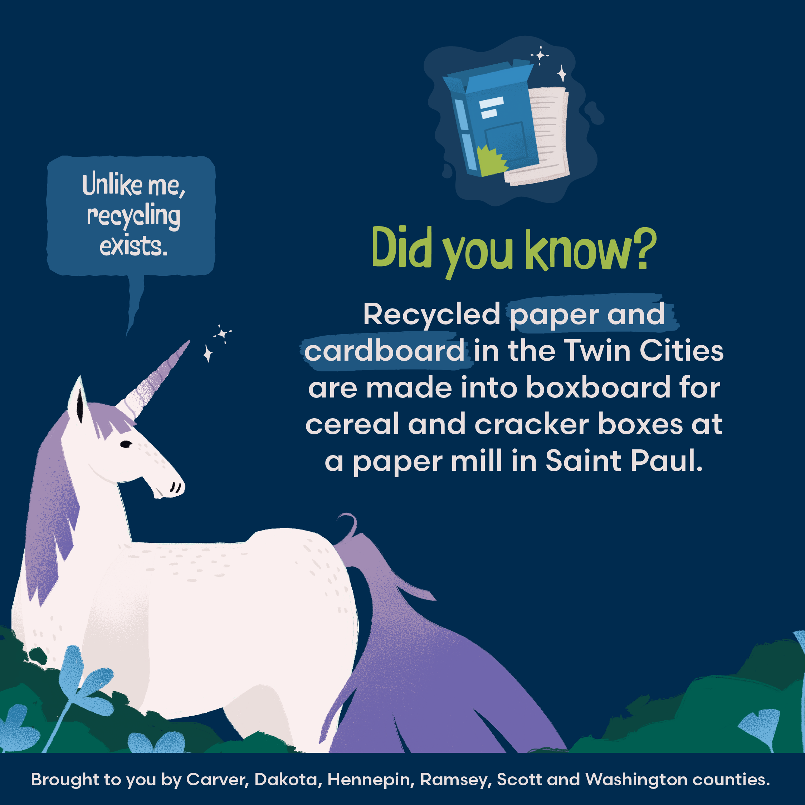
Paper and cardboard
It’s not a myth. Recycling works in the Twin Cities. Paper and cardboard get made into new cereal and cracker boxes at a paper mill in Saint Paul.
Learn the real story behind recycling at RecyclingExists.com.
Use caption with static graphic or vertical or horizontal video

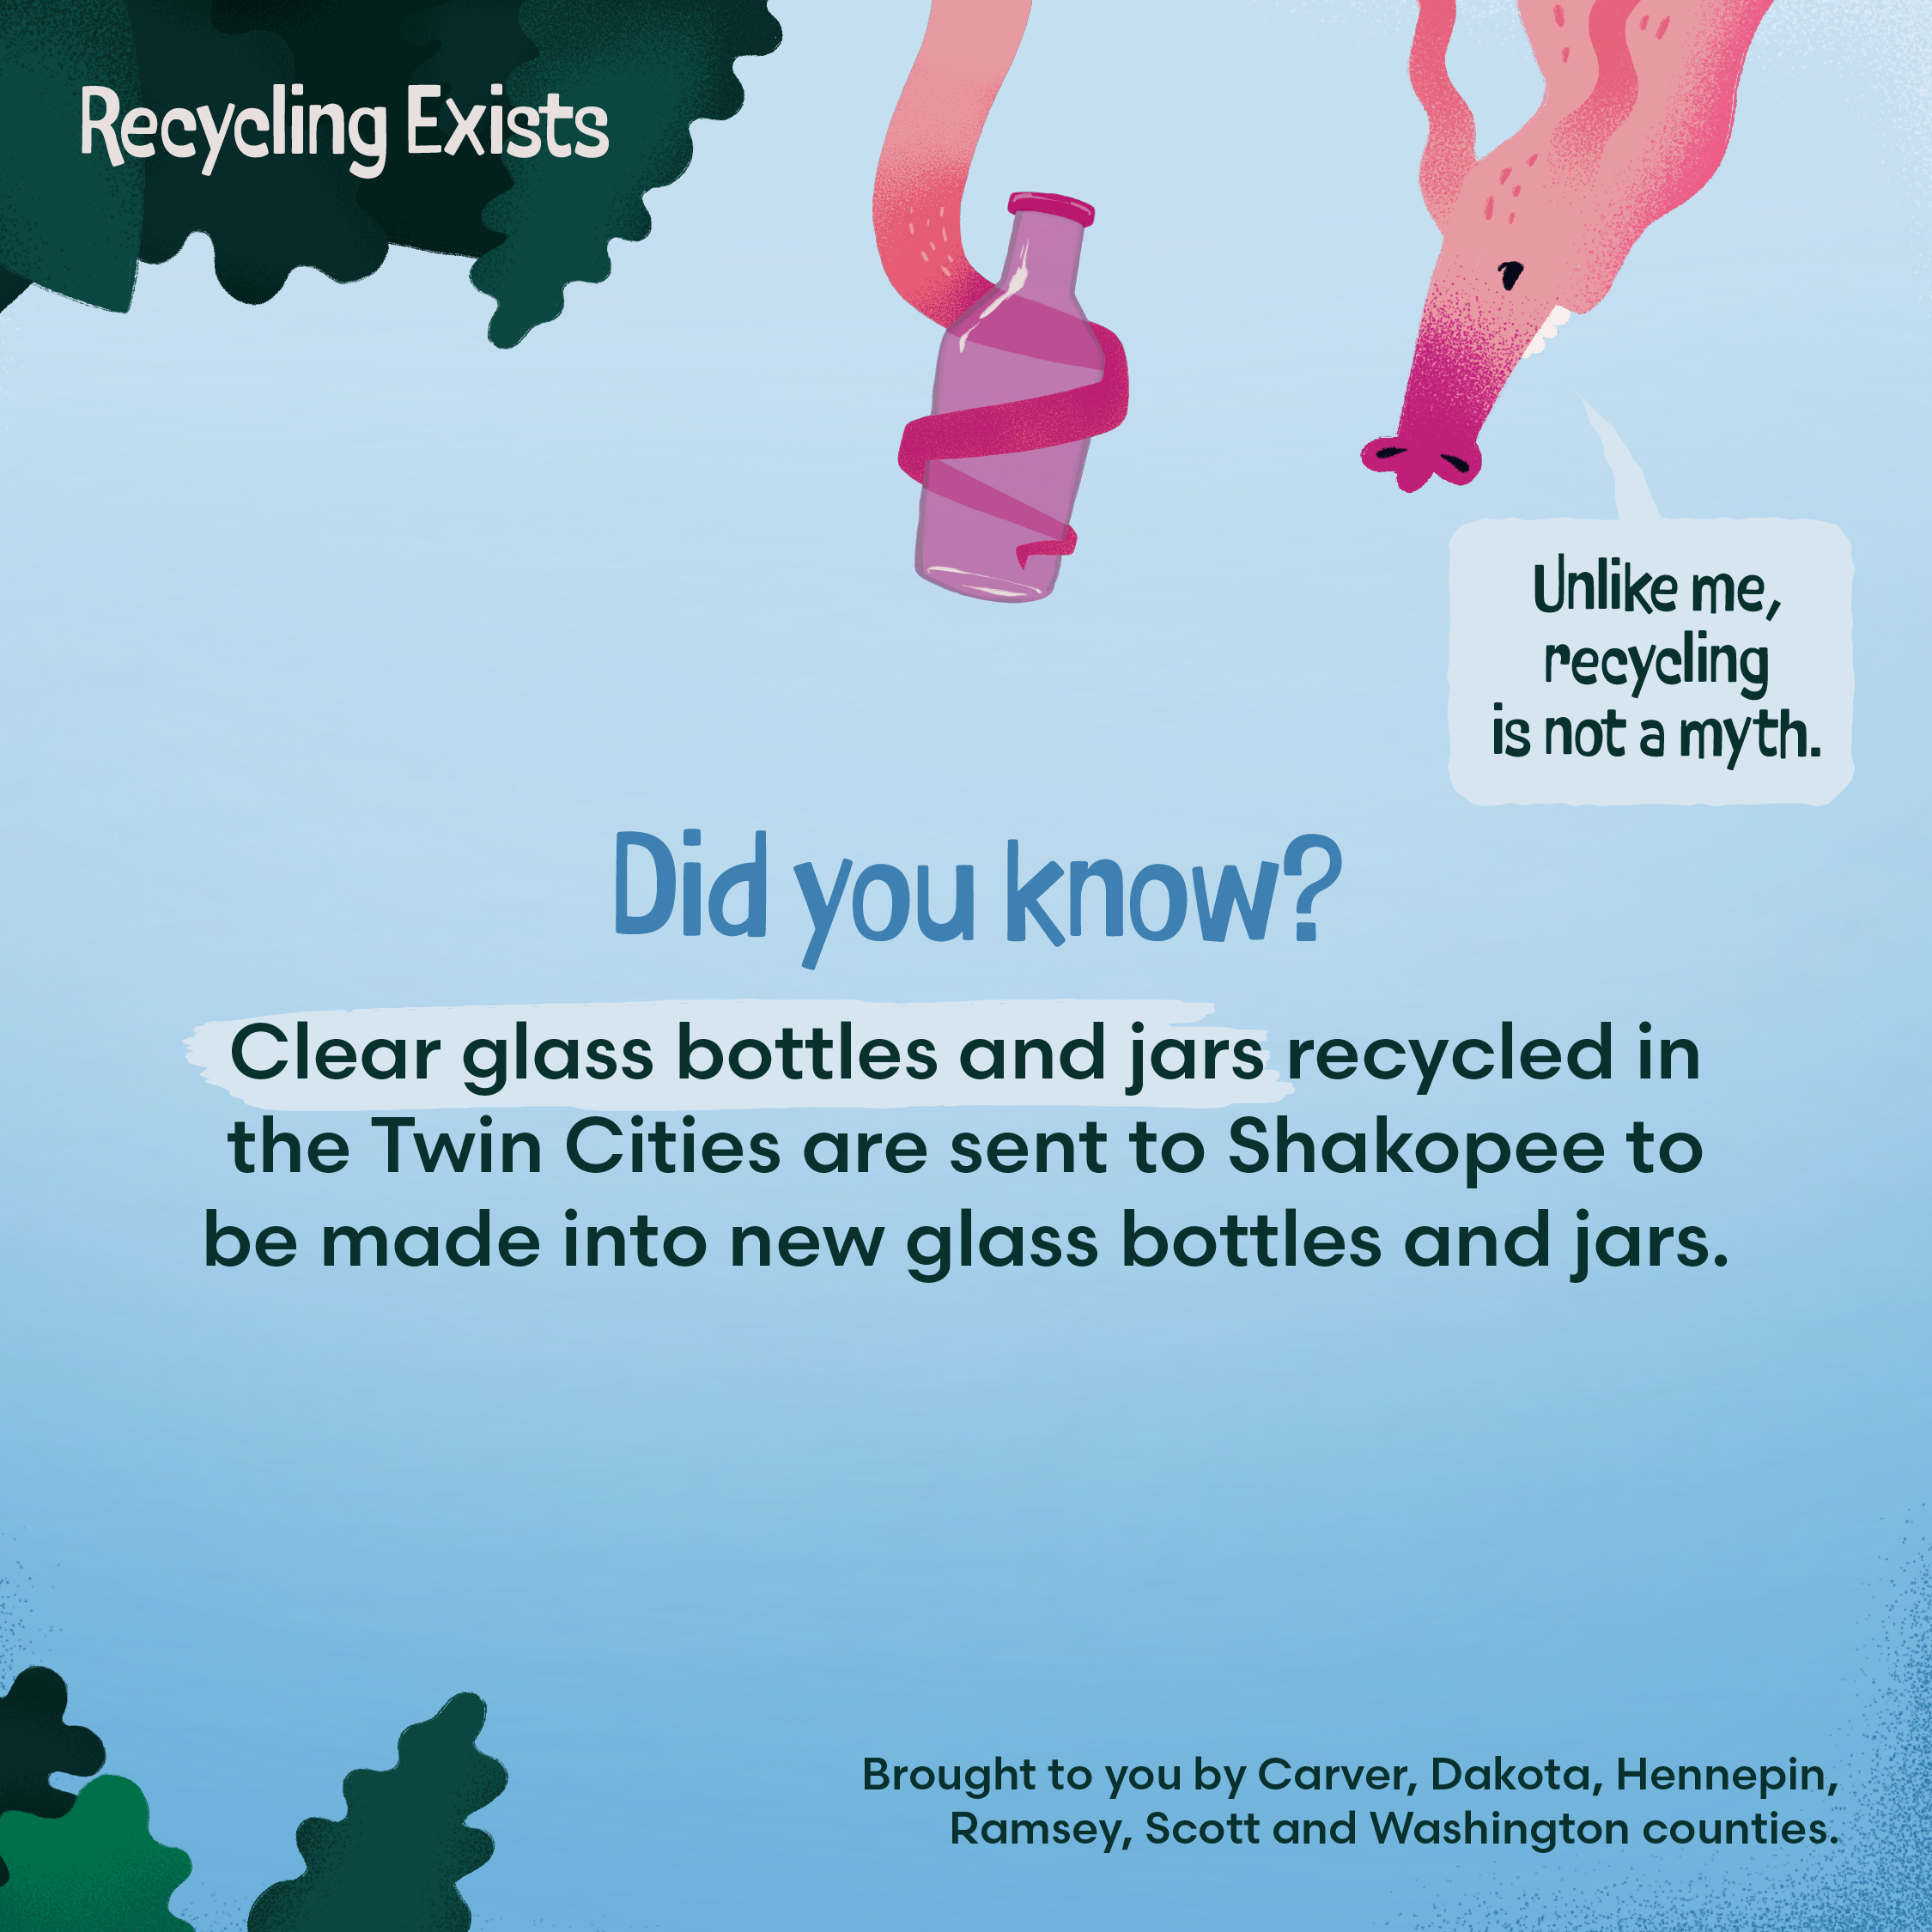
Glass
It’s not a myth. Recycling works in the Twin Cities. After getting sorted in Saint Paul, clear glass bottles and jars are made into containers for drinks, pickles, salad dressings and more in Shakopee.
Learn the real story behind recycling at RecyclingExists.com.
Use caption with static graphic or vertical or horizontal video

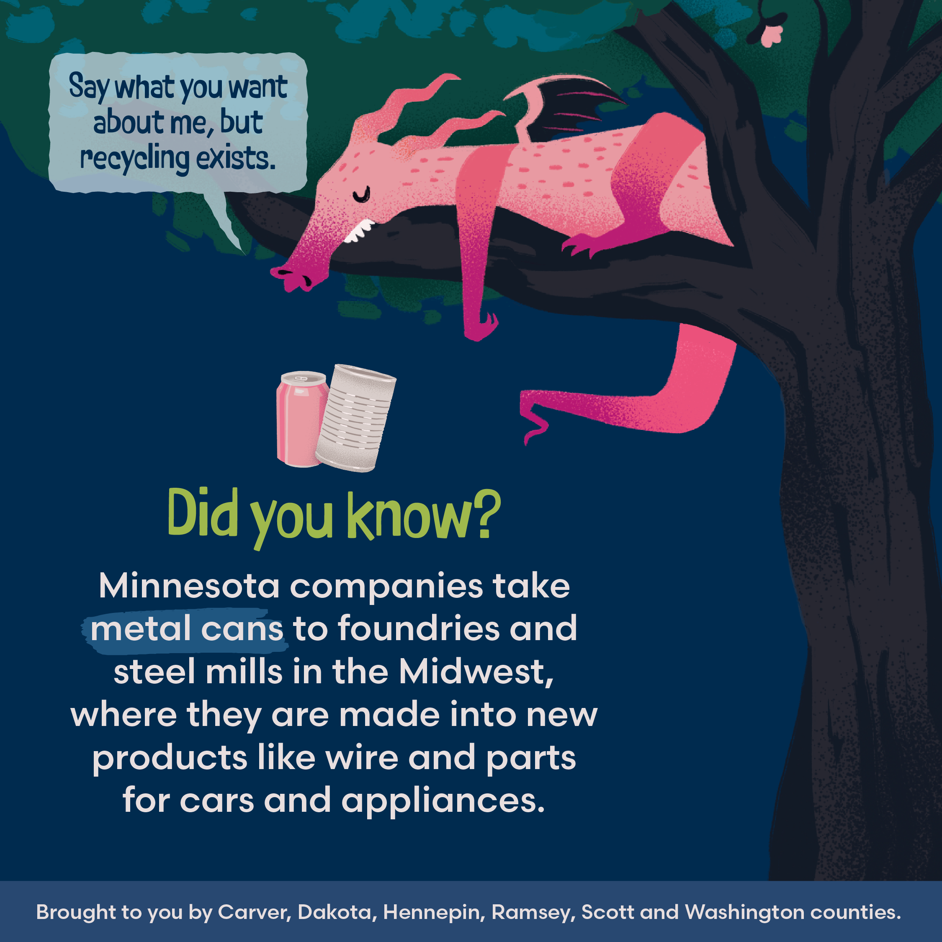
Metal cans
It’s not a myth. Recycling works in the Twin Cities. Recycled food cans are made into new products like wire and parts for cars and appliances.
Learn the real story behind recycling at RecyclingExists.com.
Use caption with static graphic or vertical or horizontal video

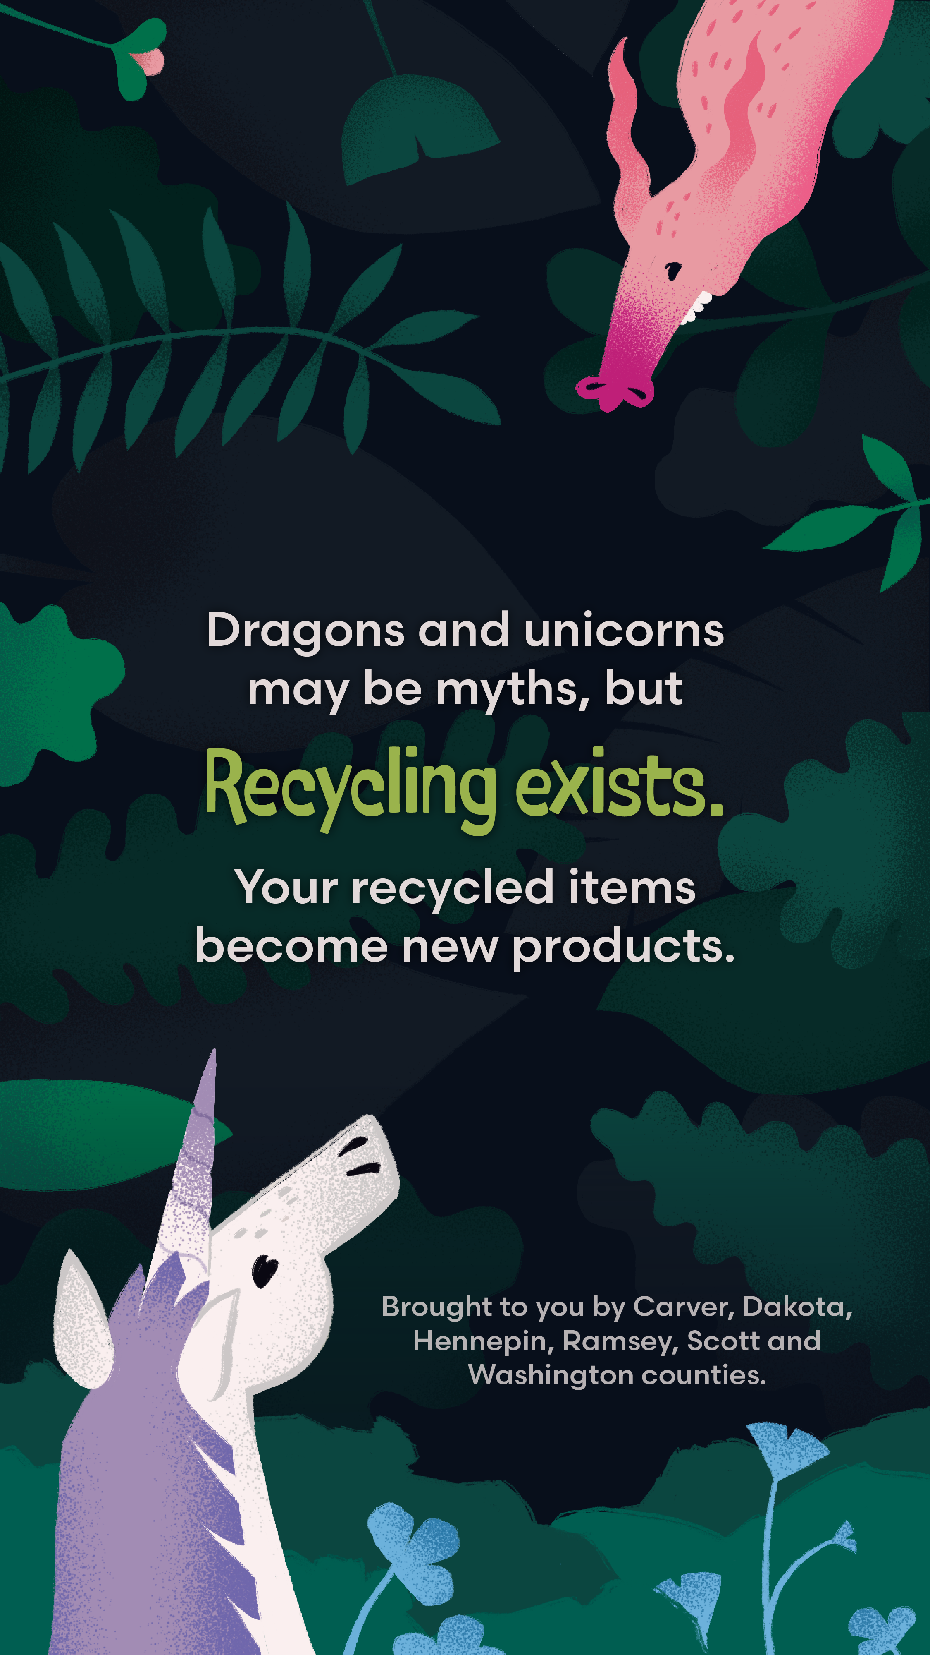
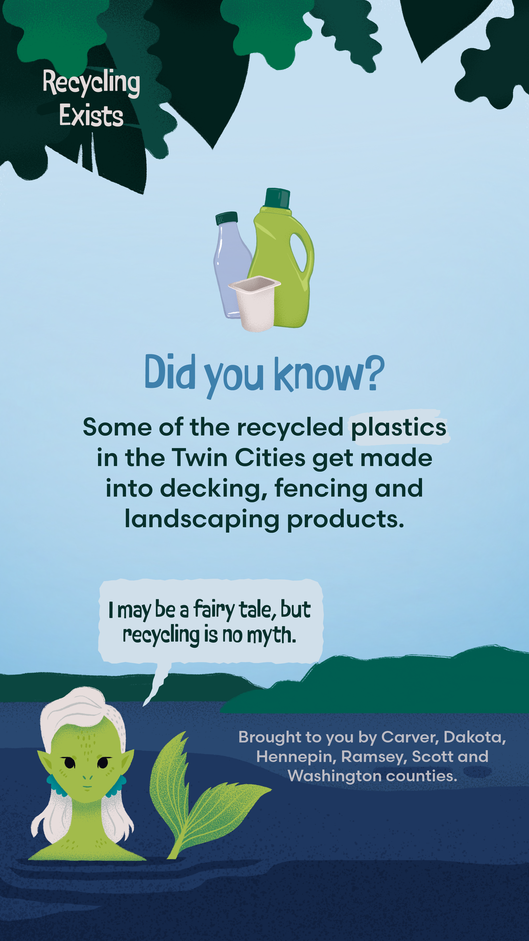
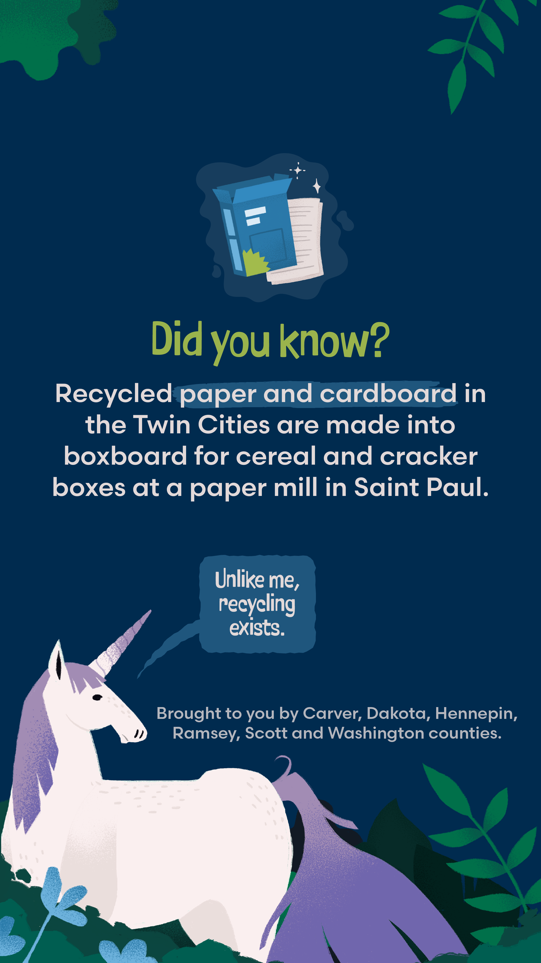
Instagram story graphics
