Recycling basics media kit

About the recycling basics
Recycling is an easy and convenient way to reduce trash and protect the environment. Recycle successfully by knowing what you can recycle and following tips for recycling at home.

Resources to promote recycling
Ways to educate the public about recycling:
- Use the sample newsletter article to share on your organization’s website or in your newsletters. These are editable so you can customize the length or message.
- Use the sample social media posts to share through your social media channels. These are editable so you can customize the message and website.
- Share the recycling guide (PDF). Printed copies can be ordered from https://environmentalresources.hennepin.us/items
- Encourage residents to order resources to improve recycling at home https://environmentalresources.hennepin.us/residents
- Follow and reshare messages posted on the Hennepin County Environment and Energy social media channels: Hennepin Environment on Facebook, Hennepin Environment on Instagram, and @hennepinenviro on Twitter
- Share the information and resources available at www.hennepin.us/recycling

Contact
For more information about this topic, contact:
- Kaitlin Steinberg, residential recycling coordinator, kaitlin.steinberg@hennepin.us
- Alisa Reckinger, communications and outreach specialist, alisa.reckinger@hennein.us

Sample newsletter article – short

Revisit the recycling basics to make sure you recycle as much as you can
Recycling is an easy and convenient way to reduce trash and protect the environment. Recycling saves energy, conserves natural resources, creates jobs in Minnesota, and boosts our economy. Additionally, recycled materials are manufactured into a variety of products.

What you can recycle
The best thing you can do to support recycling is recycle the right things.
Things you can recycle at home throughout Hennepin County include:
- Paper: Mail, office, and school papers; magazines and catalogs; newspapers and inserts; and phone books
- Boxes: Cardboard; cereal and cracker boxes; shoe boxes; electronics boxes; toiletry boxes
- Plastic: Bottles and jugs; cups and containers
- Cartons: Milk cartons; juice boxes; soup and broth cartons
- Glass: Food and beverage bottles and jars
- Metal: Food and beverage cans
If you’re not sure if something is recyclable, find out! Visit www.hennepin.us/recycling to learn more. For the most accurate information about pick-up days and accepted materials in your community, start by contacting your city recycling coordinator or waste hauler.

Tips for recycling successfully
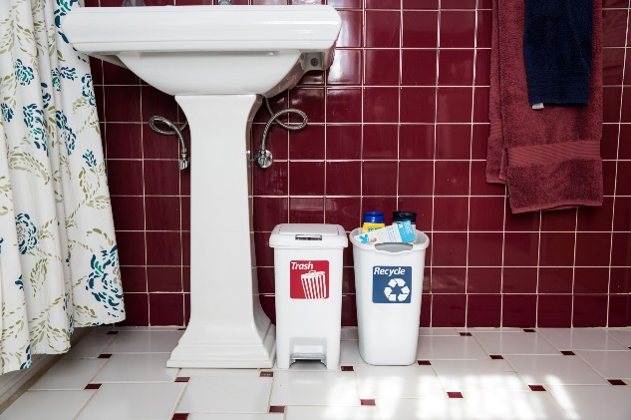
Follow these tips to make sure you are recycling as much as you can and that the items you place in your recycling cart successfully get recycled:
- Make recycling easy – put a recycling container next to all of your garbage cans and label your bins so everyone know what goes where.
- Recycle in every room – remember to collect recyclables from the bathroom, laundry room, and office.
- Items should be clean and empty – give them a quick rinse before recycling.
- Don’t bag your recyclables – place them loose in your recycling cart.
- Remove everything from boxes and collapse them.
- Don’t crush cans, plastic bottles, or cartons.
- Leave plastic caps on plastic bottles and jugs. Remove plastic caps from metal and glass containers.
Finally, be sure to look for products that contain recycled content when you’re shopping. The recycling loop can only be completed when we buy products made from recycled materials.
Learn more about recycling and get additional tips at www.hennepin.us/recycling.

Sample newsletter article – long

Revisit the recycling basics to make sure you are recycling as much as you can

Why recycle
Recycling is an easy and convenient way to reduce trash and protect the environment.
Recycling saves energy, conserves natural resources, creates jobs in Minnesota, and boosts our economy. Additionally, recycled materials are manufactured into a variety of products – from recycled-content paper to new aluminum cans to building supplies – that are available to purchase and are used by many Minnesota companies.

What you can recycle
The best thing you can do to support recycling is recycle the right things.
Things you can recycle at home throughout Hennepin County include:
- Paper: Mail, office, and school papers; magazines and catalogs; newspapers and inserts; and phone books
- Boxes: Cardboard; cereal and cracker boxes; shoe boxes; electronics boxes; toiletry boxes
- Plastic: Bottles and jugs; cups and containers
- Cartons: Milk cartons; juice boxes; soup and broth cartons
- Glass: Food and beverage bottles and jars
- Metal: Food and beverage cans
If you’re not sure if something is recyclable, find out! Visit www.hennepin.us/recycling to learn more. For the most accurate information about pick-up days and accepted materials in your community, start by contacting your city recycling coordinator or waste hauler.

How to prepare your recycling
Ensure that the items you place in your recycling cart successfully get recycled by taking these steps:
- Items should be clean and empty – give them a quick rinse before recycling.
- Don’t bag your recyclables – place them loose in your recycling cart.
- Remove everything from boxes and collapse them.
- Don’t crush cans, plastic bottles, or cartons.
- Leave plastic caps on plastic bottles and jugs. Remove plastic caps from metal and glass containers.

Setting up recycling at home
Many people could be recycling more at home. Take these steps to make sure you are recycling as much as you can:
- Make recycling easy: Start by putting a recycling bin, bag, or box next to every garbage can in your house. Then label your bins so that everyone knows how to sort their recycling and trash. Order free residential recycling resources at https://environmentalresources.hennepin.us/residents
- Recycle in every room: There are many items that can be recycled from the bathroom, laundry room, and office. Recycle as much as you can by collecting recycling from every room.
- Make recycling fun: Involve the entire family in recycling by making it fun. Have kids make a “please recycle” sign that shows what items can go in the recycling bin. Place a basketball rim above the recycling bin so your family can slam dunk their recyclables. Make it a challenge: try to generate only one bag of trash a week, and once you’ve conquered that, get a smaller trash can.

Close the loop: buy recycled products
The recycling loop can only be completed when we buy products containing recycled content. Purchasing recycled-content products helps send a message to manufacturers that more of these products are wanted.
You may be surprised by the variety of recycled-content products available. This includes:
- Clothing and shoes made from recycled plastic
- Building materials and home goods, like plastic lumber, glass countertops and tiles, rubber mats, and rugs made from recycled plastic
- Paper and paper products, including office paper, napkins, and paper plates
With so many options, be sure to look for products that contain recycled content when you’re shopping.
Learn more about recycling and get additional tips at www.hennepin.us/recycling.

Social media posts
Suggested hashtags: #recycle #hennepinrecycles #recycling #zerowaste #hennepinzerowaste
To use images and graphics: right click on image and select save picture as

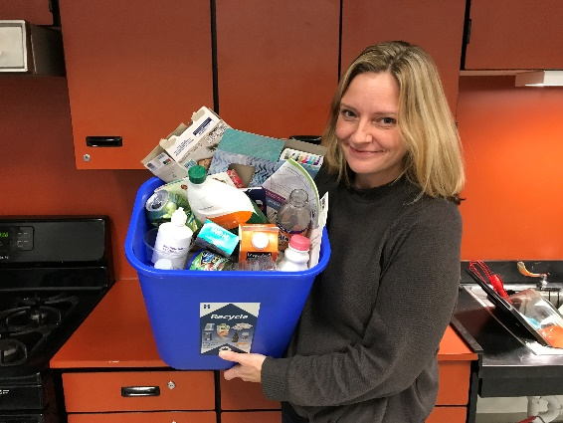
Post 1: Why recycle

Recycling is an easy and convenient way to reduce trash and protect the environment. Recycling saves energy, conserves natural resources, creates local jobs, and boosts our economy. Learn what you can recycled and get tips at www.hennepin.us/recycling

Post 2: What you can recycle
Facebook and Instagram:
The best thing you can do to support recycling is recycle the right things. Things you can recycle at home throughout Hennepin County include:
- Paper and boxes
- Plastic bottles, jugs, cups, and containers
- Cartons
- Glass bottles and jars
- Metal cans
Visit www.hennepin.us/recycling to learn more.
Twitter: The best thing you can do to support recycling is recycle the right things. Things you can recycle throughout Hennepin County include paper, boxes, plastic bottles, jugs, cups and containers, cartons, glass bottles and jars, and metal cans. Learn more www.hennepin.us/recycling
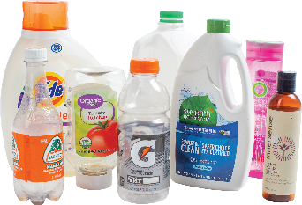
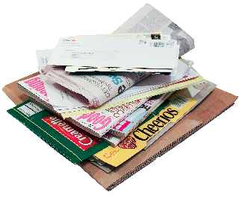
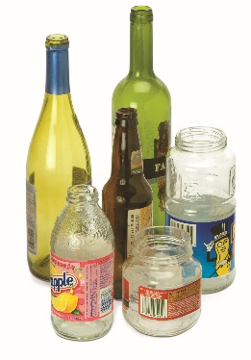
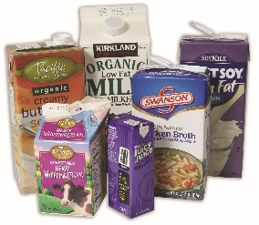
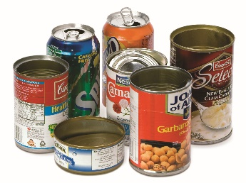
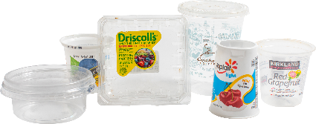

Post 3: How to prepare your recycling
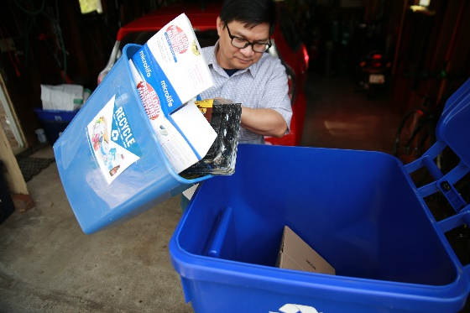
Facebook/Instagram:
Ensure that the items you place in your recycling cart successfully get recycled by taking these steps:
- Items should be clean and empty – give them a quick rinse before recycling.
- Don’t bag your recyclables – place them loose in your recycling cart.
- Remove everything from boxes and collapse them.
- Don’t crush cans, plastic bottles, or cartons.
- Leave plastic caps on plastic bottles and jugs. Remove plastic caps from metal and glass containers.
Learn more at www.hennepin.us/recycling
Twitter: Prepare your recycling by: making sure they are clean and empty, placing them loose in your cart, removing everything from boxes and collapsing them, leaving cans, plastic bottles, and cartons uncrushed. Learn more at www.hennepin.us/recycling

Post 4: Recycling as much as you can
Facebook/Instagram: Many people could be recycling more at home. Recycle as much as you can with these steps: make recycling easy by putting a recycling container next to every garbage can, label your bins so everyone knows what goes where, recycling in every room – including the bathroom, laundry room, and office – and make it fun for the whole family. Get ideas and resources at www.hennepin.us/recycling.
Twitter: Many people could be recycling more at home. Recycle as much as you can: make it easy by putting a recycling container next to all of your garbage cans, label your bins, recycle in every room, and make it fun for the whole family. Get ideas at www.hennepin.us/recycling

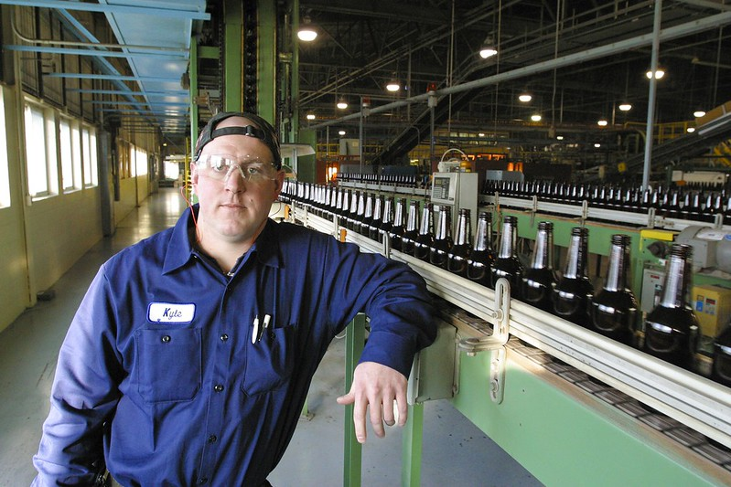
Post 5: Close the recycling loop
Facebook/Instagram/Twitter: The recycling loop can only be completed when we buy products made from recycled materials, so look for products that contain recycled content when you’re shopping. Many products are available - from paper to clothing to building materials. Learn more at www.hennepin.us/recycling

