Contact:
Ben Knudson, Hennepin County recycling specialist, ben.knudson@hennepin.us
Alisa Reckinger, Hennepin County Environment and Energy communications, alisa.reckinger@hennepin.us

Subject: Support recycling by recycling right

Newsletter articles

Recycle smart: know what goes in your recycling cart
Recycling has been in the news a lot lately due to shifts in markets and international policy changes. This has left many Minnesotans wondering what is happening to the recycling placed in their bins, and what they can do now to support recycling.
The best thing you can do to support recycling is to recycle the right stuff.

Know what goes in your recycling cart
Start with the basics of what can be recycled. This includes:
- Paper: mail, office papers, magazine, newspapers
- Boxes: cardboard boxes, cereal and cracker boxes, shoe boxes, toiletry boxes
- Cartons: milk cartons, juice boxes, broth cartons
- Glass: food and beverage bottles and jars
- Plastic bottles and jugs: soda bottles, milk jugs, shampoo bottles
- Cups and containers: yogurt cups, clear cups, cottage cheese containers, produce containers
- Metal: food and beverage cans

Keep these items out of your recycling cart
Items that are important to leave out of your recycling cart include:
- Plastic bags
- Large plastic items
- Random metal items
- Single-use plastic utensils and straws
- Paper plates, cups, and takeout containers
- Propane tanks
- Cords and string lights
- Electronics and batteries
- Needles and sharps
These items cause problems at recycling facilities and lower the quality of our recycling.

The current state of recycling
First of all, know that your recyclables are getting recycled! Unlike on the coasts where they rely heavily on international markets, recyclers in Minnesota send most of the material they collect to local and regional markets to be processed into new materials.
Overall, Minnesotans are good recyclers. We have significantly lower contamination rates, or the amount of stuff placed in the recycling that can’t actually be recycled, than elsewhere in the country. And Minnesota state law prohibits materials separated and collected for recycling from being trashed.
So recycle smart by continuing to recycle the items that can go in your recycling cart and keeping problem items out of your recycling cart.
Visit www.hennepin.us/recycling for the recycling guide of items that are accepted throughout Hennepin County and more information on the most important items to keep out of your recycling cart.

Social media posts

Recycle Smart – Keep these items out of your recycling cart
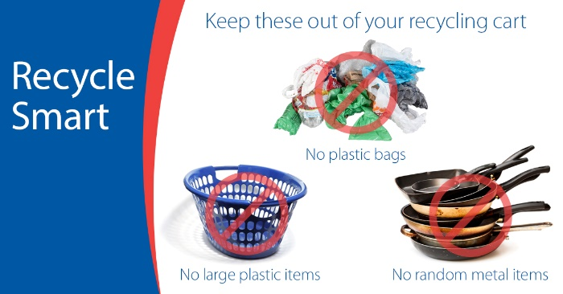
Images: Recycle Smart – keep these items out
Facebook and Instagram: The best thing you can do to support recycling is to recycle the right stuff:
- Know what’s ok to put in your recycling cart.
- Keep out stuff that’s not accepted or that you’re not sure about.
Learn more at www.hennepin.us/recycling#recycle-smart
Twitter: The best thing you can do to support recycling is to recycle the right stuff. Learn more at www.hennepin.us/recycling#recycle-smart

Recycle Smart – Keep plastic bags out of your recycling cart
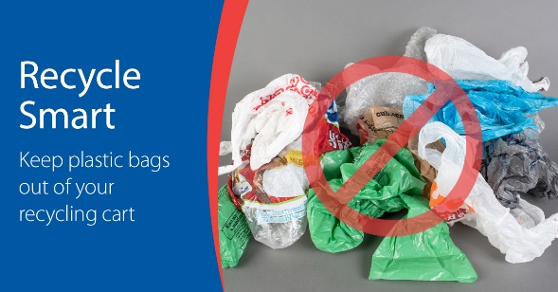
Images: Recycle Smart – plastic bags
Facebook and Instagram: Plastic bags and wrap get tangled in the equipment at recycling sorting facilities. Recycle smart: bring plastic bags to a retail drop-off to be recycled or avoid plastic bags altogether by choosing reusable bags. Find options at www.hennepin.us/green-disposal-guide/items/plastic-bags-wrap
Twitter: Plastic bags and wrap don’t belong in your recycling cart! Recycle smart: find drop-off recycling options at www.hennepin.us/green-disposal-guide/items/plastic-bags-wrap

Recycle Smart – Don’t put your recycling in bags in your recycling cart
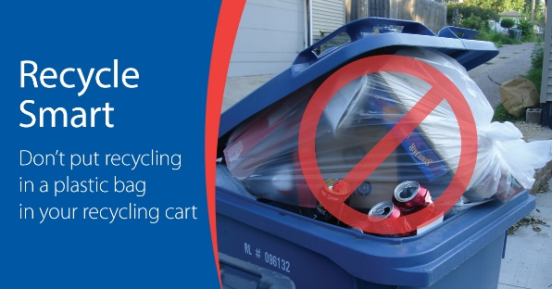
Images: Recycle Smart – bags of recycling
Facebook and Instagram: Don't put your recycling in bags in your recycling cart. Recyclers can't tell what's in the bag, so your items might not get recycled. Recycle smart: place recycling loose in your cart. Use an unlined bin or reusable bag to collect recycling in your home. Learn more at www.hennepin.us/recycling#recycle-smart
Twitter: Don't put your recycling in bags in your recycling cart. Recyclers can't tell what's in the bag, so your items might not get recycled.

Recycle Smart – Keep large plastic items out of your recycling cart
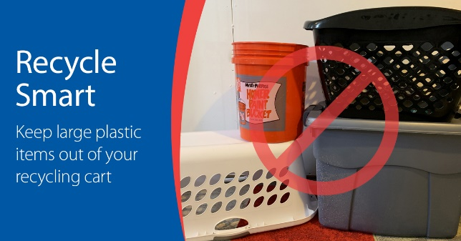
Images: Recycle Smart – keep large plastic items
Facebook and Instagram: Plastic lawn furniture, laundry baskets, and other large plastic items are difficult to sort at recycling facilities, and there aren’t good markets for recycling them. Purchase high-quality items, use them for as long as possible, and look for donation opportunities if they're still in good shape when you're ready to get rid of them. Learn more at www.hennepin.us/recycling#recycle-smart
Twitter: Large plastic items are difficult to sort at recycling facilities and don’t have good recycling markets. Keep them out of your recycling cart. Learn more at www.hennepin.us/recycling#recycle-smart

