Promotional materials for Hennepin County’s Plastic-Free Challenge

About the challenge
Although plastic is a versatile material with many uses, it is concerning because it presents health risks, contributes to litter and pollution, and is challenging to dispose of. Some of the most common and problematic plastic items we deal with every day come in the form of packaging and single-use plastics.
Hennepin County’s Plastic-Free Challenge engages residents in learning about plastics and plastic waste and committing to actions that help create a plastic-free world. The challenge has 70 actions to choose from in seven categories. Participants check off the actions they already take, then select up to five one-time actions and five daily actions to track progress on during the four-week challenge.
Organizations and businesses, including community groups, neighborhoods, schools, retailers, and more, can become a Plastic-Free Challenge Partner by helping to increase promotion, recruitment, and engagement for the challenge. The online Plastic-Free Challenge is powered by EcoChallenge.

Help spread the word and encourage others to join
- Download and share the social media posts and graphics (starting on page 9)
- Download and share Instagram story graphics (starting on page 24)
- Download and share the “I Joined” graphics (starting on page 7) to encourage your friends and family to join, too! Use the sample email message on page 6 to invite your friends.
- Share the sample newsletter articles (starting on page 3)
- Become a Plastic-Free Challenge Partner (details are on page 2)
- Create a team or join an existing team and invite people you know – your friends, family, neighbors, colleagues, etc. – to join you. Your teammates will keep each other motivated and accountable. Invitations can be sent through the EcoChallenge website or using the email message included in this document.
- Follow and reshare messages posted on the Hennepin County Environment and Energy social media channels: Hennepin Environment on Facebook, @hennepinenvironment on Instagram and @hennepinenviro on Twitter

Become a 2023 Plastic-Free Challenge partner
To use images and graphics: right click on image and select Save as Picture.
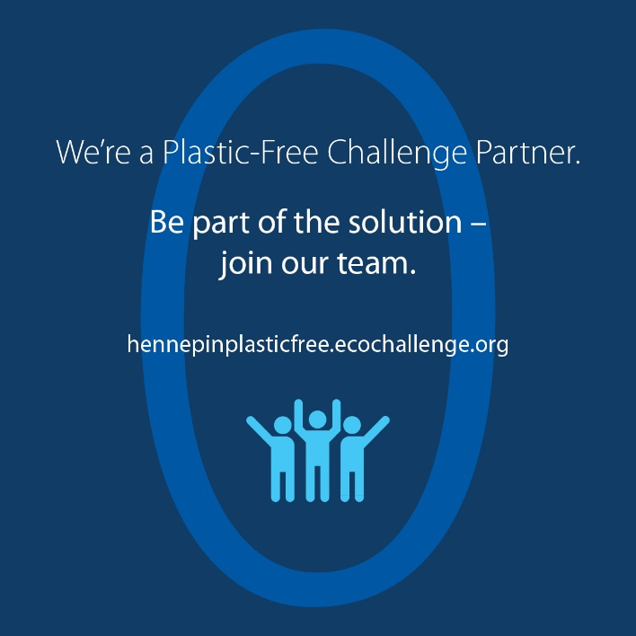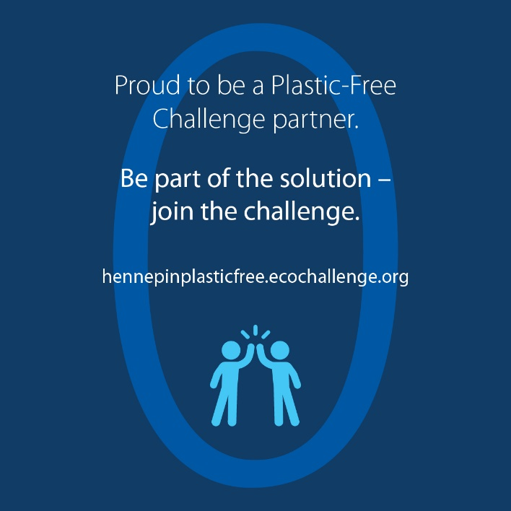
Hennepin County is working to reduce plastic waste as part of achieving our zero waste and climate action goals. As part of this effort, Hennepin County offers the Plastic-Free Challenge to engage residents in learning about plastics and committing to actions that help create a plastic-free world.
But we can’t do it alone!
For the upcoming Plastic-Free Challenge, which will run in February 2023, Hennepin County is seeking partners to help increase promotion, recruitment, and engagement for the challenge.
All partners will have their logo displayed on the challenge website, gain access to promotional materials, and get various recognition and cross-promotion during the challenge. There is no cost to becoming a partner.

Partnership opportunities include:
- Expanding our reach by promoting the challenge to your audiences.
- Strengthening engagement in the challenge by creating teams of colleagues, friends, and neighbors who motivate and hold each other accountable.
- Increasing our impact by offering educational events on plastic-free topics or discounts on plastic-free goods and services.
See the Plastic-Free Challenge partnership guide (PDF) for details on partnership opportunities, and fill out the partnership form to become a 2023 Plastic-Free Challenge partner.

Download and print partner posters:
- Join our Plastic-Free Challenge team 11x17 (PDF)
- Join our Plastic-Free Challenge team 8.5x11 (PDF)
- Proud to be a Plastic-Free Challenge partner 11x17 (PDF)
- Proud to be a Plastic-Free Challenge partner 8.5x11 (PDF)
- Be part of the solution - join the Plastic-Free Challenge 11x17 (PDF)
- Be part of the solution - join the Plastic Free Challenge 8.5x11 (PDF)

Sample newsletter article (long)

Our actions help create a plastic-free world: Join Hennepin County’s Plastic-Free Challenge
Plastics can be a hassle – they create clutter and can be confusing to recycle – plus they contribute to litter, harm water and wildlife, and have largely unknown health impacts for us. Fortunately, there’s a lot we can do to help create a plastic-free world, from learning more about plastic waste and recycling to making simple swaps to advocating for changes in your community and sharing your story with others.
Be part of the solution to reduce waste, protect water and wildlife, address climate change, and look after the health of ourselves and future generations by joining the Hennepin County Plastic-Free Challenge.

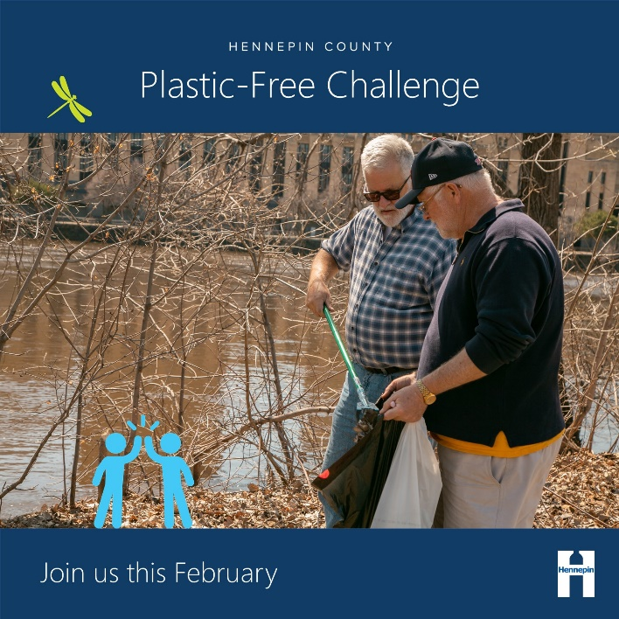
The problem with plastics
Plastics are problematic for many reasons.
Worldwide, plastic production has skyrocketed since the 1970s, and a lot of the growth has come in the form of packaging and single-use plastics. Most plastics are made from oil and gas – fossil fuels that contribute to climate change. About 4% to 8% of the world's oil production is for plastics, and most plastics are thrown away after a single use.
Since packaging and single-use plastics are used for a short period of time and then discarded, they contribute significantly to the increasing amounts of plastic waste and litter. Although recycling can be a good option for managing certain plastic items, only a small percentage of plastic products are recycled, and many types of plastic are hard to recycle.
Unlike items made from natural materials like plants that can be composted and returned to the soil, plastics don’t go away. Instead, they break down into smaller pieces of plastic. These microplastic pieces are now found almost everywhere, including in our air, water, soil, and bodies. Plastics in the environment pollute our water, harm wildlife, and have largely unknown health impacts for us.
Joining the Plastic-Free Challenge helps you be part of the solution by increasing your understanding of plastics and plastic waste and uncovering opportunities to cut back on the amount of plastic you bring into your home.

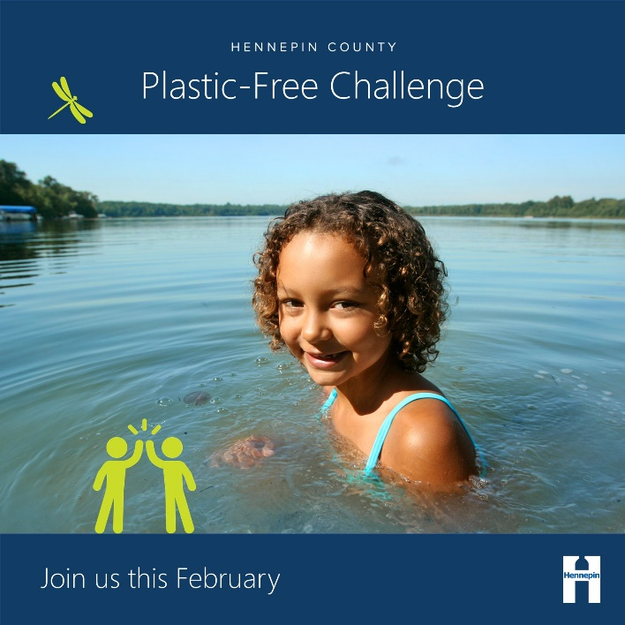
About the Plastic-Free Challenge
The Plastic-Free Challenge is a month-long effort starting February 1 to reduce plastic consumption, especially single-use plastics, in ways that fit best in your lifestyle and have the most impact on reducing your footprint.
The online challenge has 70 actions you can choose from in seven categories. Sign up opens on January 1, and the challenge runs during the month of February 2023. Once you sign up and create your profile, you can browse the categories and actions, check off the actions you already take, and select up to five one-time actions and five daily actions to make progress on during the four-week challenge.
You can also create a team to take the challenge along with your family, friends, neighbors, and colleagues. Or encourage an organization, business, or community group you are a part of to become a Hennepin County Plastic-Free Challenge Partner.
Once the challenge starts, you will report what actions you take, see the impact of your actions add up, connect with others, and support your team members to keep them motivated and accountable.
Hennepin County is focused on reducing waste, encouraging more thoughtful consumption, increasing recycling, and sending less waste to landfills. Engaging residents in taking action is critical to our success. The county’s online Plastic-Free Challenge is powered by EcoChallenge.
Learn more, sign up, and get ready to go plastic-free at hennepinplasticfree.ecochallenge.org.

Sample newsletter article (short)

Our actions help create a plastic-free world: Join Hennepin County’s Plastic-Free Challenge
Plastics can be a hassle – they create clutter and can be confusing to recycle – plus they contribute to litter, harm water and wildlife, and have largely unknown health impacts for us. Fortunately, there’s a lot we can do to help create a plastic-free world, from learning more about plastic waste and recycling to making simple swaps to advocating for changes in your community and sharing your story with others.
Be part of the solution to reduce waste, protect water and wildlife, address climate change, and look after the health of ourselves and future generations by joining the Hennepin County Plastic-Free Challenge.

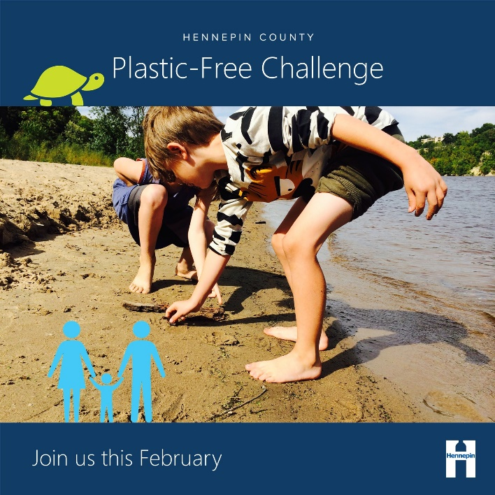
About the Plastic-Free Challenge
The Plastic-Free Challenge is a month-long effort starting February 1 to reduce plastic consumption, especially single-use plastics, in ways that fit best in your lifestyle and have the most impact on reducing your footprint.
The online challenge has 70 actions you can choose from in seven categories. Sign up opens on January 1, and the challenge runs during the month of February 2023. Once you sign up and create your profile, you can browse the categories and actions, check off the actions you already take, and select up to five one-time actions and five daily actions to make progress on during the four-week challenge.
You can also create a team to take the challenge along with your family, friends, neighbors, and colleagues. Or encourage an organization, business, or community group you are a part of to become a Hennepin County Plastic-Free Challenge Partner.
Learn more, sign up, and get ready to go plastic-free at hennepinplasticfree.ecochallenge.org.

Sample email message
Dear [name],
I am constantly amazed – and a bit overwhelmed – by the number of plastic items that I end up using and bringing into my home. Despite my efforts to avoid them, my trash and recycling bin still include a lot of single-use and disposable plastics. I am concerned about plastics because they present health risks, create litter and pollution, contribute to climate change, and are challenging to dispose of.
That’s why this February, I’m joining the Plastic-Free Challenge and committing to actions that help me be part of the solution toward creating a plastic-free world.
Through the Plastic-Free Challenge, I’m looking forward to learning about plastics and plastic waste and uncovering opportunities to cut back on the amount of plastic I bring into my home in ways that fit best in my lifestyle.
[Insert a personal message – why is this important to you, why do you think this person would be interested in joining, invite them to join your team, etc.]
The challenge has 70 actions to choose from in seven categories. Once you sign up, you can check off the actions you already take, then select up to five one-time actions and five daily actions to make progress on during the four-week challenge. You can also see the impact of your actions, see how you are doing compared to others, and connect with others who are taking action.
Sign up opens on January 1, and the challenge runs during the month of February 2023. Learn more, sign up, and get ready to go plastic-free at hennepinplasticfree.ecochallenge.org.
Sincerely,
[your name]

“I Joined” graphics to share
Share with your friends and family what motivated you to join the Plastic-Free Challenge with these graphics. To use images and graphics: right click on image and select Save as Picture.
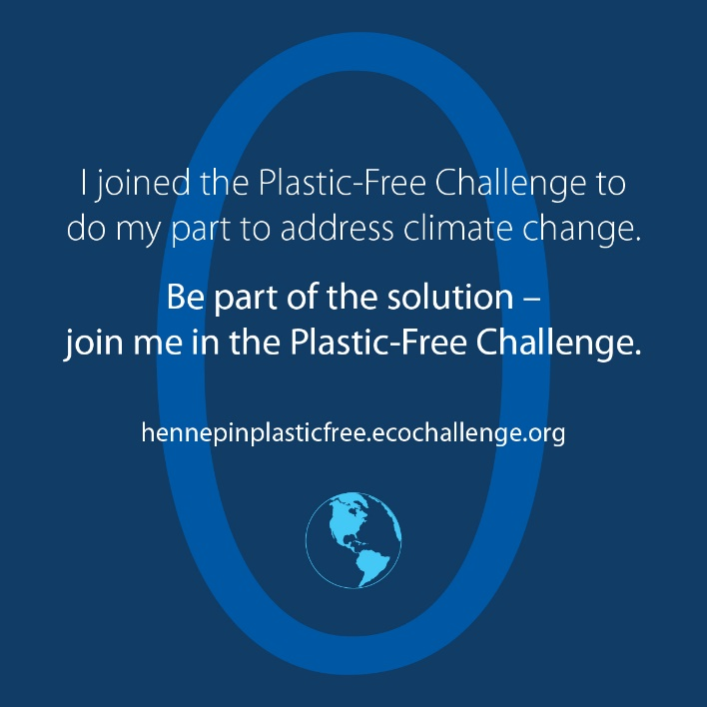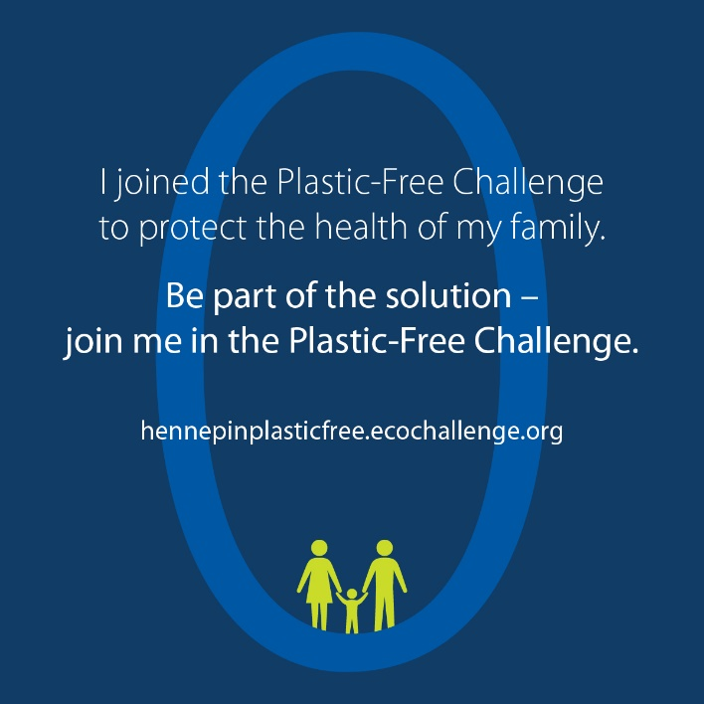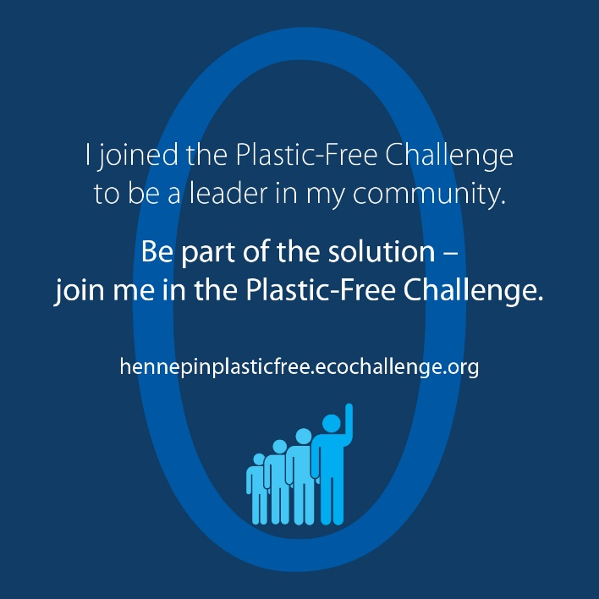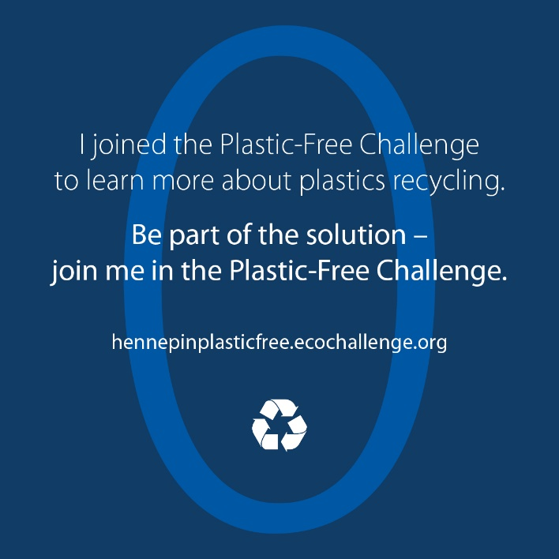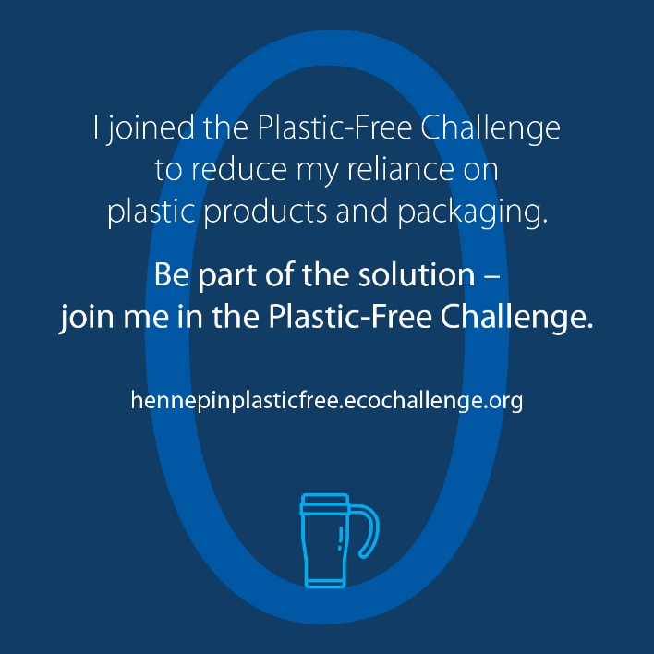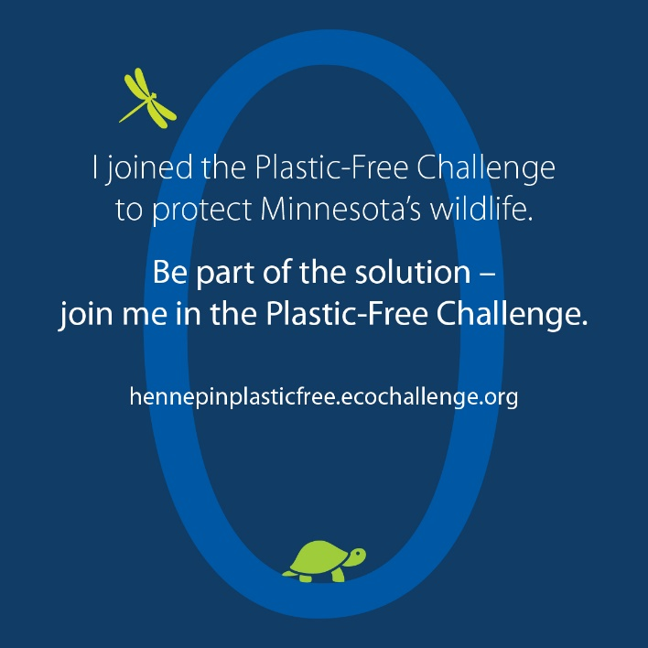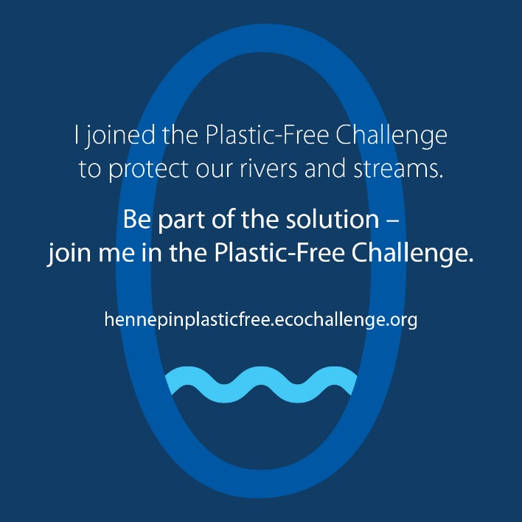

Social media posts
Social media messages for Facebook, Twitter, and Instagram posts are crafted to resonate with specific priority audience groups. Consider where your audience is in their zero-waste journey when choosing which messages to promote. Some messages below are appropriate for all audiences. Pair these messages with a graphic to promote the challenge. Example graphics for each message group are included and a full library of graphics begins on page 17. Graphics for Instagram stories are available starting on page 24.
- Zero waste learners: This audience is somewhat aware of problems with waste and may be doing a few things but are likely overwhelmed or unsure where to start. Some are more narrowly focused on recycling.
- Zero waste leaders: This audience is already taking action but know they could do more. They may be looking to influence others and need guidance and support.
- Zero waste pros: This audience is already doing a lot and are looking to truly get to zero waste. They are also eager to advocate for large-scale changes.

Message group 1 – Recycling, plastic types

Post: Learn about plastics recycling – learners
Facebook, Twitter, and Instagram (remove URL in Instagram post):
Knowing what plastics can be recycled and which ones should be avoided entirely can be confusing! Join your peers and learn how to do your part to create a #PlasticFree world. Be part of the solution by joining the Plastic-Free Challenge at hennepinplasticfree.ecochallenge.org

Post: Plastic types – learners
Facebook and Instagram (remove URL in Instagram post):
Did you know there are seven types of plastics? This is what the number 1 – 7 printed on a plastic item tells you. Although the triangle looks like a recycling symbol, it only tells you what type of plastic an item is, not if or how you can recycle it. Plastics with a number 1, 2, and 5 are generally accepted in your recycling at home because there are good markets for recycling these items. Learn more about different plastic types by joining the Plastic-Free Challenge at hennepinplasticfree.ecochallenge.org.
Twitter:
Did you know there are seven types of plastics? The number 1-7 printed on a item tells you what type of plastic it is, but not if or how to recycle it. Plastics number 1, 2, and 5 are generally accepted in your recycling at home. Learn more at hennepinplasticfree.ecochallenge.org

Post: Recycling is not a myth – learners
Facebook and Instagram (remove URL in Instagram post):
Recycling is effective when we recycle the right things. Plastic bottles, jugs, cups, and containers can be recycled into new products, including plastic bottles, fleece, carpeting, lumber, and landscaping plastics. To ensure plastic recycling is as effective as possible, learn what items can be recycled and what to keep out of your recycling bin. Be part of the solution by joining the Plastic-Free Challenge at hennepinplasticfree.ecochallenge.org.
Twitter:
Recycling is effective when we recycle the right things. Plastic bottles, jugs, cups, and containers can be recycled into new products like bottles, fleece, carpeting, and lumber. Learn about plastics recycling in the Plastic-Free Challenge. hennepinplasticfree.ecochallenge.org

Suggested graphics for message group 1:
To use images and graphics: right click on image and select Save as Picture.
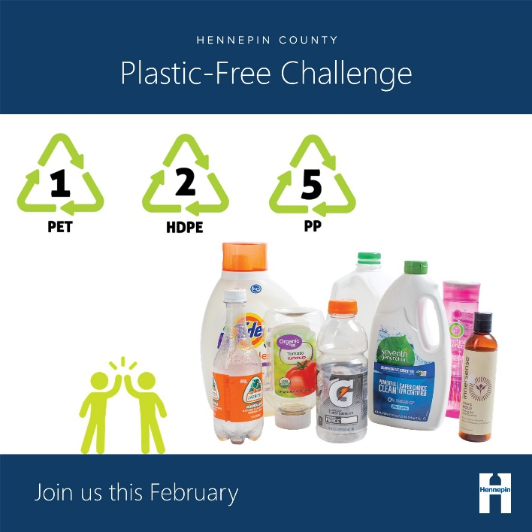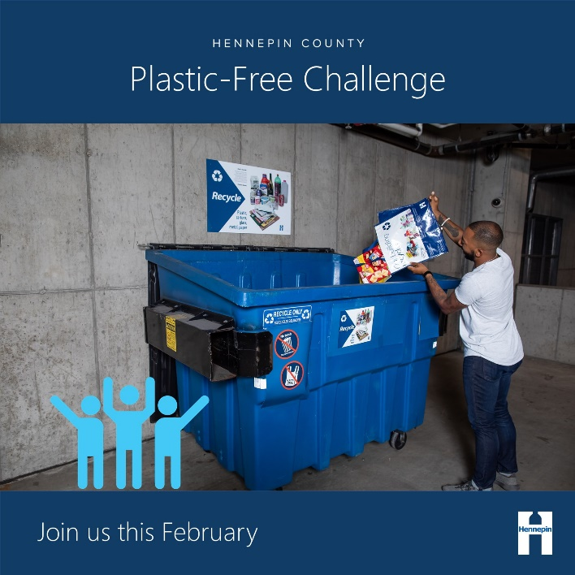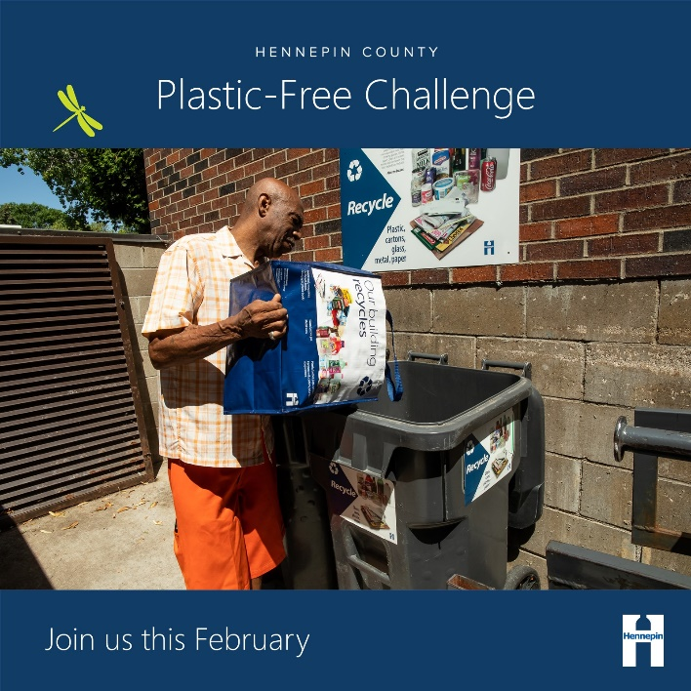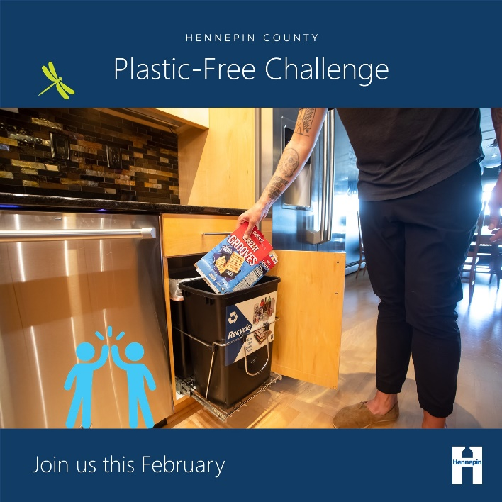

Message group 2 – Natural resources, wildlife, water

Post: Address climate change – all
Facebook and Instagram (remove URL in Instagram post):
Most plastics are made from oil and gas – fossil fuels that contribute to climate change. This February, reduce your consumption of single-use plastics to take action on climate change. Be part of the solution by joining the Plastic-Free Challenge at hennepinplasticfree.ecochallenge.org
Twitter:
Most plastics are made from oil and gas – fossil fuels that contribute to climate change. This February, reduce your consumption of plastics to take action on climate change. Be part of the solution by joining the Plastic-Free Challenge at hennepinplasticfree.ecochallenge.org

Post: Intrinsic value of water – all
Facebook, Twitter, and Instagram (remove URL in Instagram post):
Clean water is essential to the health of our environment, wildlife, and ourselves. This February, go #PlasticFree to protect our rivers and lakes. Be part of the solution by joining the Plastic-Free Challenge at hennepinplasticfree.ecochallenge.org.

Post: Intrinsic value of wildlife – all
Facebook, Twitter, and Instagram (remove URL in Instagram post):
Minnesota’s valuable wildlife need an environment that is clean and free of plastic pollution. Keep our iconic animals thriving by going #PlasticFree this February. Be part of the solution by joining the Plastic-Free Challenge at hennepinplasticfree.ecochallenge.org.

Post: Reduce consumption – pros and leaders
Facebook and Instagram (remove URL in Instagram post):
Mining resources to create plastic products is a threat to our environment. Reducing your consumption of plastics, especially plastics that are only used once, is an effective way to conserve the resources that go into manufacturing, packaging, transporting, and disposing of goods. Be part of the solution by joining the Plastic-Free Challenge at hennepinplasticfree.ecochallenge.org.
Twitter:
Mining resources to create plastic products is a threat to our environment. Reduce your consumption of single-use plastic to protect our natural resources. Be part of the solution – join the Plastic-Free Challenge at hennepinplasticfree.ecochallenge.org

Suggested graphics for message group 2:
To use images and graphics: right click on image and select Save as Picture.
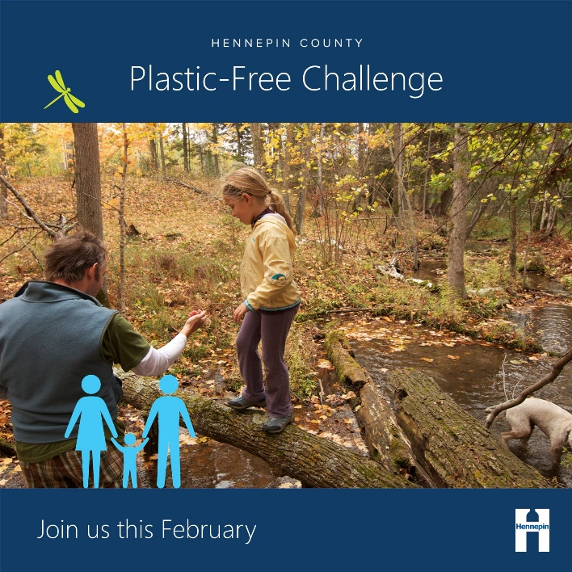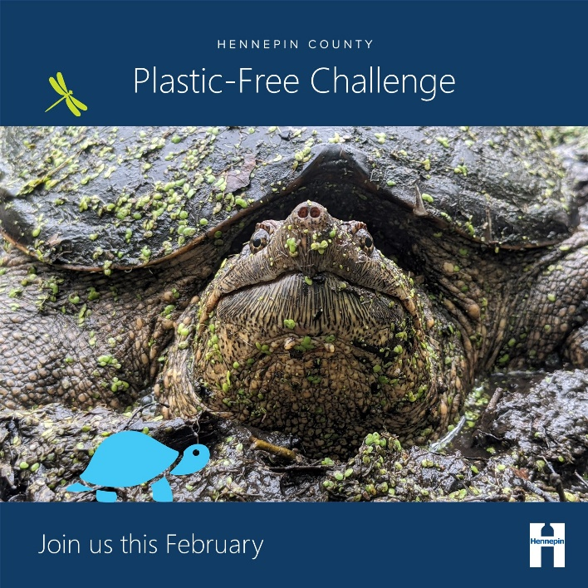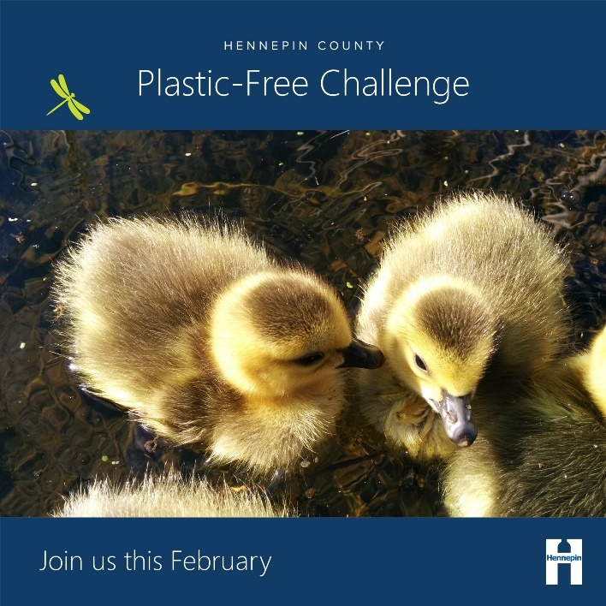

Message group 3 – Health, family, children

Post: Protect the health of your family and future generations – all
Facebook and Instagram (remove URL in Instagram post):
Plastics in our environment don’t go away. Instead, they break down into microplastics that are found almost everywhere, including in our air, water, soil, and bodies. The health impacts of these tiny bits of plastic are largely unknown. Some plastics contain harmful chemicals that interfere with the body’s hormones. Reduce your family’s reliance on plastics to protect the health of your children and the environment for future generations. Be part of the solution by joining the Plastic-Free Challenge at hennepinplasticfree.ecochallenge.org.
Twitter:
Plastics in our environment break down into tiny microplastics with unknown and potentially harmful health impacts. Reduce your family’s reliance on #plastics to protect their health. Be part of the solution by joining the Plastic-Free Challenge at hennepinplasticfree.ecochallenge.org.

Post: Recreational value of nature – all
Facebook and Instagram (remove URL in Instagram post):
Nature is vital for our well-being. Keeping our environment clean and free from plastic pollution protects the health of our families and neighbors. Go #PlasticFree this February to reduce waste, protect water and wildlife, and look after the health of ourselves and our children. Be part of the solution by joining the Plastic-Free Challenge at hennepinplasticfree.ecochallenge.org.
Twitter:
Nature is vital for our well-being. Go #PlasticFree this February to keep our environment clean and free from plastic pollution. Be part of the solution by joining the Plastic-Free Challenge at hennepinplasticfree.ecochallenge.org.

Post: Microplastics – all
Facebook and Instagram (remove URL in Instagram post):
Microplastics shed from synthetic clothing and produced when large plastic items are broken down by the sun are harmful to fish and other aquatic animals. When we eat fish that have ingested microplastics, those harmful effects may be passed on to us. Be part of the solution by joining the Plastic-Free Challenge at hennepinplasticfree.ecochallenge.org.
Twitter:
Microplastics are harmful to aquatic animals such as fish. When we eat fish that have ingested microplastics, those harmful effects may be passed on to us. Be part of the solution by joining the Plastic-Free Challenge at hennepinplasticfree.ecochallenge.org.

Suggested graphics for message group 3:
To use images and graphics: right click on image and select Save as Picture.
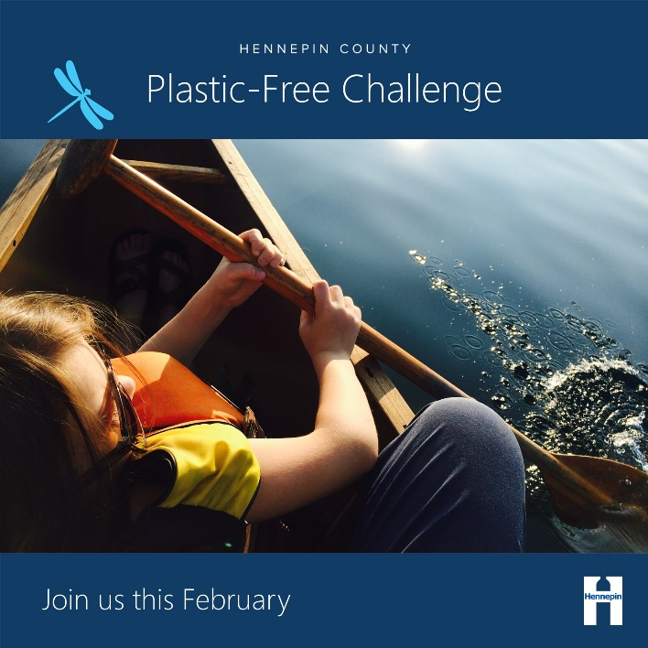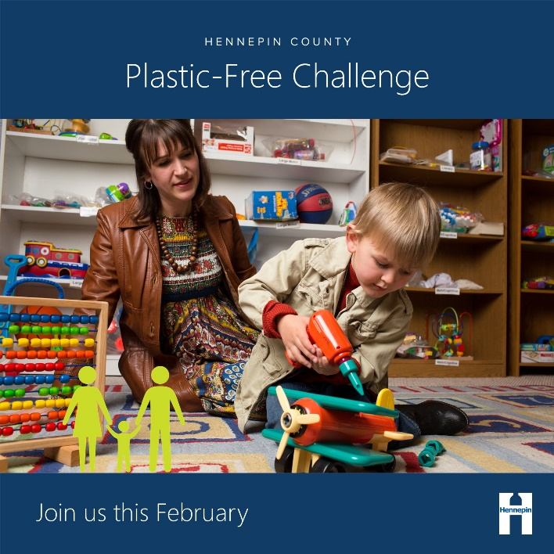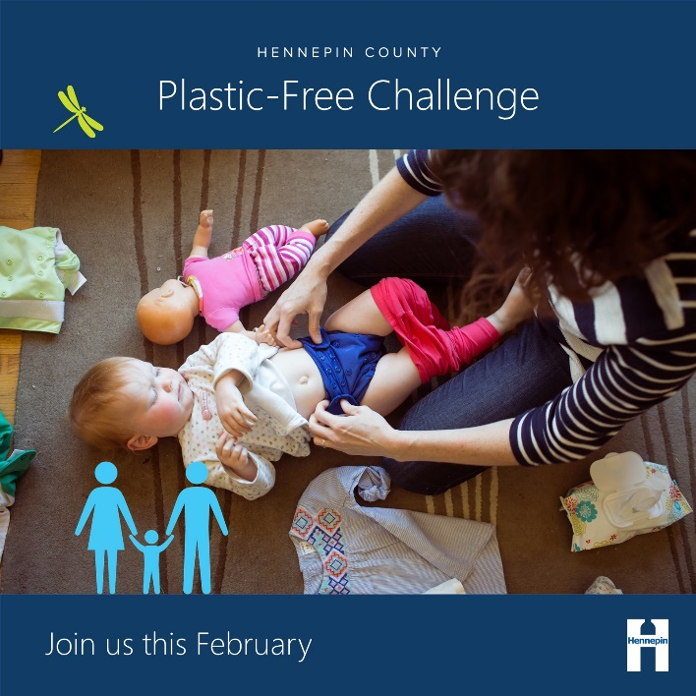

Message group 4 – Advocacy, action, influence, community

Post: Advocate for change – pros and leaders
Facebook and Instagram (remove URL in Instagram post):
Ask your favorite restaurant to get rid of single-use plastic and support businesses that are taking action to help create a #PlasticFree world. Learn how by joining the Plastic-Free Challenge and committing to actions in the community category at hennepinplasticfree.ecochallenge.org.
Twitter:
Ask your favorite restaurant to get rid of single-use plastic and support businesses that are taking action to create a #PlasticFree world. Learn how by joining the Plastic-Free Challenge and committing to actions in the community category at hennepinplasticfree.ecochallenge.org.

Post: Be an influencer – pros and leaders
Facebook and Instagram (remove URL in Instagram post):
Be a zero-waste leader by influencing your family, friends, and community to reduce their plastic use and clean up plastic litter. By working together, we can create a #PlasticFree world. Be part of the solution by joining the Plastic-Free Challenge at hennepinplasticfree.ecochallenge.org.
Twitter:
Be a zero-waste leader by influencing your family, friends, and community to reduce their plastic use and clean up plastic litter. Together, we can create a #PlasticFree world. Be part of the solution by joining the Plastic-Free Challenge at hennepinplasticfree.ecochallenge.org.

Post: DIY/Self-sustaining – pros and leaders
Facebook and Instagram (remove URL in Instagram post):
Plastic packaging is often the default when shopping for food, personal care products, cleaning products, and more. Do your part to purchase alternative products or learn to make your own to avoid harmful plastic packaging. Learn how and help create a #PlasticFree world by joining the Plastic-Free Challenge at hennepinplasticfree.ecochallenge.org.
Twitter:
Plastic packaging is hard to avoid when shopping. Do your part to purchase alternative products or learn to make your own to avoid harmful plastic packaging. Learn how and create a #PlasticFree world by joining the Plastic-Free Challenge at hennepinplasticfree.ecochallenge.org.

Suggested graphics for message group 4:
To use images and graphics: right click on image and select Save as Picture.
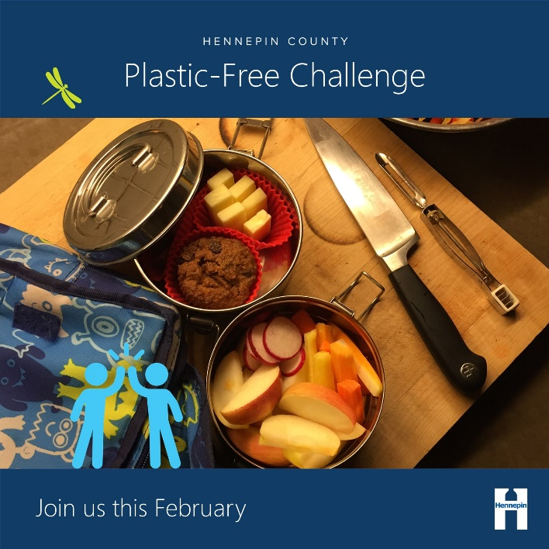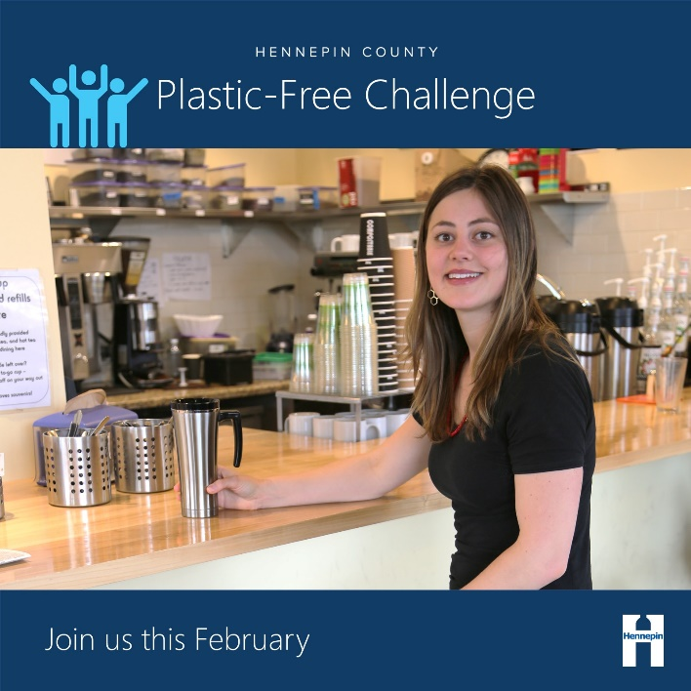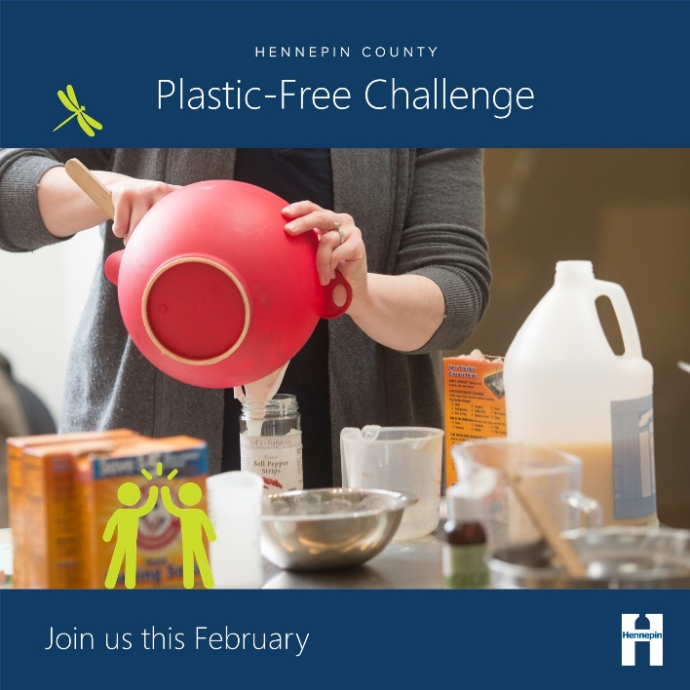

Full library of social media graphics
Download full resolution graphics here: hennepinplasticfree.ecochallenge.org/about/resources
To use images and graphics: right click on image and select Save as Picture.
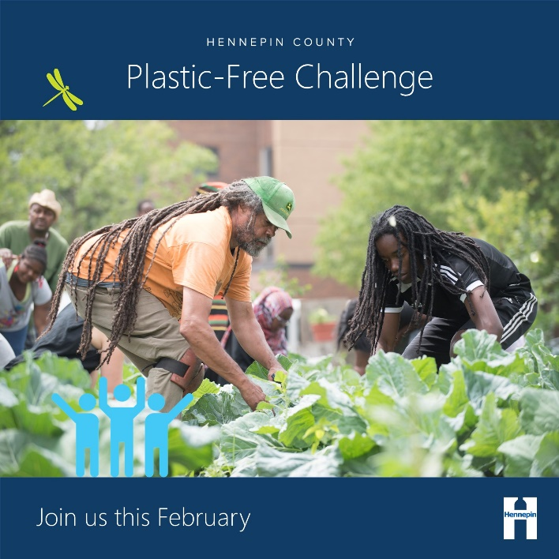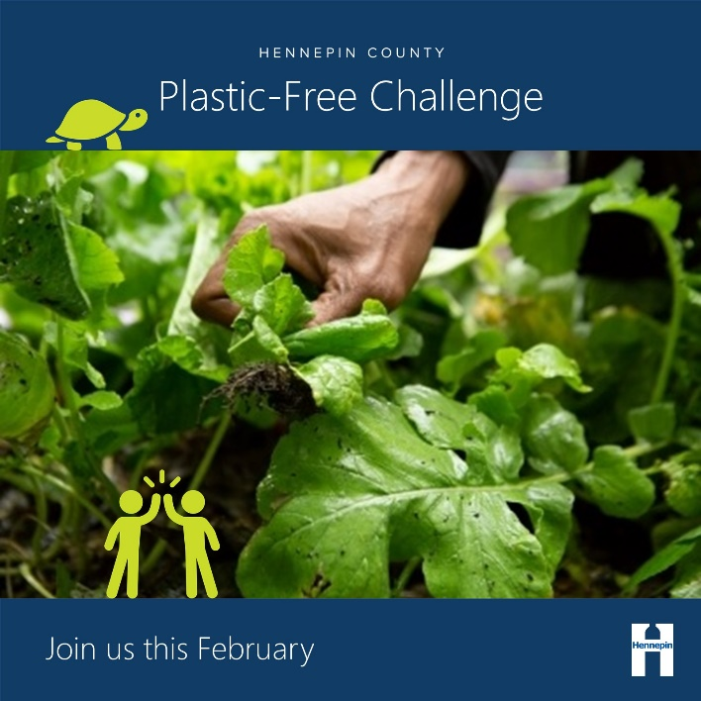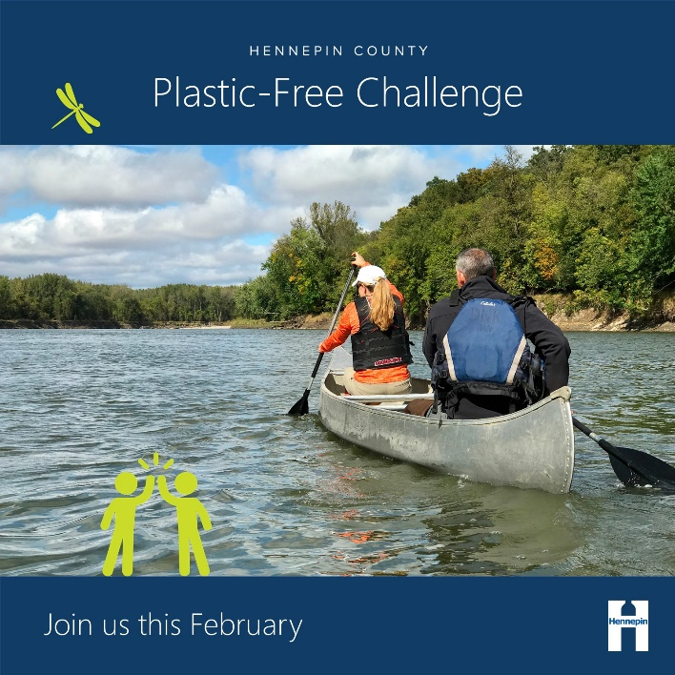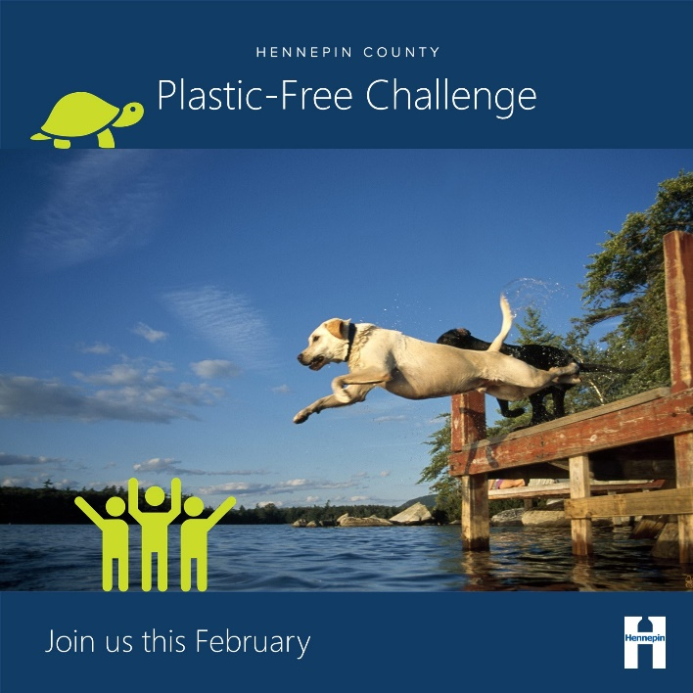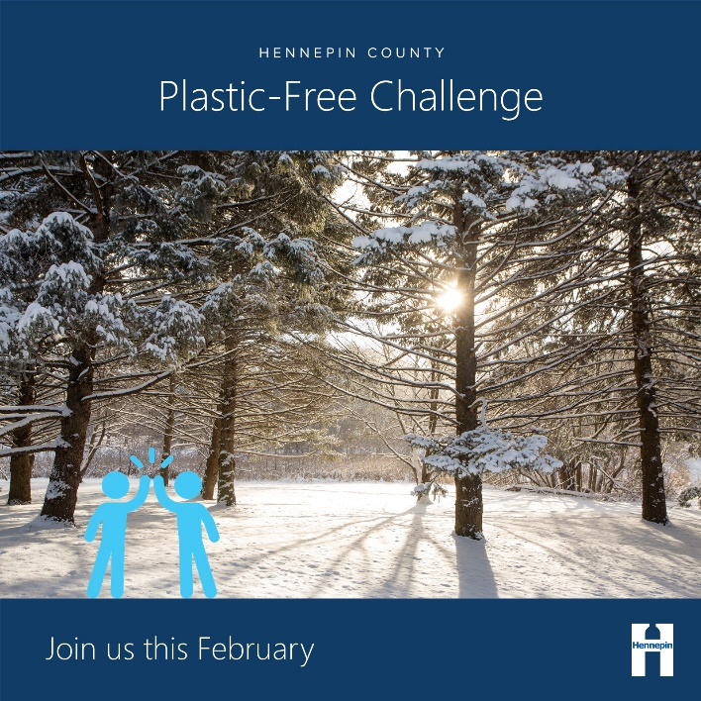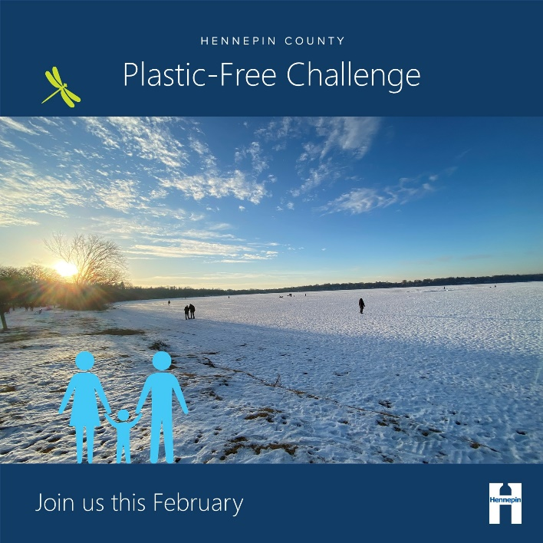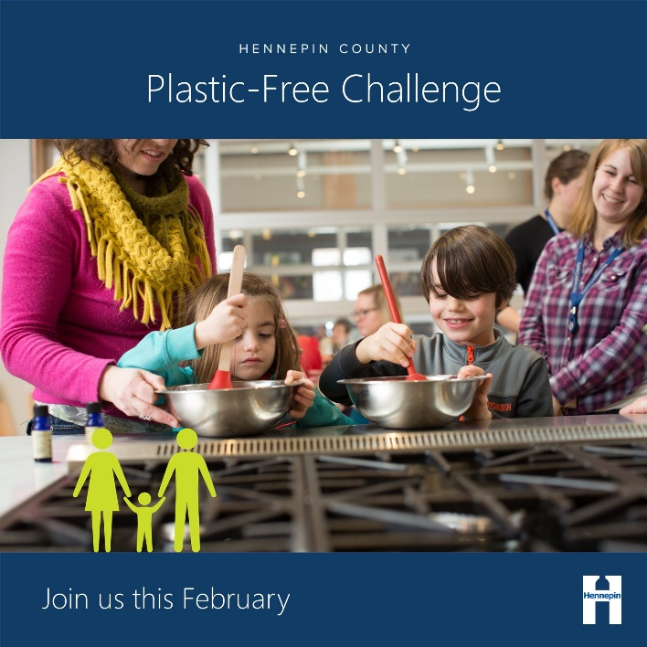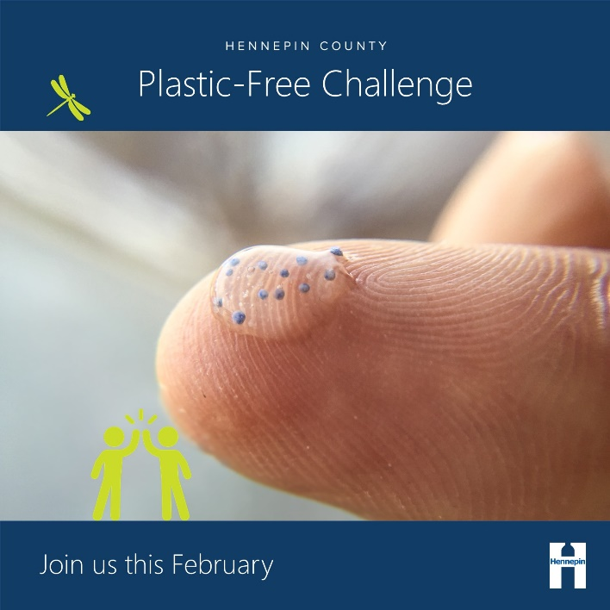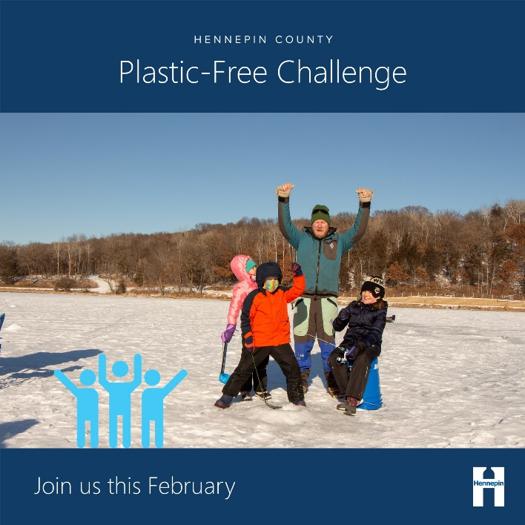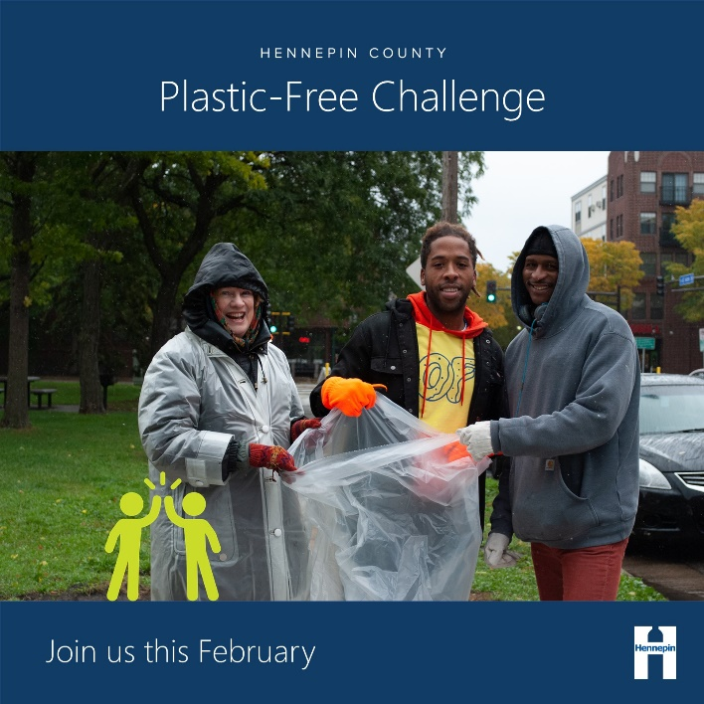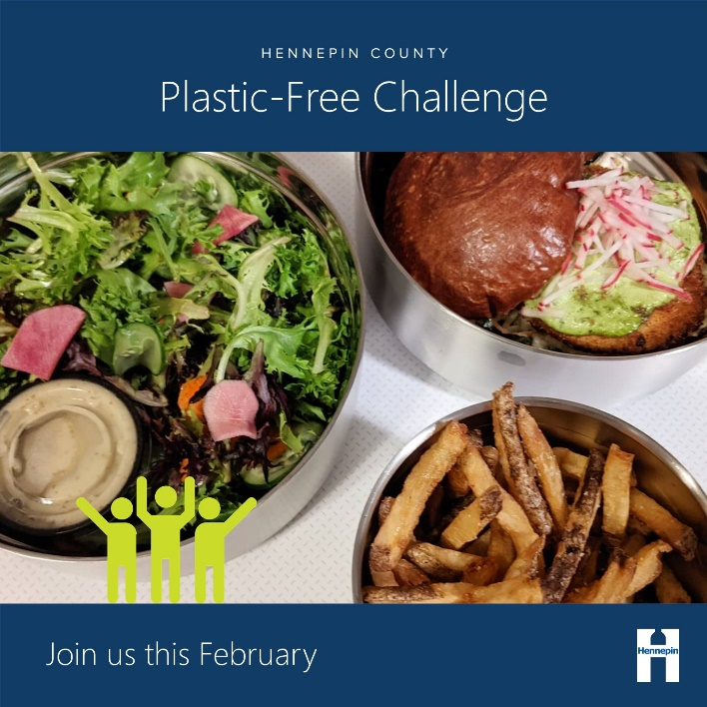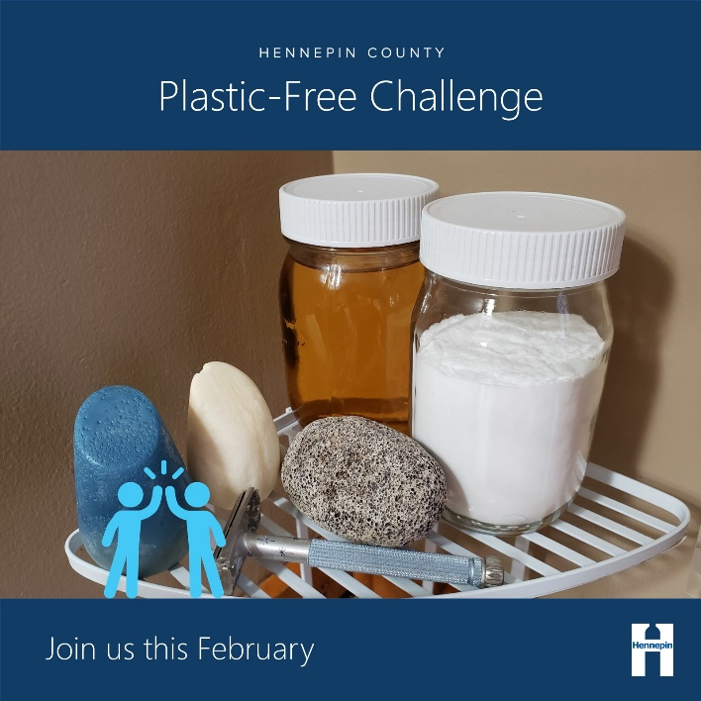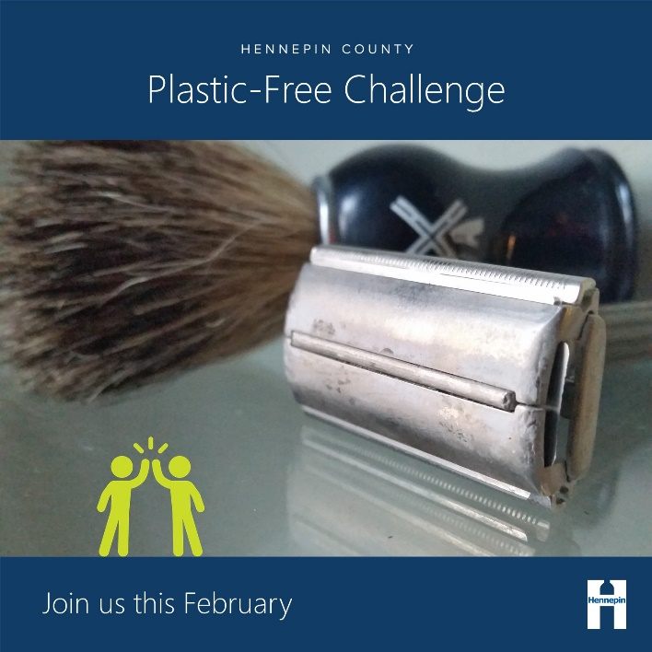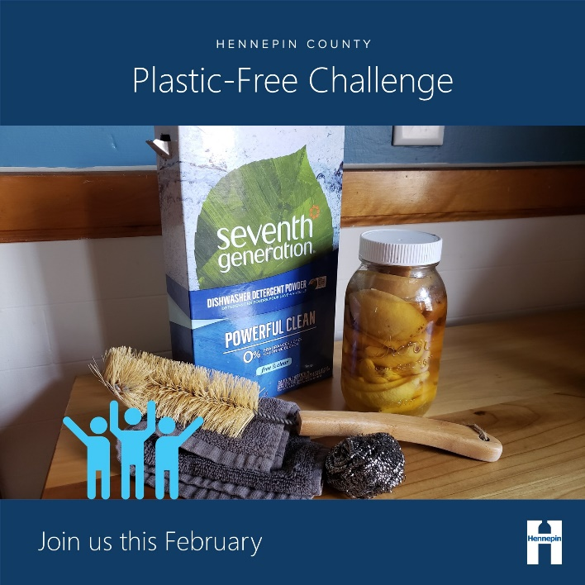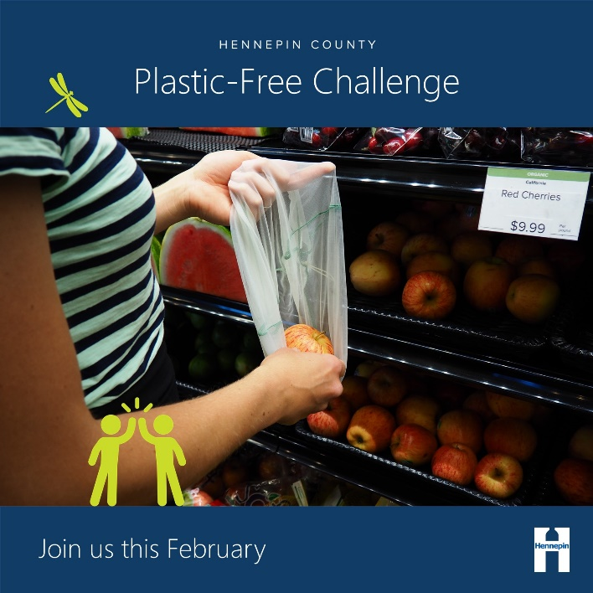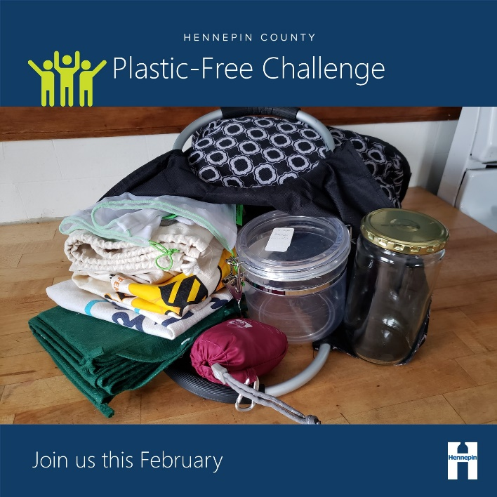

Instagram story graphics
Download full resolution graphics here: hennepinplasticfree.ecochallenge.org/about/resources
Consider adding a link to the Plastic-Free Challenge website or a relevant action category:
- https://hennepinplasticfree.ecochallenge.org/
- https://hennepinplasticfree.ecochallenge.org/challenges/at-home
- https://hennepinplasticfree.ecochallenge.org/challenges/food
- https://hennepinplasticfree.ecochallenge.org/challenges/on-the-go
- https://hennepinplasticfree.ecochallenge.org/challenges/personal-care
- https://hennepinplasticfree.ecochallenge.org/challenges/community
- https://hennepinplasticfree.ecochallenge.org/challenges/kids
- https://hennepinplasticfree.ecochallenge.org/challenges/pets
To use images and graphics: right click on image and select Save as Picture.
