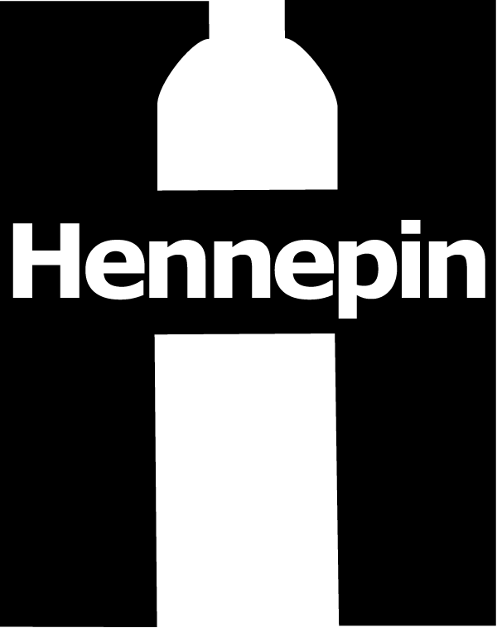 | Hennepin County Environment and Energy News  612-348-3777 • environment@hennepin.us  www.hennepin.us/environmentaleducation  701 Fourth Ave. S., Suite 700, Minneapolis, MN 55415

To: Cities, community groups and partners in Hennepin County
From: Alisa Reckinger, Environment and Energy, 612-348-4788
Date: January 2016
Subject: What Can I Recycle?

Sample Newsletter Article

What Can I Recycle?

There are various types of paper, plastic, glass, metal and cartons that you can recycle in Hennepin County. Here is a basic list of materials that are accepted for recycling:

Paper:
- Mail, office and school papers
- Catalogs and magazines
- Newspapers and inserts
- Phone books
- Shredded paper in closed paper bags
- Boxes – cardboard, cereal and crackers, shoe, gift, electronics, toothpaste, medication and other toiletry items
Plastic:
- Water, soda and juice bottles
- Juice and milk jugs
- Ketchup and salad dressing bottles
- Dishwashing liquid bottles and detergent jugs
- Shampoo, soap and lotion bottles
- Shredded paper in closed paper bags
Cartons:
- Water, soda and juice bottles
- Juice boxes
- Soup, broth and wine cartons
Glass:
- Food and beverage bottles and jars
Metal:
- Food and beverage cans

There are also items that are not recyclable, including:

- Styrofoam cups, plates or packaging
- Microwavable food trays
- Plastic wrap
- Paper soiled with food (such as pizza boxes)
- Paper plates and towels
- Gift wrap
- Drinking glasses, dishes and vases
- Window glass and mirrors
- Cans or bottles that held hazardous products (such as paint thinner or motor oil)

For more information, visit www.hennepin.us/recycling or call Hennepin County Environment and Energy at 612-348-3777.

Sample Web Story

What Can I Recycle?

Recycling just got easier for Hennepin County residents. In addition to recycling plastics, paper, glass and metal, residents can now recycle cartons. Accepted carton items include milk cartons, juice boxes, and soup, broth and wine cartons.

There are still various items that are not accepted for recycling, including:
- Styrofoam materials
- Plastic wrap
- Paper plates or towels
- Paper soiled with food (such as pizza boxes)
- Gift wrap
- Cans or bottles that held hazardous products (such as paint thinner or motor oil)
- Window glass or mirrors
For more information, visit www.hennepin.us/recycling or call Hennepin County Environment and Energy at 612-348-3777.

Sample Social Media Posts
Interact with Hennepin Environment on Facebook at www.facebook.com/hennepinenvironment and Twitter at www.twitter.com/hennepinenviro (@hennepinenviro).

Facebook:
Did you know milk, juice, wine and soup cartons are now accepted for recycling? Add them to your recycling container with other accepted recycling items such as plastic, paper, metal and glass! Learn more at www.hennepin.us/recycling.

Help keep unaccepted and problematic items out of the recycling process. These unrecyclable items include Styrofoam, plastic wrap, gift wrap and paper soiled with food. Learn more at www.hennepin.us/recycling.
Twitter:
Are you having trouble knowing what items to recycle? Check out Hennepin County’s recycling guide.

Did you know milk, juice, wine and soup cartons are now accepted for recycling? Learn more at www.hennepin.us/recycling.

Additional Promotional Materials

Hennepin County Recycling Guide (English)

Hennepin County Recycling Guide (Spanish)

