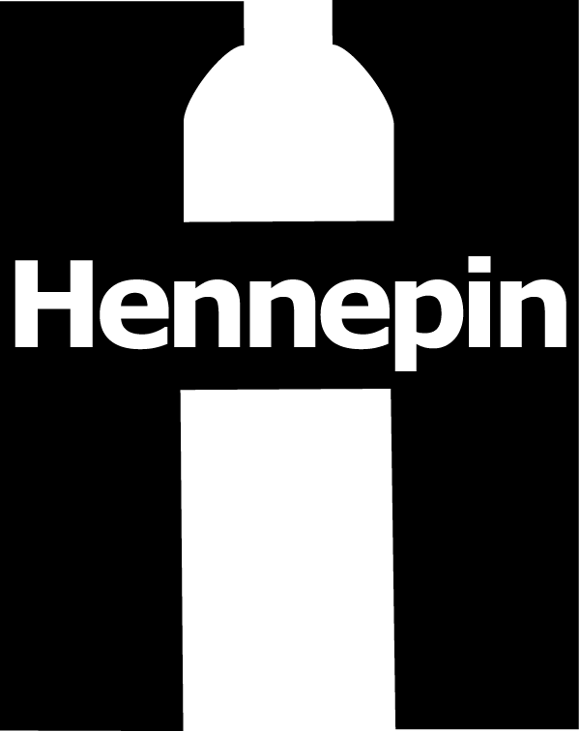 | Hennepin County Environment and Energy News  Environment and Energy • 612-348-3777 • 701 Fourth Ave. S., Suite 700, Minneapolis, MN 55415

Sept. 21, 2015

Contact: Christina Schmitt, Environment and Energy, 612-596-7740
Ben Knudson, Environment and Energy, 612-596-1176
Kayla Bromelkamp, Communications, 612-348-8536

Sample Newsletter Article

Green Disposal Guide tells you the best way to get rid of your stuff
www.hennepin.us/greendisposalguide

Fall clean up can be frustrating, especially when you find yourself with a pile of stuff that needs to go. But where?

With a click on your computer or smart phone, find ways to recycle, reuse or dispose of items from your home with the new online resource for Hennepin County residents, Green Disposal Guide: www.hennepin.us/greendisposalguide.

The Green Disposal Guide provides simple content about how to get rid of items. Easy to use and mobile friendly, the Green Disposal Guide offers a range of disposal options and also encourages responsible disposal practices.

Yard waste, mattresses, paint or fluorescent light bulbs and more—find out how to get rid of your stuff. The online Green Disposal Guide also has tips for shopping smarter, living greener and creating less waste.

Check it out: www.hennepin.us/greendisposalguide.

Sample Social Media Posts

Facebook
Fall clean up just got easier. Got old paint, mattresses and yard waste? Learn how to get rid of your stuff and also get tips for shopping smarter, living greener and creating less waste with the Green Disposal Guide, www.hennepin.us/greendisposalguide.

Twitter

Fall clean up just got easier. Learn how to get rid of your stuff with the Green Disposal Guide, www.hennepin.us/greendisposalguide.

Got paint, mattresses and yard waste? Learn how to get rid of it with the Green Disposal Guide, www.hennepin.us/greendisposalguide.

Additional Materials

These promotional materials, as well as images and other files, will be available for download by October 1, 2015, at http://www.hennepin.us/business/work-with-henn-co/environmental-education-resources#articles-posts

