MNimize Media Kit and Promotional Materials
Intended for Organizations Communicating with Residents
About MNimize
MNimize is a new program from Minnesota Waste Wise Foundation, offered in partnership with Hennepin County, to recognize and support food service businesses like restaurants, coffee shops, and other eateries in their efforts to reduce single-use plastic and achieve their sustainability goals. As a tiered recognition program, MNimize awards businesses at one of four achievement levels based on their efforts to reduce single-use plastic. The program also helps businesses identify opportunities to continue reducing single-use plastic and provides technical assistance so they can take further action.
Additionally, MNimize offers financial support to businesses through the MNimize Rebate. Participating businesses can get up to $500 toward eligible expenses to reduce single-use plastic. This rebate could be used to purchase durable reusable or certified compostable alternatives to replace single-use plastic items or for other creative plastic reduction strategies.
Reducing single-use plastic is an impactful opportunity to divert waste, keep plastic out of the environment, build brand loyalty with existing and new customers, and generate cost savings. MNimize is proud to celebrate the efforts of businesses taking action to reduce single-use plastic and advance sustainability in the food service industry!

Help spread the word
- Download and share the social media graphics. Sample social media posts to go with the graphics are included in this document. You can also download these graphics, MNimize logos, and our promotional flyer from our Google Drive. Encourage your community to reshare as well!
- Follow MNimize on social media and reshare our posts to promote participating businesses and encourage the community to support them and refer their favorite businesses to the program
  - Instagram: @mnimizeplastic
  - Facebook: MNimize
- Use the sample newsletter article(s) to share with your community.
- Encourage community members to learn more about MNimize and refer their favorite businesses to the program using the sample email message below.
- Refer potentially interested businesses directly to the program by emailing us at hello@mnimize.org
- Share our promotional flyer via email or a print handout
- Support MNimize businesses! Follow them on social media, reshare their content (especially about MNimize), become their customers, and leave positive reviews for them on Yelp or Google!

Social Media Graphics & Posts
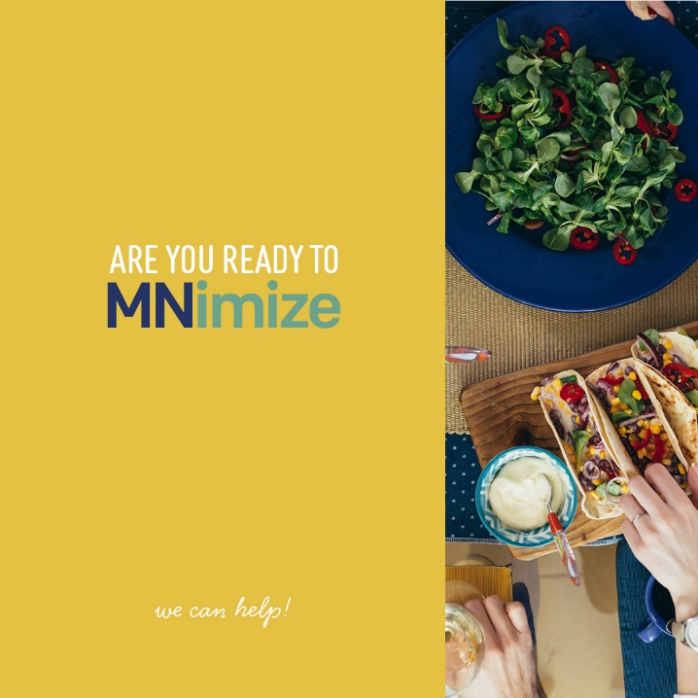
Sample Caption #1:
Tired of getting plastic utensils in your take-out order when you don’t need them? So are we. MNimize is a campaign to help food service businesses reduce plastic waste.
Encourage your favorite local eateries to get started by taking the MNimize Pledge to offer single-use plastic utensils by request only! Learn more at mnimize.org
#MNimize #singleuseplastic #sustainablebusiness

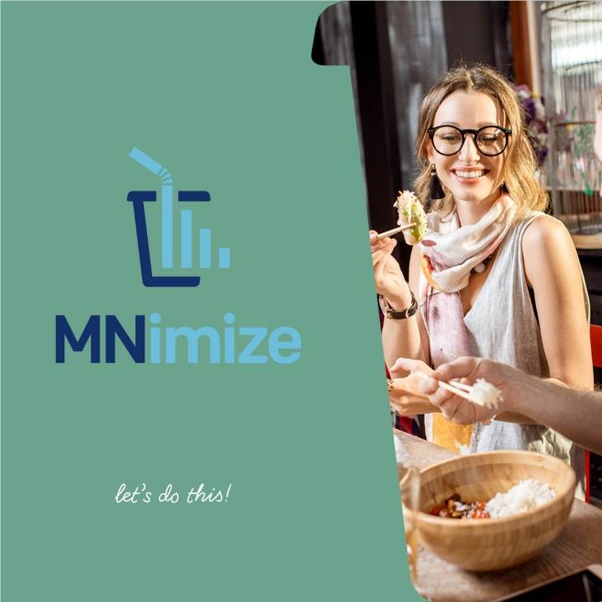
Sample Caption #2:
Want to help your favorite food businesses reduce plastic waste and save money? MNimize provides technical assistance and funding to help food businesses replace single-use plastic products with reusable or compostable alternatives. Refer your local businesses and set them up for success!
#minnesotafoodie #minnesotanice #sustainablebusiness

Sample Caption #3:
Is there a restaurant in your neighborhood that deserves recognition for taking action to reduce plastic waste? Nominate them to MNimize!
MNimize will highlight their achievement and put them on the map with other businesses that are making an impact.
Let’s celebrate the good work of our local restaurants!
#minnesotafoodie #sustainablebusiness #eatlocal

Please tag MNimize in all posts so we can reshare on our platform. You can also tag businesses in your network or community in the posts.

Sample newsletter article
Help your favorite restaurants, coffee shops, and other local eateries reduce single-use plastic waste!
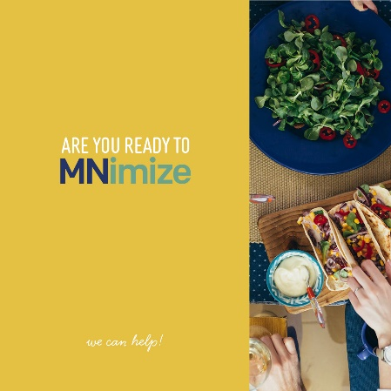
Looking to support your favorite food businesses and reduce plastic waste in our environment?
MNimize is a new program to help food businesses reduce single-use plastic waste and receive recognition for their efforts. Working closely with business owners to identify opportunities to reduce waste, MNimize also provides businesses up to $500 to replace single-use plastic products with reusable or compostable alternatives. Businesses are then recognized for their efforts with a listing on the MNimize website and other promotion.
MNimize hopes any and all food businesses will take advantage of this free opportunity, and you can help spread the word. Here are some ideas:
- Leave a positive Yelp or Google review for your favorite restaurant encouraging them to participate in MNimize. This could be a business that has already eliminated single-use plastic and should be recognized for their efforts or one that might be interested in reduction opportunities.
- Drop off a MNimize flyer the next time you visit your favorite food businesses.
- Email hello@mnimize.org to nominate businesses in your community that you’d like to see participate in MNimize.
- Follow MNimize on Instagram and Facebook. Like and share our content and tag businesses you would like to see involved!
- Support businesses participating in MNimize and let them know you appreciate their efforts to reduce single-use plastic! You can find a map of participating businesses on our website!
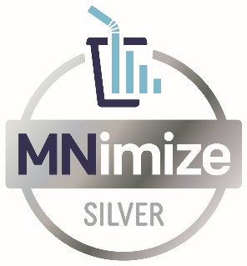
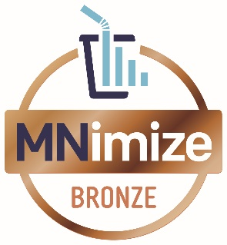
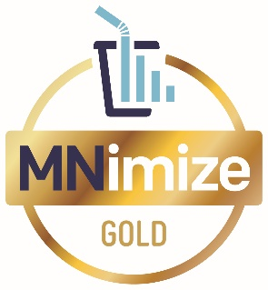
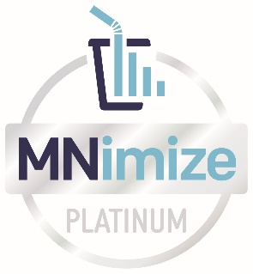

Reducing single-use plastic is an impactful opportunity to divert waste, keep plastic out of the environment, and generate cost savings for business owners. MNimize is proud to collaborate with food businesses and their customers in our community to drive change. If you have any questions or if you’d like to learn more, please reach out to MNimize at hello@mnimize.org.

Sample email message to food business owner/operator
Dear (NAME),
(Start with a brief personal message to the business about why you love being their customer! For example: “I’ve been a customer of your restaurant for years, and regularly turn to you when I am in the mood for pizza”). I truly appreciate you as a member of our community, so I wanted to share an opportunity you might find interesting!
MNimize is a new program from Minnesota Waste Wise Foundation to help food businesses reduce single-use plastic waste and receive recognition for their efforts. MNimize awards businesses at one of four achievement levels based on their efforts to reduce single-use plastic, and provides technical assistance so they can take further action.
Additionally, MNimize offers financial support to businesses through the MNimize Rebate. Participating businesses can get up to $500 toward eligible expenses to reduce single-use plastic. This rebate could be used toward durable reusable or certified compostable alternatives to replace single-use plastic items or for other creative plastic reduction strategies.
To learn more, visit the mnimize.org or reach out directly to hello@mnimize.org. You can also learn more about businesses that have already joined by following MNimize on Instagram or Facebook.
We hope you choose to take advantage of this great opportunity, and we’re excited to celebrate and promote your achievements!
Sincerely,
(YOUR NAME)

Download promotional materials from Google Drive

