Fix-It Clinics and repair tips media kit

About Fix-It Clinics

Get help with your broken stuff and learn valuable repair skills at free Fix-It Clinics. Fix-It Clinics offer free, guided assistance from volunteers with repair skills to disassemble, troubleshoot, and (hopefully) fix small household appliances, clothing, electronics, mobile devices and more. Fix-It Clinics teach valuable troubleshooting and basic repair skills, build community connections and reduce the number of repairable items that are thrown in the trash.

Resources to promote Fix-It Clinics
Ways to educate the public about Fix-It Clinics:
- Use the sample newsletter article to share on your organization’s website or in your newsletters. These are editable so you can customize the length or message.
- Use the sample social media posts to share through your social media channels. These are editable so you can customize the message and website.
- Follow and reshare messages posted on Hennepin County Environment and Energy social media channels: Hennepin Environment on Facebook, Hennepin Environment on Instagram, and @hennepinenviro on Twitter.
- Share the information and resources available at www.hennepin.us/fixitclinic

Contact
For more information about Fix-It Clinics, contact:
Nancy Lo, Environmentalist, nancy.lo@hennepin.us
Emily McDonald, Environmental Educator, emily.mcdonald@hennepin.us

Sample newsletter article – Long version

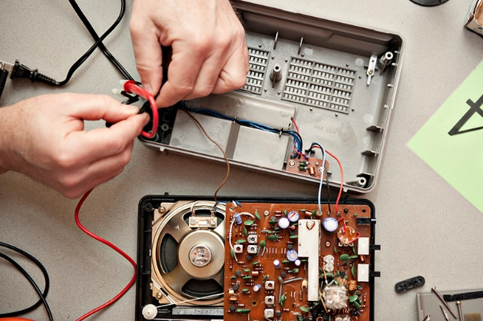
Repair tips from handy Fix-It Clinic volunteers
At monthly Hennepin County Fix-It Clinics, residents bring in small household appliances, clothing, electronics, mobile devices and more and receive free guided assistance from volunteers with repair skills to disassemble, troubleshoot and fix their items. Fix-It Clinics teach valuable troubleshooting and basic repair skills, build community connections and reduce the number of repairable objects that are thrown in the trash.
After helping hundreds of residents get their broken household items back in working order, the handy volunteers at Hennepin County Fix-It Clinics have gained some valuable insights into common repair issues. Here are some of their fixing tips:

Don’t be afraid to take it apart
One of the first things to overcome is the fear of taking something apart. Remember, the item is already broken, so there’s no harm in trying to fix it. Plus, troubleshooting and fixing things is challenging and fun! There are generally three outcomes when you take something apart:
- You fix it!
- You get lost in the disassembly. Prevent this by being methodical in your disassembly and taking lots of pictures to help you put your item back together.
- You make the problem worse. If you hit a dead end, search for help online or bring the item to a Fix-It Clinic for assistance. A wide variety of replacement parts are available online or at a local hardware store.

Repair and purchasing tips
- Items that seem broken often just need to be cleaned.
- You will need tools and some knowledge of how to use them in order to fix things. You don’t necessarily need a lot of specialty tools – a basic toolset can go a long way.
- Look for replacement parts. Many items stop working due to one broken part that is relatively inexpensive to replace. You may be surprised by the variety of replacement parts you can find online or at a local hardware store.
- Invest in good-quality household items and consumer goods. Higher-quality items are likely to last longer, making them less expensive and less of a hassle in the long run.
- Consider the ability to repair an item when purchasing it, including how feasible it is to take the item apart and how well-made the components are.
- Some things that are broken may not be worth fixing. Examples include old, energy-hogging appliances such as mini-fridges and dehumidifiers as well as outdated electronics such as computers that cannot run on current operating systems. Make sure to properly dispose of these items. Search the Hennepin County Green Disposal Guide for options.
For more information, visit www.hennepin.us/fixitclinic.

Sample newsletter article – Short version

Repair tips from handy Fix-It Clinic volunteers
At monthly Hennepin County Fix-It Clinics, residents bring in small household appliances, clothing, electronics, mobile devices and more and receive free guided assistance from volunteers with repair skills to disassemble, troubleshoot and fix their items. Fix-It Clinics teach valuable troubleshooting and basic repair skills, build community connections and reduce the number of repairable objects that are thrown in the trash.
After helping hundreds of residents get their broken household items back in working order, the handy volunteers at Fix-It Clinics have gained some valuable insights into common repair issues. Here are some of their fixing tips:
- Don’t be afraid to take it apart. One of the first things to overcome is the fear of taking something apart. Remember, the item is already broken, so there’s no harm in trying to fix it.
- Items that seem broken often just need to be cleaned.
- You will need tools and some knowledge of how to use them in order to fix things. You don’t necessarily need a lot of specialty tools – a basic toolset can go a long way.
- Look for replacement parts. Many items stop working due to one broken part that is relatively inexpensive to replace.
- Invest in good-quality household items and consumer goods. Higher-quality items are likely to last longer, making them less expensive and less of a hassle in the long run.
- Consider the ability to repair an item when purchasing it, including how feasible it is to take the item apart and how well-made the components are.
- Some things that are broken may not be worth fixing. Make sure to properly dispose of these items. Search the Hennepin County Green Disposal Guide for options.
For more information, visit www.hennepin.us/fixitclinic.

Social media posts
To use images and graphics: right click on image and select save as picture. Alt text is included with the pictures and graphics.

Post 1: General promotion of upcoming Fix-It Clinics
Facebook: Bring your small household appliances, clothing, electronics, mobile devices and more to an upcoming Fix-It Clinic and receive free guided assistance from volunteers with repair skills to disassemble, troubleshoot and fix your items! Visit hennepin.us/fixitclinic for upcoming clinic dates and locations.
Twitter: Bring your small household appliances, clothing, electronics, mobile devices and more to an upcoming Fix-It Clinic and receive free assistance from volunteers to fix your items! Visit hennepin.us/fixitclinic for upcoming clinic dates and locations. #FixIt #Repair
Instagram: Bring your small household appliances, clothing, electronics, mobile devices and more to an upcoming Fix-It Clinic and receive free guided assistance from volunteers with repair skills to disassemble, troubleshoot and fix your items! #FixIt #Repair
Clinics are held monthly. No pre-registration required.
- April 13, Grace Center for Community Life, 1500 6th Street Northeast, Minneapolis, noon - 4 p.m.
- May 11, Hope Presbyterian Church, 7132 Portland Avenue, Richfield, noon - 4 p.m.
- June 8, St. Louis Park Recreation Center, 3700 Monterey Drive, St. Louis Park, noon - 4 p.m.
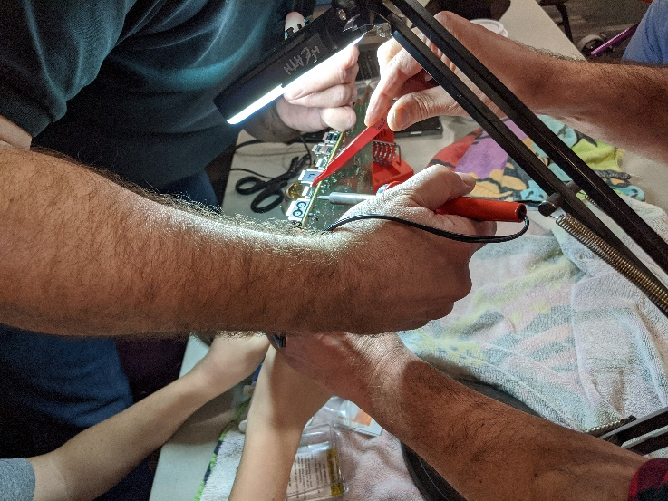
Alt text: Close up of hands repairing electronic device

Post 2: Repair tip: Don’t fear!
Facebook: Do you have a broken item you can’t bear to throw away? Fix-It Clinic volunteers say one of the first things to overcome is the fear of taking something apart. Remember, the item is already broken, so there’s no harm in trying to fix it. Get help at a Fix-It Clinic! Find upcoming clinic dates and locations at hennepin.us/fixitclinic.
Twitter: Do you have a broken item you can’t bear to throw away? Remember, the item is already broken, so there’s no harm in trying to fix it. Get help at a Fix-It Clinic! Find upcoming clinic dates and locations at hennepin.us/fixitclinic. #FixIt #Repair
Instagram: Do you have a broken item you can’t bear to throw away? Fix-It Clinic volunteers say one of the first things to overcome is the fear of taking something apart. Remember, the item is already broken. Get help at a Fix-It Clinic! #FixIt #Repair
Clinics are held monthly. No pre-registration required.
- April 13, Grace Center for Community Life, 1500 6th Street Northeast, Minneapolis, noon - 4 p.m.
- May 11, Hope Presbyterian Church, 7132 Portland Avenue, Richfield, noon - 4 p.m.
- June 8, St. Louis Park Recreation Center, 3700 Monterey Drive, St. Louis Park, noon - 4 p.m.
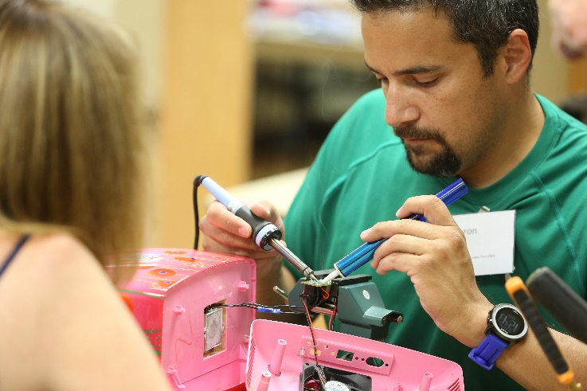
Alt text: Man repairing pink sewing machine

Additional images
To use images and graphics: right click on image and select save as picture. Alt text is included with the pictures and graphics.
