Contact:
Jen Kullgren, Hennepin County Environment and Energy forester, jen.kullgren@hennepin.us
Dustin Ellis, Hennepin County Environment and Energy forester, dustin.ellis@hennepin.us
Alisa Reckinger, Hennepin County Environment and Energy communications, alisa.reckinger@hennepin.us

Subject: Emerald ash borer and managing ash trees

Sample newsletter article and web content (long version)

Deciding how to manage ash trees from the threat of emerald ash borer
Emerald ash borer, an invasive tree pest that attacks and kills ash trees, is the biggest current threat to our tree canopy. There are over 1 million ash trees in Hennepin County, and 100 percent of them are threatened by the emerald ash borer.
Most residents live within 15 miles of an infested ash tree, which means you should be taking steps now to determine if you have ash trees on your property and how you are going to manage them.

Identifying and inventorying ash trees
The first step is to inventory your ash trees. That is, figure out if you have ash trees, how many you have, and where they are located.
Look for the following characteristics to determine if your tree is an ash tree:
- Branches that grow directly opposite from one another
- Compound leaves, or multiple leave on one stalk joined to a branch.
- Bark with a diamond-shaped pattern.
- Seeds that are oar-shaped samaras that typically hang in clusters.

Determine if your ash trees are worth saving
Next, decide if you are interested in saving your ash trees and if your trees are worth saving.
Ash trees that are worth saving are healthy, at least 30 inches in circumference or 10 inches in diameter at chest height, show no or few signs of emerald ash borer infestation, are in a good location, and are valuable to the property owner.
Work with a certified arborist to treat your ash trees with a trunk injection of ememectin benozoate (commercial name Tree-age). Prevention treatments must be administered by a certified arborist every two to three years in late spring. Cost is typically $100 to $200 depending on the size of the tree.

Monitor and make a plan for removal
Any ash tree not being treated will eventually become infested need to be removed.
Monitor your trees for signs of emerald ash borer, which includes leaves on the top or one part of the tree start dying, sprouts growing from the root or base of the tree, increased woodpecker activity with sections of the bark stripped away, D-shaped exit holes created by adult beetles leaving the tree, a serpentine pattern underneath the bark from larvae.
Remove ash trees between October 1 and April 30 to avoid the season when emerald ash borer is active and in flight. Trees should be removed by a certified arborist, and you can coordinate with your neighbors to reduce individual costs of removing trees.

Replanting
Trees provide numerous benefits, including improving air and water quality, reducing soil erosion, increasing wildlife habitat, providing savings in heating and cooling, and improving health. So planting new trees in place of any you remove is a great idea.
Plant the right tree for the right location, and plant a variety of tree species. Be sure to call 811 before you dig, follow proper planting techniques, and give your young tree enough water.

Learn more
Learn more about emerald ash borer, options for managing ash trees, and tips for hiring a certified arborist at hennepin.us/ashtrees.

Sample newsletter article and web content (short version)

Deciding how to manage ash trees from the threat of emerald ash borer
Emerald ash borer, an invasive tree pest that attacks and kills ash trees, is the biggest current threat to our tree canopy. There are over 1 million ash trees in Hennepin County, and 100 percent of them are threatened by the emerald ash borer.
Most residents live within 15 miles of an infested ash tree, which means you should be taking steps now to determine if you have ash trees on your property and how you are going to manage them.
Take the following steps to decide how to manage ash trees on your property from the threat of emerald ash borer:
- Identify and inventory ash trees: figure out if you have ash trees, how many you have, and where they are located
- Determine if your ash trees are worth saving: they should be healthy, at least 30 inches in circumference or 10 inches in diameter at chest height, show no or few signs of emerald ash borer infestation, in a good location, and valuable to the property owner
- Work with a certified arborist to treat trees that are worth saving: use a trunk injection of ememectin benozoate (commercial name Tree-age) every two to three years in late spring; cost is typically $100 to $200 depending on the size of the tree.
- Monitor and make a plan for removal for trees that aren’t being treated: monitor your trees for signs of emerald ash borer, work with a certified arborist to remove your trees when necessary between October 1 and April 30 to avoid the season when emerald ash borer is active, and consider planting a tree or two to replace any you remove
Learn more about emerald ash borer, how to identify ash trees, signs of emerald ash borer infestation, and tips for hiring a certified arborist at hennepin.us/ashtrees.

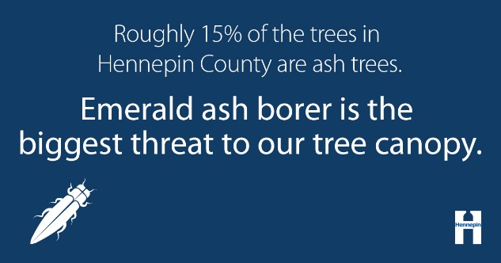
Social media posts

The threat of emerald ash borer
GIF: spread of emerald ash borer in Hennepin County
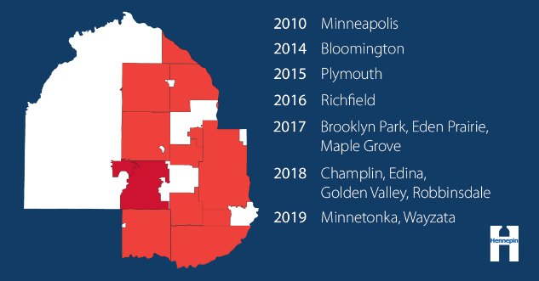
Facebook: There are over 1 million ash trees in Hennepin County, and 100 percent of them are threatened by the emerald ash borer. Since emerald ash borer was first found in Minneapolis in 2010, the infestation has spread to 13 cities in Hennepin County. And the impact if likely more widespread than we are currently aware. Learn how to identify ash trees and options for managing your trees at www.hennepin.us/ashtrees
Twitter: There are over 1 million ash trees in Hennepin County, and 100 percent of them are threatened by emerald ash borer. Learn more at www.hennepin.us/ashtrees

Identifying ash trees
Video: Identifying ash trees video
Facebook: Identifying and taking an inventory of your ash trees is the first step in deciding how to manage your trees from the threat of emerald ash borer. Learn how to identify ash trees and your options for managing them at www.hennepin.us/ashtrees
Twitter: Identifying and inventorying your ash trees is the first step in preparing for emerald ash borer. Find out more at www.hennepin.us/ashtrees

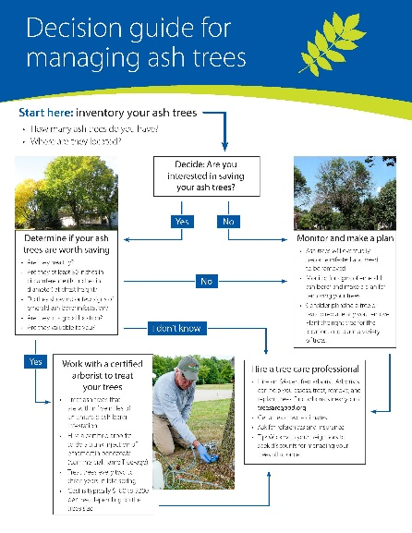
Decision guide for managing ash trees
Image: Ash tree decision guide
Facebook: Emerald ash borer, an invasive tree pest that attacks and kills ash trees, is the biggest current threat to our tree canopy. Most residents live within 15 miles of an infested ash tree, which means you should be taking steps now to determine if you have ash trees on your property and how you are going to manage them. Use our decision guide for managing ash trees to help you figure out what you are going to do. Link to https://www.hennepin.us/-/media/hennepinus/residents/environment/documents/ash-tree-decision-guide.pdf
Twitter: Use our decision guide for managing ash trees to help you prepare for the threat of emerald ash borer. Link to https://www.hennepin.us/-/media/hennepinus/residents/environment/documents/ash-tree-decision-guide.pdf

