Business recycling grants media kit

About the grants
Hennepin County is offering two types of grants to businesses for recycling and waste prevention in 2024. Applications for both grant programs will be accepted on an ongoing basis until mid-November 2024, or until the annual program budget is exhausted. Grant information can be accessed here: www.hennepin.us/businessrecycling#assistance-signs-grants. Use the article, social media posts, and images below to help promote the grants.
If you have questions about grants, contact a business recycling program specialist at businessrecycling@hennepin.us

Waste prevention grants
This grant program funds projects that prevent waste in the business sector. Areas of focus include replacing disposables with reusables, food waste prevention and innovative projects around research and development (to prevent waste). This year $300,000 is available for business waste prevention grants. The grant flyer (PDF) provides an overview of the program. Applications will be accepted on an ongoing basis until Monday, November 11, 2024, or until the annual program budget is exhausted, whichever occurs first.

Bin and compostable bag grants
The county is providing free resources and assistance for small businesses and nonprofit organizations to start or improve recycling and organics recycling. Applicants may select up to $3,000 worth of containers and compostable bags from the county's product list. The grant flyer (PDF) provides an overview of the program. Applications will be accepted on an ongoing basis until Monday, November 11, 2024, or until the annual program budget is exhausted, whichever occurs first.

Sample newsletter articles
Share the sample newsletter articles on your organization’s website or in your newsletters. These are editable so you can customize the length or message.

Waste prevention grants are available to businesses and nonprofit organizations
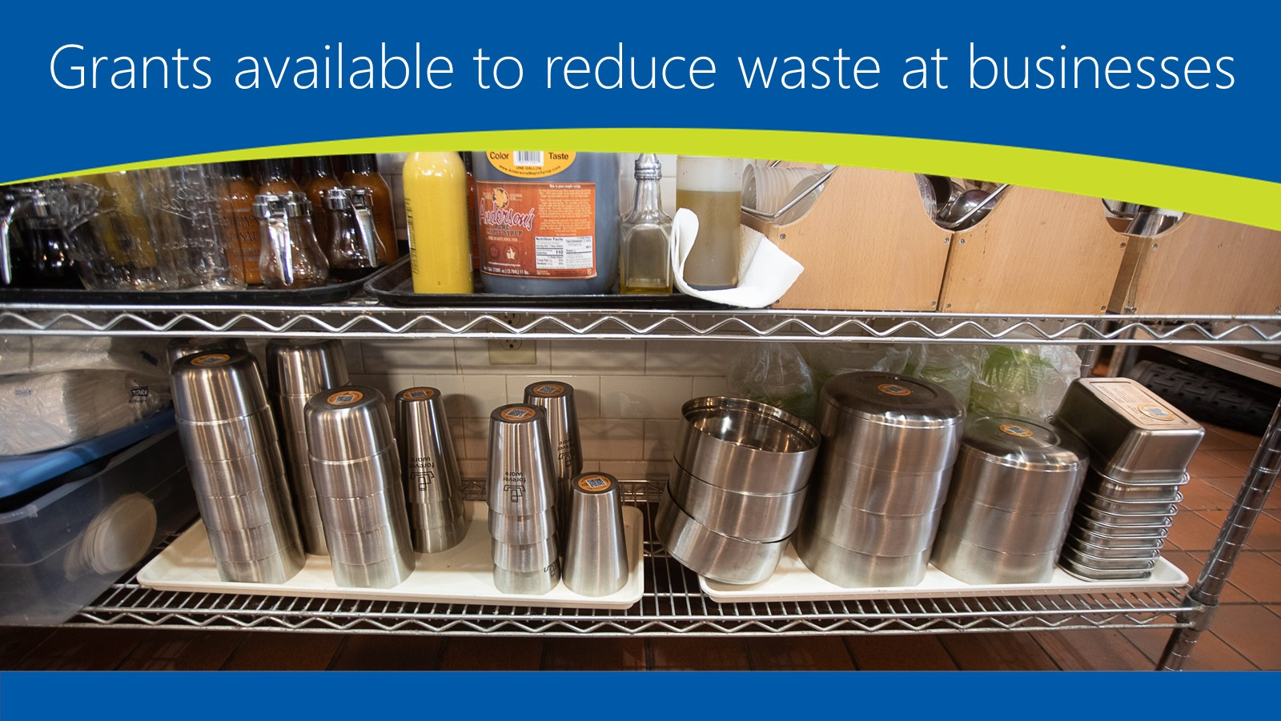
Are you a business, nonprofit organization or reuse retailer looking to reduce waste? Hennepin County has a grant program to support just that! This year, $300,000 is available to fund projects that focus on waste prevention, including:
- Replacing disposables with reusables
- Preventing wasted food
- Reusing and recovering goods and materials
- Supporting innovative waste prevention research and development
Apply for up to $50,000 for your project, with a minimum grant amount of $2,500. All projects must include matching funds of 25% of the total grant fund request. Review the grant guidelines (PDF) and flyer (PDF) for more information on the program and requirements.

Start the application process today!
Applications will be accepted until Monday, November 11, 2024, or until funding is exhausted, whichever occurs first. Visit the business recycling web page to learn more and begin the application process.

Bin and compostable bag grants for small businesses and nonprofit organizations
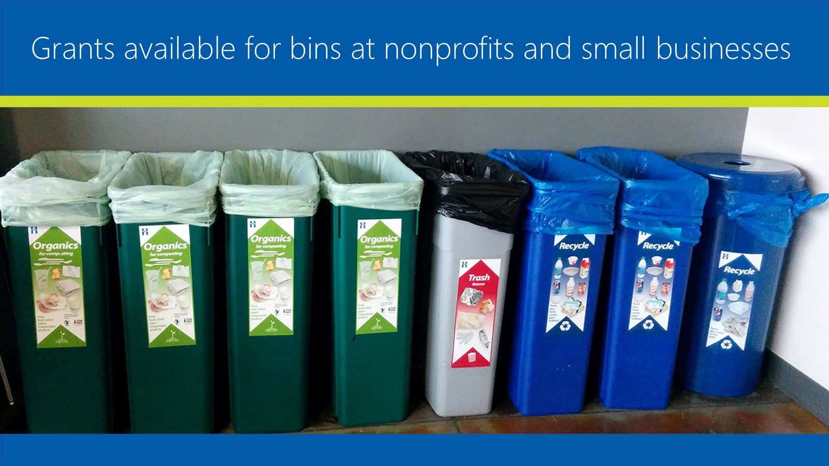
Hennepin County is offering free resources and support to small businesses and nonprofit organizations to start or enhance their recycling and organic waste recycling programs. Select up to $3,000 worth of containers and compostable bags from the county's product list to help you get started. Check out the grant guidelines (PDF) and flyer (PDF) for details on container and bag options.

Start the application process now
Applications will be accepted on an ongoing basis until Monday, November 11, 2024, or until funding is exhausted, whichever occurs first. Visit the business recycling web page to learn more and begin the process to get your bins and compostable bags.

Social media posts
Share these posts through your social media channels.

Facebook
Funding is available from Hennepin County to businesses and nonprofit organizations to prevent waste. Project ideas include replacing disposable packaging, dishes, utensils and cups with reusables, food waste prevention, and innovative research and development to prevent waste. Learn more: www.hennepin.us/businesswasteprevention
Recycling and organics for composting containers, along with compostable bags, are available to small businesses and nonprofit organizations through the Hennepin County bin and compostable bag program. Learn more and apply: www.hennepin.us/businessrecycling

Twitter
Funding is available from Hennepin County for businesses and nonprofits to prevent waste. Project ideas include replacing disposables with reusables, preventing food waste and innovative research and development to prevent waste. Learn more: www.hennepin.us/businesswasteprevention
Recycling and organics for composting containers, along with compostable bags, are available from Hennepin County for small businesses and nonprofit organizations through our bin and compostable bag program. Learn more and apply: www.hennepin.us/businessrecycling

Images
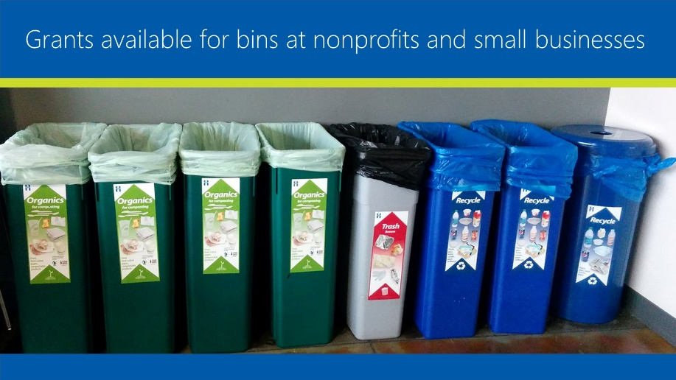
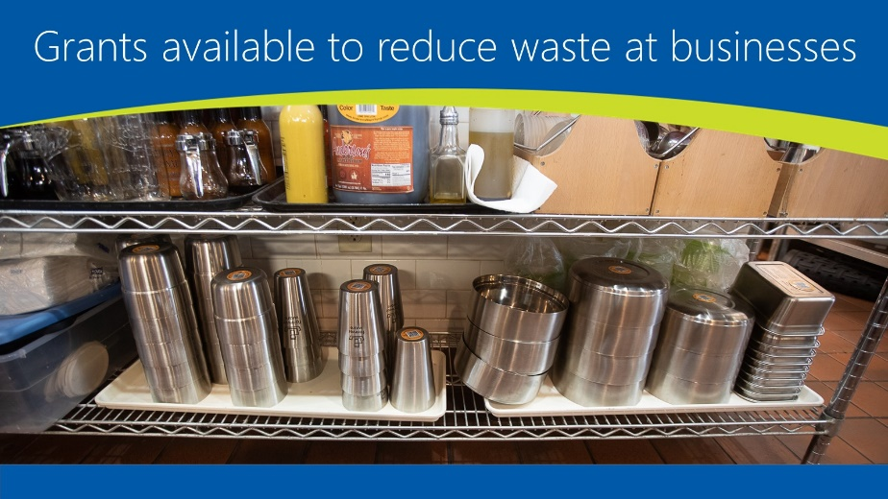
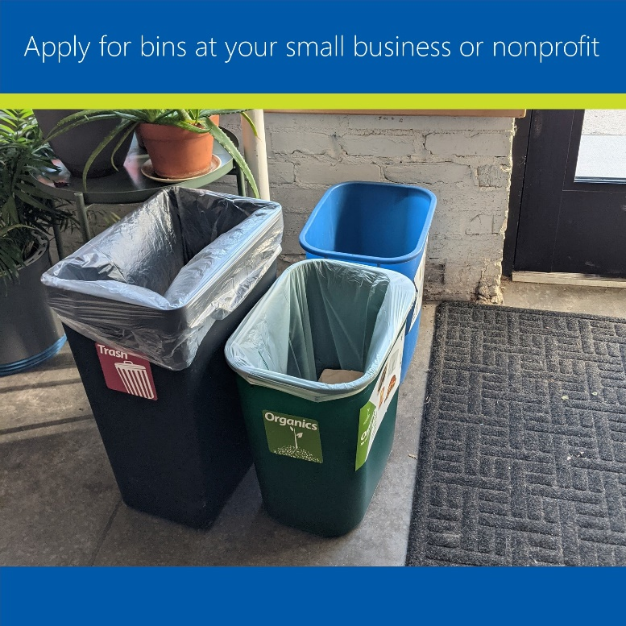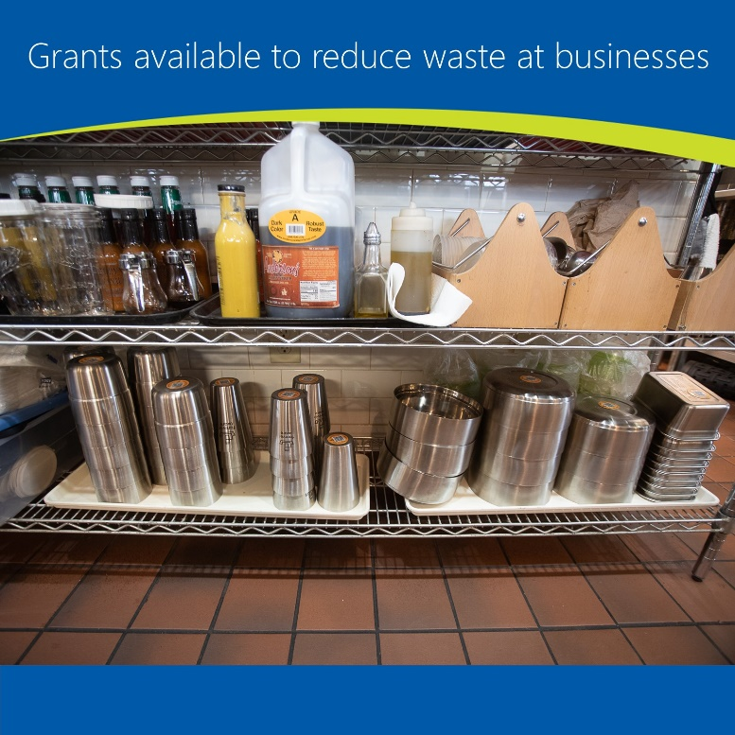

Contact
If you have questions about grants, contact a business recycling program specialist at businessrecycling@hennepin.us
Communications contact: Angie Ziobro, angie.ziobro@hennepin.us

