Building reuse grants media kit

About the building reuse grants program
Reusing and reducing construction and demolition waste is a key strategy of Hennepin County’s Climate Action Plan (PDF)
To help make the reuse and recycling of building materials more affordable, Hennepin County has funding available for a variety of building projects:
- Residential deconstruction grants: Funding for residential properties built prior to 1970 to deconstruct building materials for reuse. Residential deconstruction flyer (PDF)
- Commercial deconstruction grants: Funding for commercial properties, including multi-family apartment buildings over 4 units, to deconstruct building materials for reuse. Commercial deconstruction flyer (PDF)
- Structural move grants: Funding to physically relocate a building to another location, avoiding demolition waste and preserving the cultural and historical integrity of the building. Structural move flyer (PDF)
- Used building material installation grants: A new grant to “close the loop” by funding remodel, renovation, and new construction projects that incorporate used building materials into project designs. Used building material installation flyer (PDF)

Help spread the word
Please share messaging about our new grants with the communities you work with. You can download assets below. Materials are available in multiple languages.
- Use the sample newsletter article to share on your organization’s website or in your newsletters. These are editable so you can customize the length or message.
- Use the sample social media posts to share through your social media channels. These are editable so you can customize the message and website.
- Follow and reshare messages posted on the Hennepin County Environment and Energy social media channels: Hennepin Environment on Facebook, Hennepin Environment on Instagram, and @hennepinenviro on Twitter

Contact
For more information about the building reuse grants, contact:
- Christina Schmitt, environmental communications and outreach, christina.schmitt@hennepin.us

Promotional materials
To use images and graphics: Open image in your browser. Then right click on image and select Save picture as.
Images available: residential-deconstruction (JPG), commercial-deconstruction (JPG), house-move (JPG), used-building-material-treasure (JPG)
Blog about Hennepin County building reuse grants: Salvaging and reusing building materials to combat climate change
Social media and newsletter posts: Text and suggested images are below

Sample newsletter article

Building reuse grant funding available
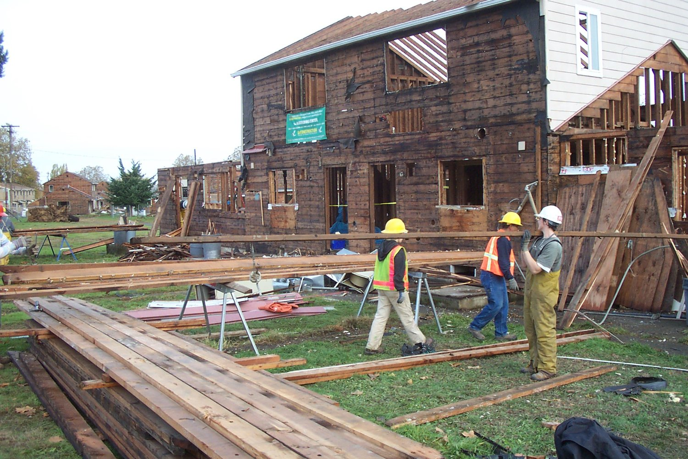When it’s time to remodel or demolish a building, materials have the potential to be reused or recycled. In fact, about 85% of the materials in a typical demolition project could be salvaged for reuse and kept out of the landfills through practices like deconstruction and structural moves.
Hennepin County has funding available for the following projects that reuse and recycle building materials in a variety of projects.
- Residential deconstruction grants: Funding for residential properties built prior to 1970 to deconstruct building materials for reuse. Residential deconstruction flyer (PDF)
- Commercial deconstruction grants: Funding for commercial properties, including multi-family apartment buildings over 4 units, to deconstruct building materials for reuse. Commercial deconstruction flyer (PDF)
- Structural move grants: Funding to physically relocate a building to another location, avoiding demolition waste and preserving the cultural and historical integrity of the building. Structural move flyer (PDF)
- Used building material installation grants: A new grant to “close the loop” by funding remodel, renovation, and new construction projects that incorporate used building materials into project designs. Used building material installation flyer (PDF)

Apply for a building reuse grant
Applicants must be a property owner or developer in Hennepin County. Projects must meet the reuse and disposal criteria. For more details on project eligibility and to complete an application, see Building reuse grants eligibility. Contact Olivia.Cashman@hennepin.us with any questions.

Social media posts

Residential deconstruction:
Home improvement projects are a big deal. Go green from the start, and that means deconstructing—rather than demolishing—the parts of your home that no longer work for you. Learn more about building reuse grants.
Suggested image: residential-deconstruction (JPG)

Commercial deconstruction:
Property managers: Think green when it's time to redo your buildings. Commercial deconstruction grants can offset the cost to salvage, reuse and recycle demo waste. Learn more.
Suggested image: commercial-deconstruction (JPG)

Used building material installation grant:
Want to add true craftsman character or retro flair to your home remodel? Install a salvaged treasure with a used building material installation grant. Learn more.
Suggested image: used-building-material-treasure (JPG)

Structural move grant:
Great old house on the chopping block? Move it! Funding is available to physically relocate a building to another location, avoiding demolition waste and preserving the cultural and historical integrity of the building.
Suggested image: house-move (JPG)
Post 6:
Batteries are a big part of our everyday lives. They can be found in so many devices and electronics that it’s easy to accidentally throw them in the trash.
But batteries can cause problems – like fires! – when thrown in the trash or recycling. Learn about different types of batteries, where they can be found and how to properly dispose of them.
https://www.hennepin.us/-/media/hennepinus/business/work-with-hennepin-county/environmental-education-resources/battery-hero-info-sheet-english.pdf
Suggested image: English-info (PNG)

