Be a Battery Hero media kit

About the campaign
Used batteries can cause fires when they end up in the trash or curbside recycling. To help promote proper battery disposal, Hennepin County is partnering with Ramsey and Washington Counties to raise awareness in the region with a campaign: Be a Battery Hero. The campaign is inspired by Marvel Comics, starring mischievous batteries that need to be put in their place.
Batteries can be recycled at Hennepin County’s drop-off facilities in Bloomington and Brooklyn Park.
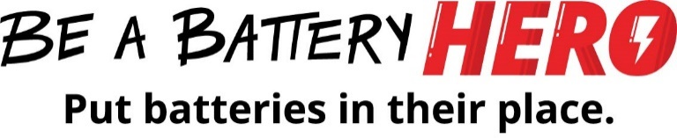

Help spread the word and Be a Battery Hero
Please share campaign messaging with the communities you work with. You can download campaign assets below. Materials are available in multiple languages.
- Use the sample newsletter article to share on your organization’s website or in your newsletters. These are editable so you can customize the length or message.
- Use the sample social media posts to share through your social media channels. These are editable so you can customize the message and website.
- Follow and reshare messages posted on the Hennepin County Environment and Energy social media channels: Hennepin Environment on Facebook, Hennepin Environment on Instagram, and @hennepinenviro on Twitter

Contact
For more information about the Be a Battery Hero campaign, contact:
- Christina Schmitt, environmental communications and outreach, christina.schmitt@hennepin.us

Promotional materials
Images available: English-1 (PNG), English-2 (PNG), English-3 (PNG), English-4 (PNG), English-5 (PNG), English-info (PNG), English-button (PNG), Hmong (PNG), Somali (PNG), Spanish (PNG)
To use images and graphics: Open image in your browser. Then right click on image and select Save picture as.
Battery informational PDF: English (PDF), Hmong (PDF), Somali (PDF), Spanish (PDF)
Newsletter articles: English (DOCX), Hmong (DOCX), Somali (DOCX), Spanish (DOCX)
Social media posts: Text and suggested images are below

Sample newsletter article

Be a Battery Hero: Put batteries in their place
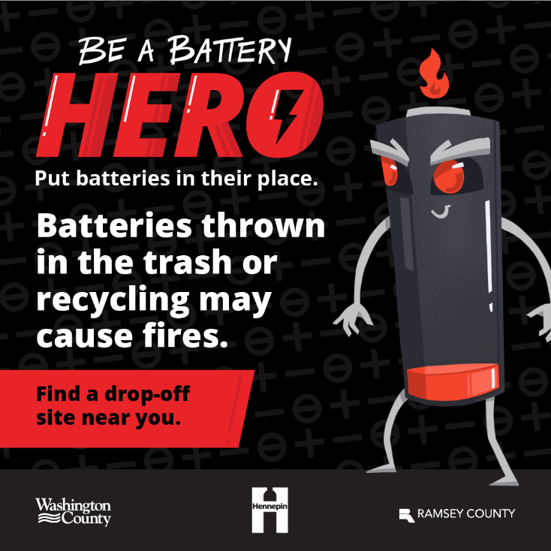
Batteries are a big part of our everyday lives. They are found in so many devices and electronics that it’s easy to accidentally throw them in the trash. But batteries can cause problems – like fires! – when thrown in the trash or recycling.
Be a Battery Hero! Put batteries in their place by dropping them off at a Hennepin County Drop-Off Facility: www.hennepin.us/batteryrecycling
If it lights up, makes a noise, or moves without a plug, it has a battery. Some batteries contain toxic metals, such as cadmium, lead, or mercury, which pose a threat to human health and the environment when batteries are improperly disposed. Learn more about different types of batteries: Battery info sheet (PDF).
With so many kinds of batteries, it can be confusing to know what to do with them. To make it simple, the county accepts all types of household batteries from residents at Hennepin County drop-off facilities.

Social media posts
Post 1:
Rechargeable nickel-metal hydride batteries can be found in things like power tools, two-way radios, digital cameras and cordless phones. Be a battery hero and bring all batteries to a drop-off location near you. hennepin.us/batteryrecycling
Suggested image: English-1 (PNG)
Post 2:
Button batteries can be easy to miss because they are found in so many household items like flashlights, watches, remote controls and toys. Don’t let batteries get past you! Be a battery hero and bring all batteries to a drop-off location near you. hennepin.us/batteryrecycling
Suggested image: English-2 (PNG)
Post 3:
Lithium-ion batteries can be dangerous if punctured or crushed. They can ignite or explode when damaged, putting lives and property at risk. Don’t let batteries get the best of you. Be a battery hero and bring all batteries to a drop-off location near you. hennepin.us/batteryrecycling
Suggested image: English-3 (PNG)
Post 4:
Nickel cadmium batteries contain cadmium, which can be toxic to the environment. These batteries can be found in things like power tools, garden path lights and remote-controlled cars. Be a battery hero and bring all batteries to a drop-off location near you. hennepin.us/batteryrecycling
Suggested image: English-4 (PNG)
Post 5:
If batteries are thrown in the trash or recycling, they can cause a spark which could start a fire and endanger people and property. Put batteries in their place by bringing them to a drop-off location near you. hennepin.us/batteryrecycling
Suggested image: English-5 (PNG)
Post 6:
Batteries are a big part of our everyday lives. They can be found in so many devices and electronics that it’s easy to accidentally throw them in the trash.
But batteries can cause problems – like fires! – when thrown in the trash or recycling. Learn about different types of batteries, where they can be found and how to properly dispose of them.
https://www.hennepin.us/-/media/hennepinus/business/work-with-hennepin-county/environmental-education-resources/battery-hero-info-sheet-english.pdf
Suggested image: English-info (PNG)

