Adopt-a-Drain media kit

About Adopt-a-Drain

The Adopt-a-Drain program is administered by Hamline University and the Metro Watershed Partners. Volunteer fifteen minutes, twice a month, for cleaner waterways and healthier communities. Storm drains flow directly to local lakes, rivers, and wetlands, acting as a conduit for trash and organic pollutants. Adopt-a-Drain asks residents to adopt a storm drain in their neighborhood and keep it clear of leaves, trash, and other debris to reduce water pollution.

Resources to promote Adopt-a-Drain
Ways to educate the public about Adopt-a-Drain:
- Use the sample newsletter articles to share on your organization’s website or in your newsletters. These are editable so you can customize the length or message.
- Use the sample social media posts to share through your social media channels. These are editable so you can customize the message and website.
- Visit the Adopt-a-Drain website: mn.adopt-a-drain.org
- Follow and reshare messages posted on the Hennepin County Environment and Energy social media channels: Hennepin Environment on Facebook, Hennepin Environment on Instagram, and @hennepinenviro on Twitter.
- Share the information and resources available at hennepin.us/environmentaleducation

Contact
For more information about Adopt-a-Drain, contact:
Emily Johnson, Environmental Educator, emily.johnson@hennepin.us

Sample newsletter article

Join the growing community of storm drain adopters
Hennepin County residents have prevented thousands of pounds of algae from growing in our lakes and streams by doing this one simple thing: adopting a storm drain!
Trash and decaying organic debris like fallen leaves are harmful to lakes, rivers, and streams. As leaves decompose, the resulting nutrients fuel algae growth. The unsightly algae blooms can cover the surface of polluted lakes, sucking oxygen out of the water and choking fish and native plants. Keeping leaves and other pollution out of our storm drains helps keep our lakes and rivers clean and clear.
Since the start of the Adopt-a-Drain program, over 10,800 people have adopted drains throughout Minnesota and collectively prevented 565,000 pounds of pollution from getting into our waters. This is the largest community engagement program of its type in the entire United States!
Getting involved is simple and only takes a few minutes. Just follow these steps:
- Adopt an available storm drain near you at mn.adopt-a-drain.org
- Gather the tools you'll need. These might include: gloves, rake, trash grabber, dust pan, safety vest, bins for separating waste, yard and/or trash bag.
- Collect and separate trash and recycling from the area around your adopted drain. To learn how to sort the litter you clean up, refer to the waste sort guide (PDF).
- Rake or sweep up leaves, sediment, and sticks and place in compost or yard waste bag.
- Report the debris you collect on mn.adopt-a-drain.org
Learn more about how to keep your neighborhood clean and protect local waterways: mn.adopt-a-drain.org

Sample newsletter article - Fall

This fall, protect our water and adopt a drain!
When leaves fall in your street, they wash into storm drains and then directly into the nearest lake or river—to feed unwanted algae growth next summer.
This fall, do something to stop the pollution! Adopt a storm drain. It takes 15 minutes, twice a month, to adopt a storm drain. Here are quick tips to get you started.
- Get your cleaning gear together: A broom, a rake, a trash grabber, gloves, an orange cone and/or safety vest, a snow shovel or dustpan, and a pail or yard waste bag.
- Never remove the grate or otherwise attempt to clean inside the catch basin. Clean only the surface of the storm drain grate and the area around it. If the drain seems to be plugged or have any problem, contact city staff and they will send workers to address the issue.
- Safety first. Wear gloves to protect your hands and be careful when picking up leaves and trash. You might want to use a trash grabber to collect debris. Consider wearing bright or reflective clothing. Do not stand or crouch on busy streets.
- Separate and dispose of the waste. Sort it into the appropriate bin: recyclables (glass and plastic bottles, cans), yard waste (leaves, grass clippings, sticks, and sediment), and trash. Sediment collected in the spring is not compostable, as it contains chemical residue from deicers used over the winter. Put it in the trash.
Learn more about how to keep your neighborhood clean and protect local waterways: mn.adopt-a-drain.org

Sample newsletter article - Winter
Protect water and care for your community by keeping storm drains clear in every season
A local MPR photojournalist’s efforts to clear a storm drain of snow and ice to address a street flooding issue went viral, according to a feature on Kare11, helping to highlight the effort thousands of Minnesotans put in to keep our storm drains clear year-round.
Nearly 20,000 storm drains have been adopted throughout the state by more than 10,500 people – and about half of those participants and drains adopted are in Hennepin County! In 2022 alone, Adopt-a-Drain participants report collecting 125,000 pounds of debris, protecting our lakes, rivers, and streams from pollution.
While the busiest times for drain cleanup are spring and fall, plenty can be done in winter to keep our roads and sidewalks safe and protect local water resources.
Here are some tips:
- Manually clear drains of snow and ice with a shovel – never use salt! Keeping them clear reduces local flooding, minimize puddles, and prevents debris from flowing into lakes, rivers, and streams.
- Avoid or minimize salt use on sidewalks and driveways. Shovel first, select the right product for the right conditions, and consider using sand or gravel for traction instead.
- Cleanup leftover salt and sand so it can be reused later and to prevent it from washing into storm drains – remember that anything that goes into the storm drain flows directly into local bodies of water.
Learn more and adopt a drain of your own at mn.adopt-a-drain.org.

Social media posts
To use images and graphics: right click on image and select Save as Picture.
Suggested hashtags: #AdoptADrainMN #AdoptADrain
Tag the official Adopt-a-Drain social media accounts:
- @Adopt-a-Drain MN on Facebook: https://www.facebook.com/AdoptaDrainMN
- @AdoptaDrainMN on Twitter: https://twitter.com/AdoptaDrainMN
- @AdoptaDrainMN on Instagram: https://www.instagram.com/adoptadrainmn/

General messages

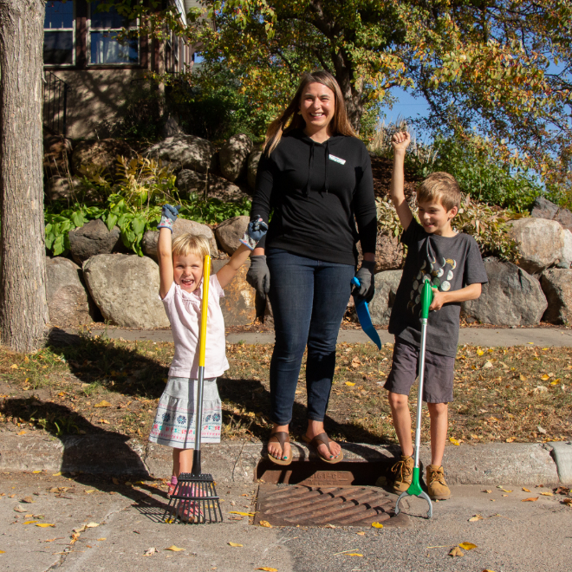
Post 1: Do your part
Facebook: Do your part to keep leaves and trash from washing down storm drains and into lakes and streams. Adopt a drain! Tip: Never remove the grate or otherwise attempt to clean inside the catch basin. Clean only the surface of the storm drain grate and the area around it. If the drain seems to be plugged, contact city staff and they will send workers to address the issue. Learn more and adopt a drain of your own: mn.adopt-a-drain.org
Twitter: Do your part to keep leaves and trash from washing down storm drains and into lakes and streams. Adopt a drain! Never remove the grate or try to clean inside the catch basin. Clean only the surface of the storm drain and the area around it. Learn more: mn.adopt-a-drain.org
Instagram: Do your part to keep leaves and trash from washing down storm drains and into lakes and streams. Adopt a drain! Tip: Never remove the grate or otherwise attempt to clean inside the catch basin. Clean only the surface of the storm drain grate and the area around it. If the drain seems to be plugged, contact city staff and they will send workers to address the issue.

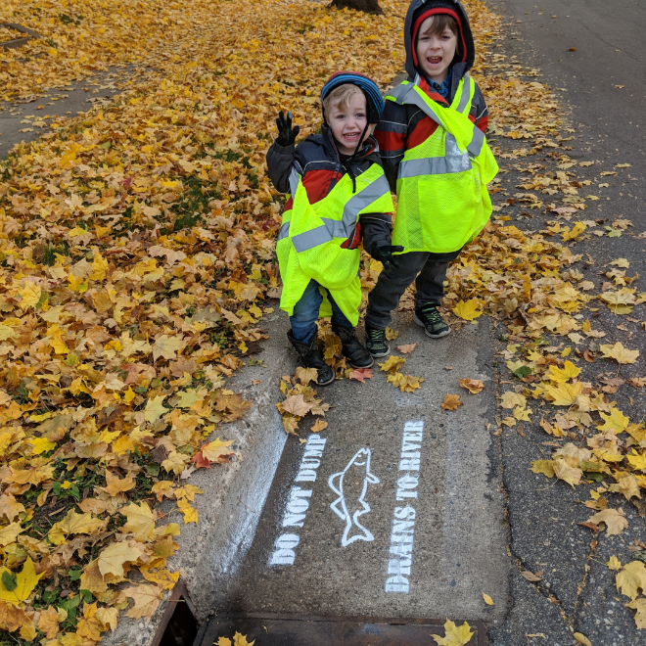
Post 2: Safety first
Facebook: Keep leaves and trash from washing into lakes and rivers. Adopt a drain! Safety first: Wear gloves to protect your hands and be careful when picking up leaves and trash. You might want to use a trash grabber to collect debris. Consider wearing bright or reflective clothing. Do not stand or crouch on busy streets. Learn more: mn.adopt-a-drain.org
Twitter: Keep leaves from washing into lakes and rivers. Adopt a drain! Safety first: Wear gloves to protect your hands, use a trash grabber to collect debris, wear bright or reflective clothing, and do not stand or crouch on busy streets. Learn more: mn.adopt-a-drain.org
Instagram: Keep leaves and trash from washing into lakes and rivers. Adopt a drain! Safety first: Wear gloves to protect your hands and be careful when picking up leaves and trash. You might want to use a trash grabber to collect debris. Consider wearing bright or reflective clothing. Do not stand or crouch on busy streets.

Messages for spring and summer

Post 1: Family-friendly
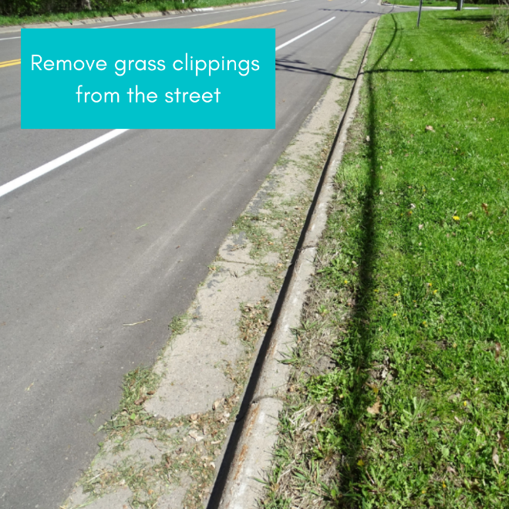
Facebook/Twitter: Are you looking for a family-friendly, environmentally oriented, outdoor activity for the summer? Cleaning your storm drain is a “grate” option! Join in on the fun by adopting a drain at mn.adopt-a-drain.org

Post 2: Grass clippings
Facebook/Twitter: Remember to keep grass clippings off the street and pavement when you mow your lawn! Sweep them back onto your lawn so they don't wash down the nearest storm drain and into your local lake or stream where they would become food for algae. Learn more: mn.adopt-a-drain.org
Instagram: Remember to keep grass clippings off the street and pavement when you mow your lawn! Sweep them back onto your lawn so they don't wash down the nearest storm drain and into your local lake or stream where they would become food for algae.

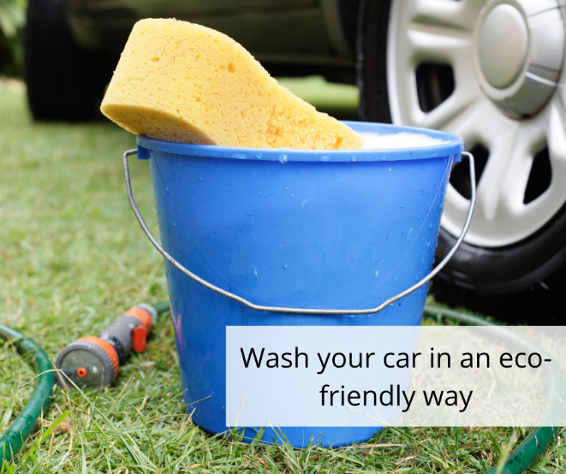
Post 3: Wash your vehicle
Facebook: Wash your vehicle the eco-friendly way this summer! If you wash your car in your street or driveway, soapy, polluted, untreated wash water may run into storm drains and into our lakes and streams. Washing your vehicle at a car wash is best because they treat and recycle polluted wash water. If you do wash your car at home, please use eco-friendly soap and wash it over grass or gravel where the wash water will be absorbed. Help protect our lakes, creeks and the Mississippi River by washing your vehicle away from storm drains! Learn more: mn.adopt-a-drain.org
Twitter: Help protect our lakes by washing your vehicle away from storm drains! If you wash your car at home, use eco-friendly soap and wash it over grass or gravel where the wash water will be absorbed. Learn more: mn.adopt-a-drain.org
Instagram: Wash your vehicle the eco-friendly way this summer! If you wash your car in your street or driveway, soapy, polluted, untreated wash water may run into storm drains and into our lakes and streams. Washing your vehicle at a car wash is best because they treat and recycle polluted wash water. If you do wash your car at home, please use eco-friendly soap and wash it over grass or gravel where the wash water will be absorbed. Help protect our lakes, creeks and the Mississippi River by washing your vehicle away from storm drains!

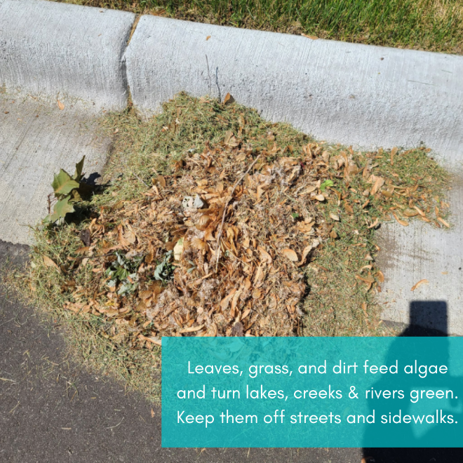
Post 4: Organic debris
Facebook: Help prevent organic debris like this from going down a storm drain! While leaves, grass and dirt might not seem like pollution because they’re “organic” they feed algae and turn lakes and rivers green. Rain washes down anything that is on the streets into storm drains and into our local lakes, streams, and rivers. Help keep our water clean by adopting a drain near you! mn.adopt-a-drain.org
Twitter: Prevent organic debris like leaves, grass and dirt from going down a storm drain! Rain washes down anything that is on the streets into storm drains and into our local lakes, streams, and rivers to become food for algae. Adopt a drain near you: mn.adopt-a-drain.org
Instagram: Help prevent organic debris like this from going down a storm drain! While leaves, grass and dirt might not seem like pollution because they’re “organic” they feed algae and turn lakes and rivers green. Rain washes down anything that is on the streets into storm drains and into our local lakes, streams, and rivers. Help keep our water clean by adopting a drain near you!

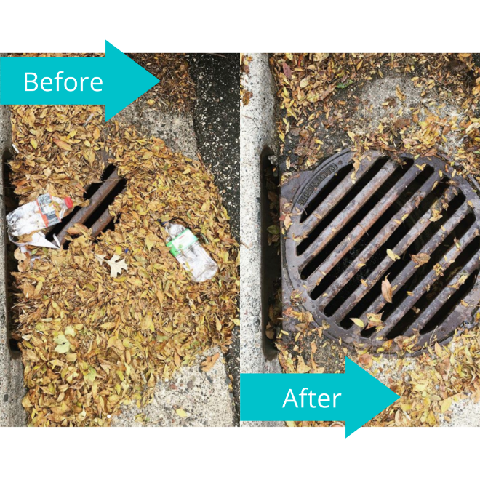
Messages for Fall

Post 1: Fall leaves
Facebook/Twitter: When leaves fall in the street, they wash into storm drains and into the nearest lake or river—to feed unwanted algae growth next summer. This fall, stop the pollution and adopt a storm drain! It takes 15 minutes, twice a month. Learn more: mn.adopt-a-drain.org
Instagram: When leaves fall in the street, they wash into storm drains and into the nearest lake or river—to feed unwanted algae growth next summer. This fall, stop the pollution and adopt a storm drain! It takes 15 minutes, twice a month.

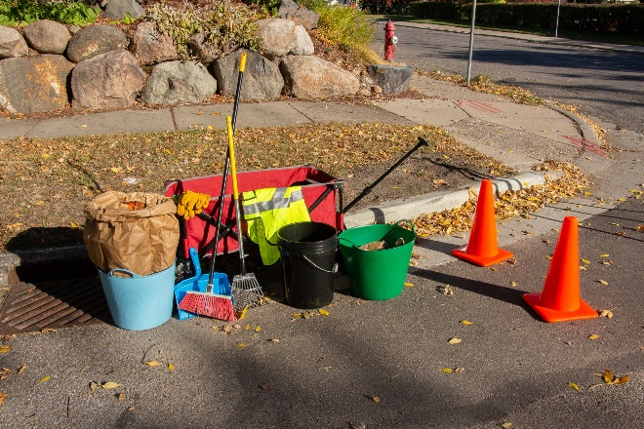
Post 2: Gather your gear
Facebook/Twitter: Keep leaves from washing into lakes and rivers. Adopt a drain! First thing to do is get your gear together: a broom, a rake, a trash grabber, gloves, an orange cone and/or safety vest, a snow shovel or dustpan, and a pail or yard waste bag. Learn more: mn.adopt-a-drain.org
Instagram: Keep leaves from washing into lakes and rivers. Adopt a drain! First thing to do is get your gear together: a broom, a rake, a trash grabber, gloves, an orange cone and/or safety vest, a snow shovel or dustpan, and a pail or yard waste bag.

Post 3: Fall is the perfect time
Facebook/Twitter: Fall is the perfect time to adopt a storm drain! Keeping fallen leaves out of storm drains is vital to keeping our waterways clean. Even though leaves are natural, just five bags worth of leaves can result in up to 1,000 pounds of algae blooms! mn.adopt-a-drain.org
Instagram: Fall is the perfect time to adopt a storm drain! Keeping fallen leaves out of storm drains is vital to keeping our waterways clean. Even though leaves are natural, just five bags worth of leaves can result in up to 1,000 pounds of algae blooms!

Messages for Winter

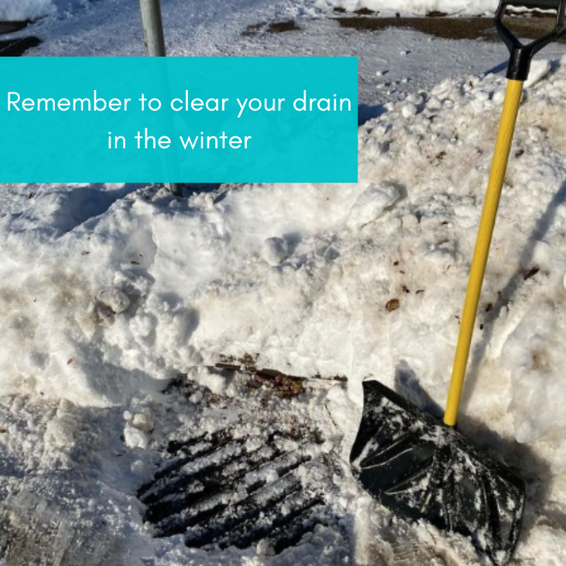
Post 1: Frozen drains
Facebook: Your storm drain is hard at work, even in the winter! Clear your storm drains of snow and ice to prevent localized flooding. Water from storm drains goes directly into our local waterways, so it's important to keep them clear to prevent flooding. Always use a shovel to clear off drains - never use salt! mn.adopt-a-drain.org
Twitter: Remember to keep your storm drains clear of snow so they don't freeze. Water from storm drains goes directly into our local waters, so it's important to keep them clear to prevent flooding. Always use a shovel to clear off drains - never use salt! mn.adopt-a-drain.org
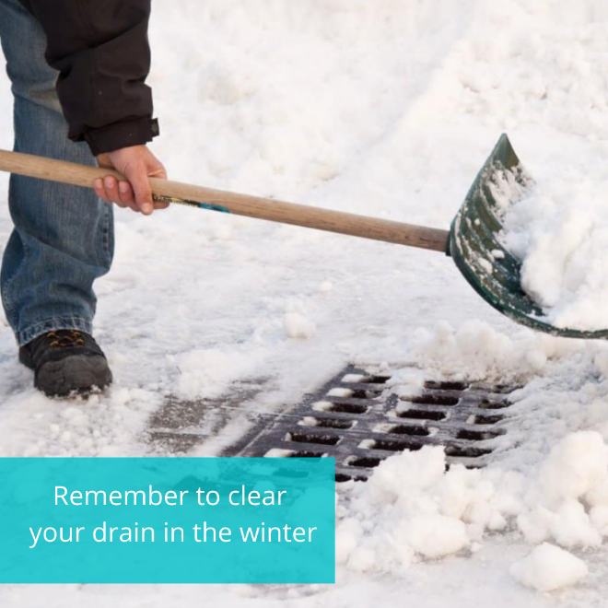
Instagram: Your storm drain is hard at work, even in the winter! Clear your storm drains of snow and ice to prevent localized flooding. Water from storm drains goes directly into our local waterways, so it's important to keep them clear to prevent flooding. Always use a shovel to clear off drains - never use salt!

Post 2: Prevent flooding
Facebook/Twitter: Cleaning your adopted drains isn’t just a warm-weather activity! To prevent flooding, keep your drains clear of snow, ice, and debris during the winter. Always remove snow with a shovel - never use salt to clear storm drains. mn.adopt-a-drain.org
Instagram: Cleaning your adopted drains isn’t just a warm-weather activity! To prevent flooding, keep your drains clear of snow, ice, and debris during the winter. Always remove snow with a shovel - never use salt to clear storm drains.

Additional images
To use images and graphics: right click on image and select Save as Picture.
