Maalinta Dhulka 2022

Habka warbaahinta
Tasiilaadyo lagu horumarinayo Maalinta Dhulka
Ways to educate the public:
- Use the sample newsletter article to share on your organization’s website or in your newsletters. These are editable so you can customize the length or message.
- Use the sample social media posts to share through your social media channels. These are editable so you can customize the message and website.
- Share Celebrate Earth Day 2022 article on the Climate Action website: www.hennepin.us/climate-action/what-we-can-do/earth-day-2022
- Share Earth Day 2022 webpage: hennepin.us/earth-day
- Follow and reshare messages posted on the Hennepin County Environment and Energy social media channels: Hennepin Environment on Facebook, Hennepin Environment on Instagram, and @hennepinenviro on Twitter. #EarthDay2022 #HennepinEarthDay2022 #HennepinClimateAction

Tusmo maqaal warside

Maalinta Dhulka 2022: Waa in cimilada wax laga qabto
Maalintan Dhulka, waa in si shakhsi ah iyo si bulsho ahaaneed aan diiradda u wada saarno sidii aan wax uga qaban lahayn isbeddelka cimilada.

Cimiladu waa isbeddeleyaa, oo xalkeedana waa in ay dadka oo dhan qeyb ka qaataan
Isbeddelka cimilada waa wax xal loo heli karo, waan ognahay xalkeeda, balse waa in aan ka wada shaqeyno.

Siyaabaha ugu saameynta badan ee cimilada wax looga qaban karo:
- Waa in la sameeyo wixii cimilo ahaan noo fiicaan
- Waa in la helo tamar nadiif ah oo la keydsan karo
- Waa in aan la khasaarin cunto oo lagu tiirsanaado dalagyada beeraha
- Waa in la raaco qaab-nololeed qashin yar oo la cuno wixii lagama maarmaanka ah
- Waa in aad loogu ololeeyo adeegsiga kheyraadka dabiiciga ah
- Waa in laga hadlo isbeddelka cimilada oo qeyb laga noqdo bulshada

Wax badan ka baro Qorshaha Waxqabadka Cimilada ee hennepin.us/climate-action oo ogow barnaamijyada iyo tasiilaadka laguu heli karo si laguuga caawiyo in aad ficil sameyso hennepin.us/earth-day.

Social media posts

Post 1: Guud ahaan Maalinta Dhulka
Waxaa jira siyaabo badan oo loogu dabbaaldegayo Maalinta Dhulka ee sannadkan! Gurigaaga ma ku tacban doontaa beer, oo baaskiil ma ku dhex wadan kartaa deegaankaaga, ama ma ka qeybqaadan doontaa ololaha nadaafadda bulshada? Fikrado badan iyo maabka waxqabadka ka eego halkan: hennepin.us/earth-day. Bannaanka u bax oo ku raaxayso!

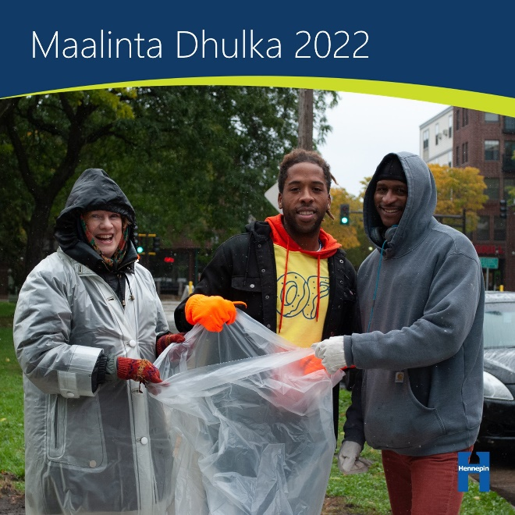

Post 2: Dadka la wadaag fikradahaaga mustaqbalka ee qashin-la'aanta
Maxaa fikrado ah oo aad haysaa si aad u yareyso qashinka iyo si aad u badiso dibu-warshadeynta? Nagula wadaag beheardhennepin.org/zero-waste-future

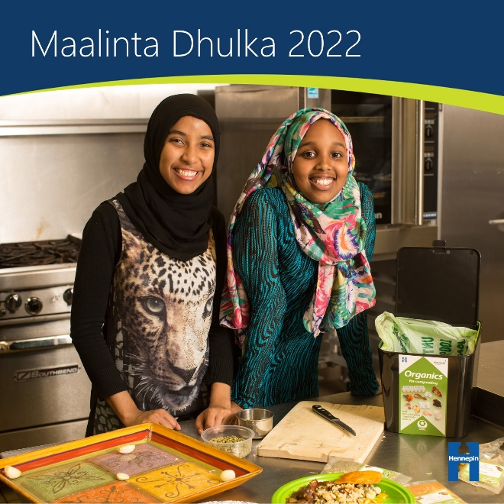

Post 3: Dhaqaaleynta tamarta guriga
In kasta oo maalgelinta tamarta nadiifka ah ay tahay tallaabada ugu fiican ee lagu yareyn karo qiiqa hawada galaya, haddana waxaa jira hab lagu keydsan karo tamarta lagu isticmaalo guriga! Hoos u dhig heerkulka kuleyliyaha markaad guriga ka maqan tahay, xir daaqadaha iyo albaabbada si aysan tamartu u khasaarin, ama baaris ku samee tamarta guriga si aad u hesho hab kale oo aad tamarta u dhaqaaleysan karto.

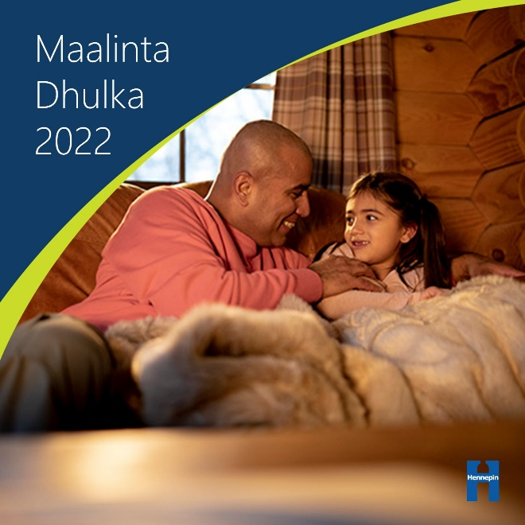

Post 4: Ha khasaarin cuntada
In ka badan 40% cuntada Mareykanka waa la daadiyaa, oo waxaa ka dhalanaya khasaare isugu jira tamarta iyo dhaqaalaha la geliyo beerista, raridda, iyo diyaarinta cuntada. Baro sida saxda ah ee loo keydsado cuntada si aad u cunto wax kugu filan iyo si aadan wax cunto ah u khasaarin.

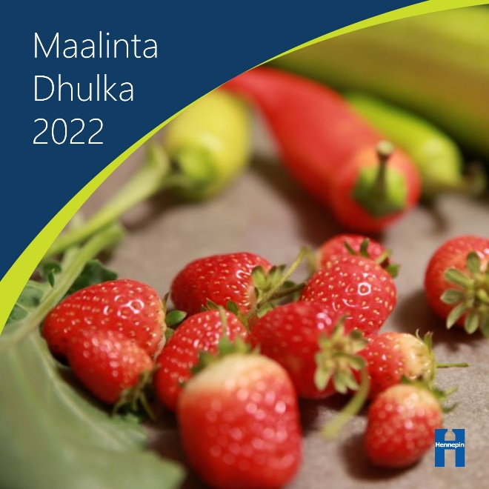

Post 5: Dhul-nafaqeyn
Cuntooyinka soo hara ee aan la cuni karin waa in bacrimin ahaan dhulka loogu nafaqeeyo! Ka qeybqaado barnaamijka dibu-warshadeynta qashinka oo bilow in aad barxadda gurigaaga ku daadiso cuntada idinka soo harta si aysan u khasaarin cuntada aydnaan rabin.

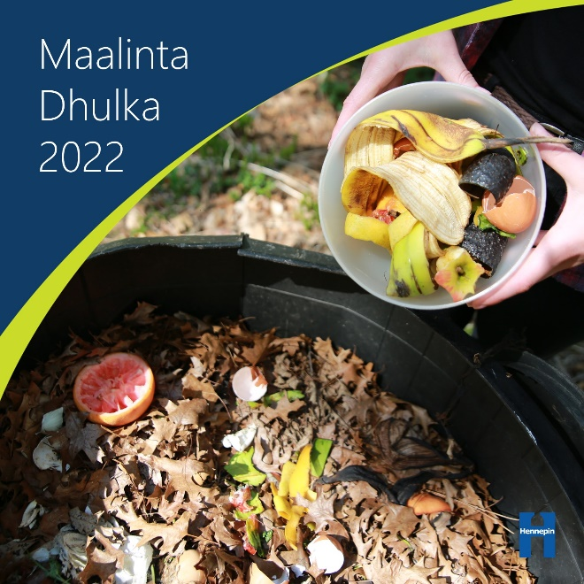

Post 6: Iska yaree balaastikada
Inta badan balaastikada waxaa laga sameeyaa saliid iyo kiimikooyin – oo qiiqa warshadaha iyo dhuxul-dhagaxda ayaa keena isbeddelka cimilada. Si wax looga qabto isbeddelka cimilada waa in mar kasta la isticmaalo boorsooyin ama baco, waa in aan la istimaalin bacaha balaastiigga ah waxyeello lagu ogyahay awgeed, oo waa in la soo iibsado cuntooyinka aan baakadeysneyn.

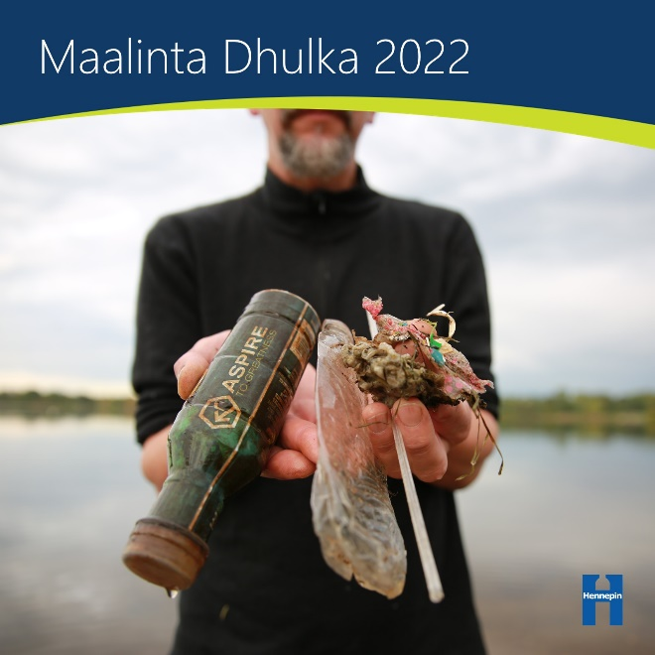

Post 7: Geedaha
Geeduhu waxay hawada ka saaraan kaarboonka sunta ah ee laba ogsaaydh oo dhumucda laamahooda ayey ku keydiyaan kaarboonka. Waa in ay geedo kaagu baxaan agagaarka gurigaaga, waa in aad sii beerato geedo cusub, oo waa in aad ka qeybqaadato daryeelka iyo beerista dhirta ee ay bulshadu sameyso.

