Hnub Tiv Thaiv Ntiaj Teb Xyoo 2022

Tsab Xov Xwm
Cov peev txheej los txhawb Hnub Tiv Thaiv Ntiaj Teb
Ways to educate the public:
- Use the sample newsletter article to share on your organization’s website or in your newsletters. These are editable so you can customize the length or message.
- Use the sample social media posts to share through your social media channels. These are editable so you can customize the message and website.
- Share Celebrate Earth Day 2022 article on the Climate Action website: www.hennepin.us/climate-action/what-we-can-do/earth-day-2022
- Share Earth Day 2022 webpage: hennepin.us/earth-day
- Follow and reshare messages posted on the Hennepin County Environment and Energy social media channels: Hennepin Environment on Facebook, Hennepin Environment on Instagram, and @hennepinenviro on Twitter. #EarthDay2022 #HennepinEarthDay2022 #HennepinClimateAction

Tus Qauv ntawm tsab xov xwm

Hnub Tiv Thaiv Ntiaj Teb Xyoo 2022: Kev nqis tes hloov huab cua
Hnub Tiv Thaiv Ntiaj Teb no, peb tab tom tsom mus rau tias yuav ua li cas peb tuaj yeem nqis tes los daws kev hloov pauv huab cua raws li tib neeg thiab hauv zej zog.

Peb cov huab cua hloov pauv zuj zus, thiab peb txhua tus yuav tsum yog ib feem ntawm kev daws teeb meem
Kev hloov pauv huab cua yog daws tau, peb paub cov kev daws teeb meem, thiab peb nyob hauv qhov no ua ke.
Cov kev cuam tshuam tshaj plaws ntawm kev nqis tes hloov huab cua yog:
- Ib ncig ntawm txoj kev nyab xeeb
- Hloov mus rau lub zog tauj dua tshiab thiab txuag lub zog
- Tsis txhob nkim zaub mov thiab noj mov zaub ntau dua
- Ua neej nyob tsis muaj khib nyiab thiab xyum noj mov kom zoo
- Ua tus saib xyuas ntawm peb cov khoom siv hauv ntiaj teb
- Tham txog kev hloov pauv huab cua thiab koom nrog hauv koj lub zej zog

Kawm paub ntxiv txog Kev Nqis Tes Hloov Huab Cua mus rau ntawm hennepin.us/climate-action thiab tshawb nrhiav cov kev pab cuam thiab cov peev txheej muaj los pab koj nyob rau ntawmhennepin.us/earth-day.

Social media posts

Post 1: Hnub Tiv Thaiv Ntiaj Teb
Muaj ntau txoj hauv kev los ua kev zoo rau Hnub Tiv Thaiv Ntiaj Teb xyoo no! Koj puas yuav muaj ib lub vaj, tsheb kauj vab nyob ib puag ncig koj lub zej zog, los sis koom nrog kev ua si hauv zej zog? Nrhiav ntau lub tswv yim thiab daim ntawv qhia txog cov xwm txheej tau nyob rau ntawm no: hennepin.us/earth-day. Tawm sab nrauv thiab txaus siab!
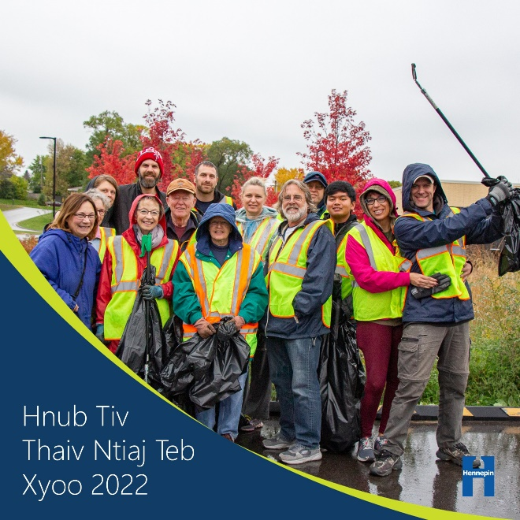

Post 2: Qhia koj cov tswv yim pab rau yav tom ntej kom tsis pub nkim pov tseg
Koj muaj tswv yim dab tsi los txo cov khib nyiab thiab rov ua dua tshiab? Qhia rau ntawm beheardhennepin.org/zero-waste-future
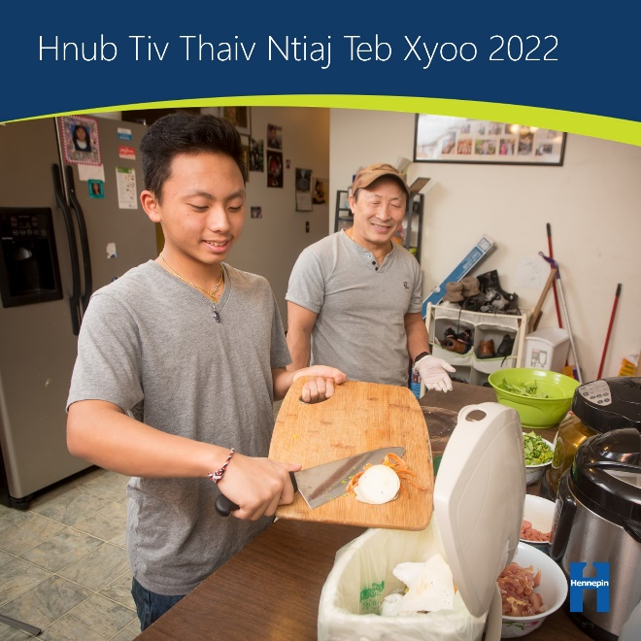

Post 3: Kev siv hluav taws xob hauv tsev
Thaum kev nqis peev hauv lub zog tauj dua tshiab yog ib kauj ruam muaj zog los txo cov pa hluav taws xob hauv tsev cog khoom, muaj peev xwm loj rau kev txuag hluav taws xob hauv tsev! Teem koj lub ntsuas sov kom qis dua thaum koj nyob deb, kaw cov dej xau hauv qhov rais thiab qhov rooj, los sis ua qhov kev tshuaj xyuas lub zog hauv tsev kom pom lwm txoj hauv kev txuag hluav taws xob.
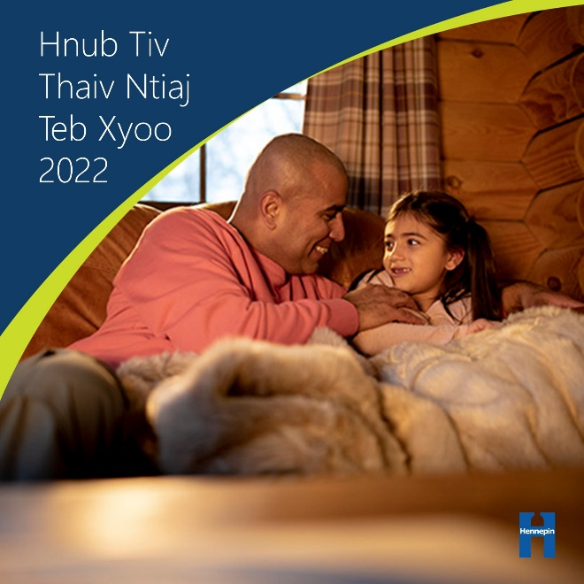

Post 4: Tsis txhob nkim zaub mov
Ntau tshaj 40% ntawm cov zaub mov hauv Asmeskas yog nkim, uas nkim lub zog thiab cov peev txheej uas nkag mus rau hauv kev loj hlob, thauj mus los, thiab ua cov zaub mov ntawv. Kawm paub yuav ua li cas khaws zaub mov kom zoo kom nws noj tsis txhob muaj pov tseg.
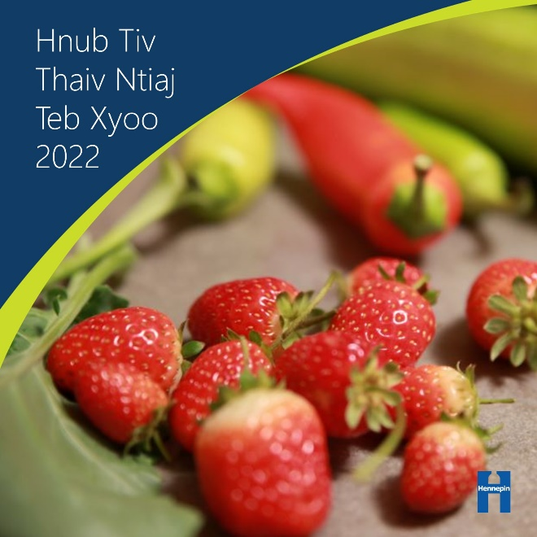

Post 5: Kev rau chiv
Cov khoom noj uas tsis tuaj yeem noj tau yog cov neeg sib tw zoo rau kev ua qoob loo! Koom nrog cov kev pab cuam kev ywg dej rov ua dua tshiab los sis pib rov ua dua tom tsev kom tso cov khoom pov tseg uas koj tsis tuaj yeem zam kom siv tau zoo.
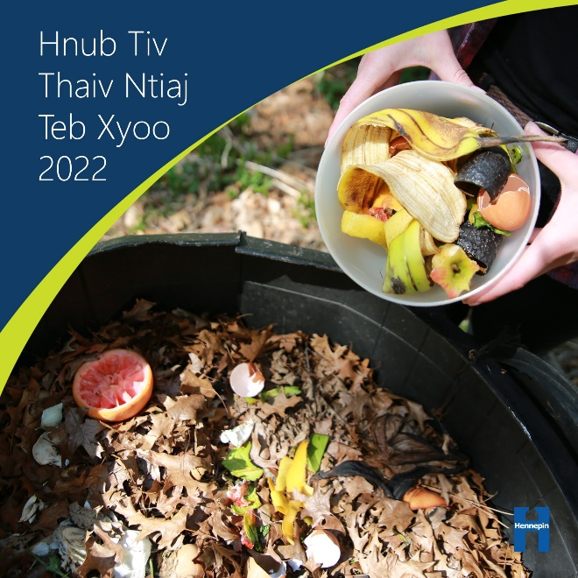

Post 6: Txo hnab yas
Feem ntau cov hnab yas yog tsim los ntawm cov roj thiab roj too uas ua rau muaj kev hloov pauv huab cua. Hais txog kev hloov pauv huab cua los ntawm kev siv lub hnab yas kom rov qab siv tau, mus yuav cov thawv ntim khoom loj, zam cov khoom tsis zoo, thiab yuav cov khoom uas tsis ntim khoom.
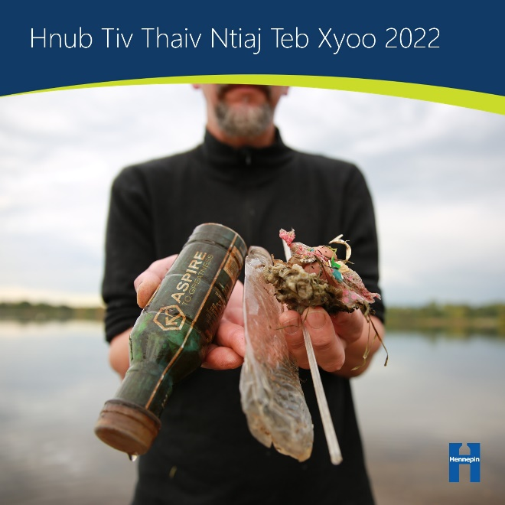

Post 7: Xyoob ntoo
Cov ntoo tshem cov pa roj carbon monoxide tawm ntawm qhov chaw thiab khaws cov pa roj carbon monoxide hauv lawv cov ntoo. Saib xyuas cov ntoo uas paub tab ntawm koj lub vaj tse, nrhiav sij hawm los cog ntoo tshiab, thiab koom nrog kev saib xyuas ntoo thiab cog rau hauv koj lub zej zog
