Earth Day 2022 media kit

Resources to promote Earth Day
Ways to educate the public:
- Use the sample newsletter article to share on your organization’s website or in your newsletters. These are editable so you can customize the length or message.
- Use the sample social media posts to share through your social media channels. These are editable so you can customize the message and website.
- Share Celebrate Earth Day 2022 article on the Climate Action website: www.hennepin.us/climate-action/what-we-can-do/earth-day-2022
- Share Earth Day 2022 webpage: hennepin.us/earth-day
- Follow and reshare messages posted on the Hennepin County Environment and Energy social media channels: Hennepin Environment on Facebook, Hennepin Environment on Instagram, and @hennepinenviro on Twitter. #EarthDay2022 #HennepinEarthDay2022 #HennepinClimateAction

Contact
For more information, contact:
Emily Johnson, Environmental Educator, emily.johnson@hennepin.us

Sample newsletter article – long version

Earth Day 2022: Take climate action
Climate change is one of the most pressing challenges the county faces because of its significant environmental, societal, and economic impacts on both a global and local level. This Earth Day, we are focusing on how we can take action to address climate change as individuals and as a community.

Our climate is changing, and we all need to be part of the solution
Climate change is solvable, we know the solutions, and we’re in this together. Even in Minnesota, we are starting to notice the effects of climate change from warming winter temperatures to more extreme precipitation events. Thankfully, most people are interested in creating a climate-friendly future. To create that future, we need to be willing to take significant action on the most impactful changes.
The most impactful ways to take climate action are:
- Get around in a sustainable way
- Switch to renewable energy and conserve energy
- Avoid wasting food and eat a more plant-based diet
- Live a low-waste lifestyle and practice thoughtful consumption
- Be a good steward of our natural resources
- Talk about climate change and get involved in your community
In 2021, Hennepin County launched the county’s Climate Action Plan to guide our response to climate change. Pursuing the strategies laid out in the plan will enable us to create a better future for ourselves and future generations. The plan includes 5 goals, 29 strategies, and 145 tactics. The strategies focus on cutting greenhouse gas emissions and adapting to our changing climate in ways that reduce vulnerabilities and ensure a more equitable and resilient Hennepin County.
Learn more about the Climate Action Plan at hennepin.us/climate-action and discover programs and resources available to help you take action at hennepin.us/earth-day.

Sample newsletter article – short version

Earth Day 2022: Take climate action
Climate change is one of the most pressing challenges the county faces because of its significant environmental, societal, and economic impacts on both a global and local level. This Earth Day, we are focusing on how we can take action to address climate change as individuals and as a community.

Our climate is changing, and we all need to be part of the solution
Climate change is solvable, we know the solutions, and we’re in this together. Most people are interested in creating a climate-friendly future. To create that future, we need to be willing to take significant action on the most impactful changes.
The most impactful ways to take climate action are:
- Get around in a sustainable way
- Switch to renewable energy and conserve energy
- Avoid wasting food and eat a more plant-based diet
- Live a low-waste lifestyle and practice thoughtful consumption
- Be a good steward of our natural resources
- Talk about climate change and get involved in your community
Learn more about the Climate Action Plan at hennepin.us/climate-action and discover programs and resources available to help you take action at hennepin.us/earth-day.

Social media posts
Suggested hashtags: #EarthDay2022 #HennepinEarthDay2022 #HennepinClimateAction
To use images and graphics: right click on image and select save as picture. Alt text for you to use is included with the pictures and graphics

Post 1: Promote Earth Day 2022 webpage (no climate change message)
Facebook: There are so many ways to celebrate Earth Day this year! Will you plant a garden, bike around your neighborhood, or participate in a community clean up event? Find more ideas and a map of events here: hennepin.us/earth-day. Get outside and enjoy! #EarthDay2022
Twitter: There are so many ways to celebrate Earth Day this year! Will you plant a garden, bike around your neighborhood, or participate in a community clean up event? Find more ideas and a map of events here: hennepin.us/earth-day. Get outside and enjoy! #EarthDay2022
Instagram: There are so many ways to celebrate Earth Day this year! Will you plant a garden, bike around your neighborhood, or participate in a community clean up event? Find more ideas and a map of events at the link in our bio. Get outside and enjoy! #EarthDay2022
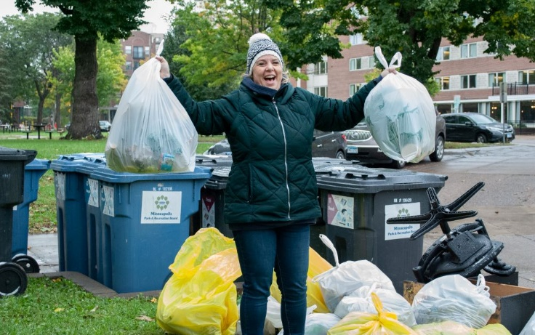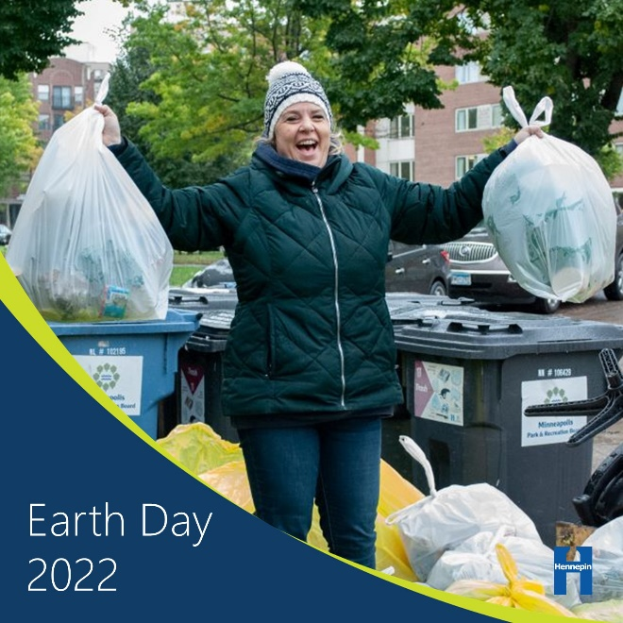
Image alt text: Woman triumphantly holding up two bags of litter during clean up event.

Post 2: Be part of the solution to climate change
Facebook: Climate change is solvable, we know the solutions, and we’re in this together. Most people are interested in creating a climate-friendly future. To create that future, we need to be willing to take significant action on the most impactful changes. Learn how you can take action to address climate change at hennepin.us/earth-day. #EarthDay2022
Twitter: Climate change is solvable, we know the solutions, and we’re in this together. Most people are interested in creating a climate-friendly future. Learn how you can take action to address climate change at hennepin.us/earth-day. #EarthDay2022
Instagram: Climate change is solvable, we know the solutions, and we’re in this together. Most people are interested in creating a climate-friendly future. To create that future, we need to be willing to take significant action on the most impactful changes. Learn how you can take action to address climate change at the link in our bio. #EarthDay2022
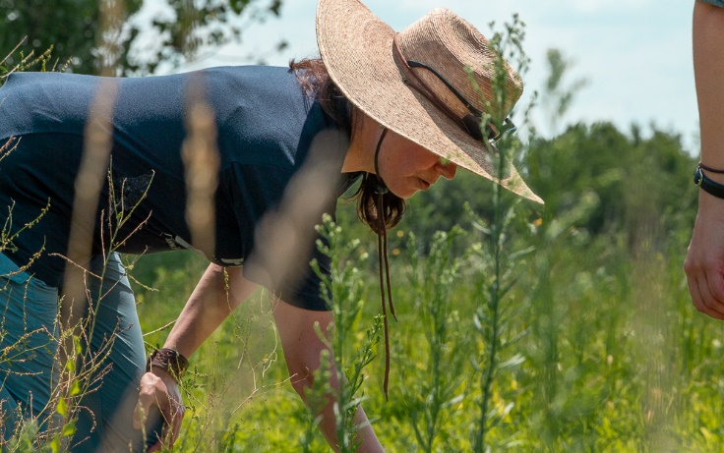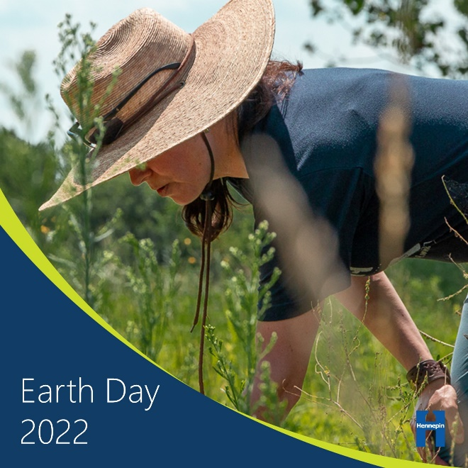
Image alt text: Woman in hat leaning over tall prairie grasses.

Post 3: Get around in a sustainable way – Biking, reduce vehicle miles traveled
Facebook: About one-third of greenhouse gas emissions in Hennepin County come from transportation. Reducing vehicle miles traveled, which is a measure of all the miles driven by all the cars and trucks on all the roadways in a region, is critical to meeting greenhouse gas emission reduction goals. Choose to bike, walk, take public transit, and carpool instead. #EarthDay2022
Twitter: About one-third of greenhouse gas emissions in Hennepin County come from transportation. Reducing vehicle miles traveled is critical to meeting greenhouse gas emission reduction goals. Choose to bike, walk, take public transit, and carpool instead. #EarthDay2022
Instagram: About one-third of greenhouse gas emissions in Hennepin County come from transportation. Reducing vehicle miles traveled, which is a measure of all the miles driven by all the cars and trucks on all the roadways in a region, is critical to meeting greenhouse gas emission reduction goals. Choose to bike, walk, take public transit, and carpool instead. #EarthDay2022
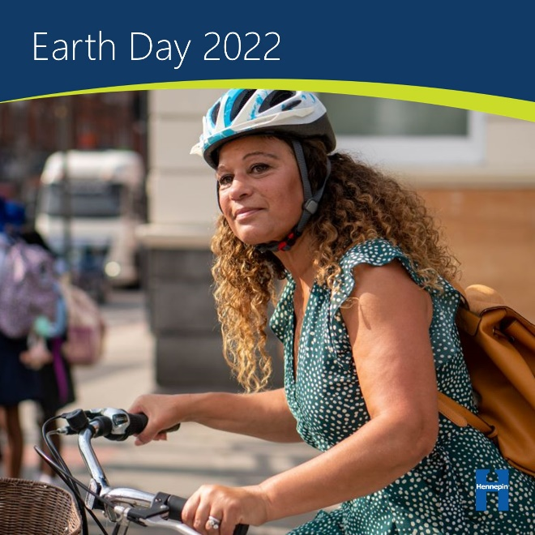
Image alt text: Woman in bike helmet riding bike looking for cars at an intersection.

Post 4: Switch to renewable energy and conserve energy – Solar
Facebook: Much of our electricity comes from burning fossil fuels like coal and natural gas, making electricity production the second largest contributor of greenhouse gas emissions in the U.S. Conserving energy and transitioning to renewable energy sources will make a big difference. If you want to create clean, renewable, local power right at home, going solar may be a good option. #EarthDay2022
Twitter: Much of our electricity comes from burning fossil fuels, making electricity production the second largest contributor of greenhouse gas emissions in the U.S. If you want to create clean, renewable, local power right at home, going solar may be a good option. #EarthDay2022
Instagram: Much of our electricity comes from burning fossil fuels like coal and natural gas, making electricity production the second largest contributor of greenhouse gas emissions in the U.S. Conserving energy and transitioning to renewable energy sources will make a big difference. If you want to create clean, renewable, local power right at home, going solar may be a good option. #EarthDay2022
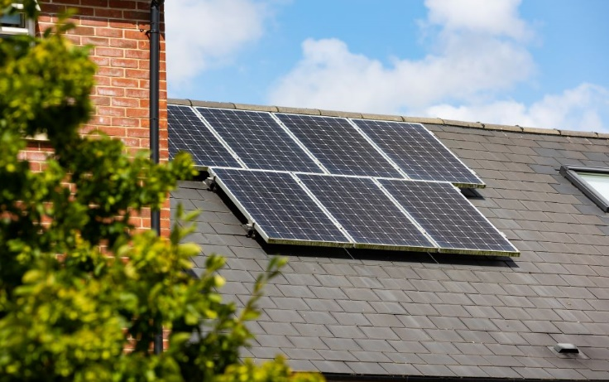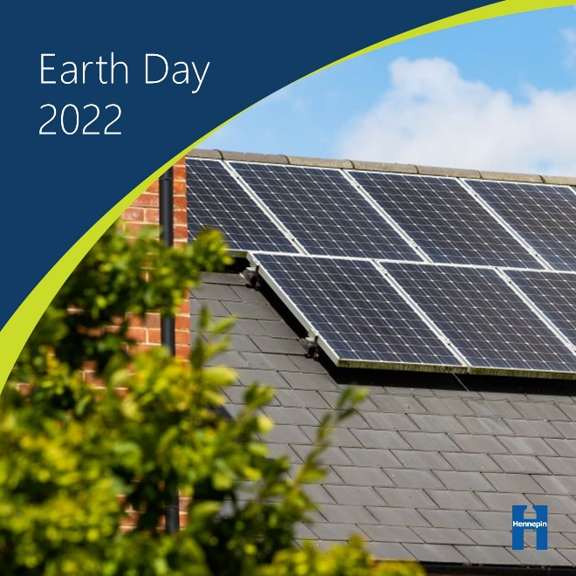
Image alt text: Solar panels on a roof.

Post 5: Switch to renewable energy and conserve energy – Home energy efficiency
Facebook: While investing in renewable sources of energy, like solar and wind, can be a powerful step in reducing greenhouse gas emissions, these investments can be costly and take time to implement. That’s why it’s important to make sure you have the basics of energy efficiency covered first. There is huge potential for energy savings right at home! Set your thermostat lower when you are away, seal any leaks in windows and doors, or conduct a home energy audit to find other ways to save energy. #EarthDay2022
Twitter: There is huge potential for energy savings right at home! Set your thermostat lower when you are away, seal any leaks in windows and doors, or conduct a home energy audit to find other ways to save energy. #EarthDay2022
Instagram: While investing in renewable sources of energy, like solar and wind, can be a powerful step in reducing greenhouse gas emissions, these investments can be costly and take time to implement. That’s why it’s important to make sure you have the basics of energy efficiency covered first. There is huge potential for energy savings right at home! Set your thermostat lower when you are away, seal any leaks in windows and doors, or conduct a home energy audit to find other ways to save energy. #EarthDay2022
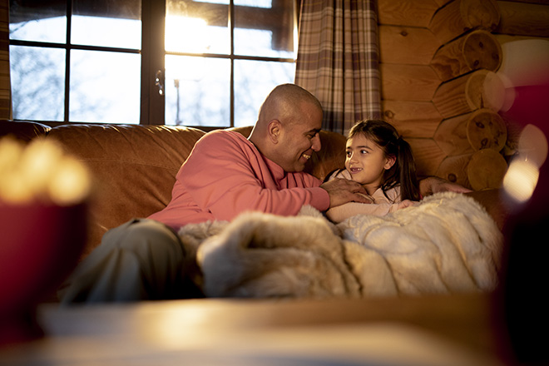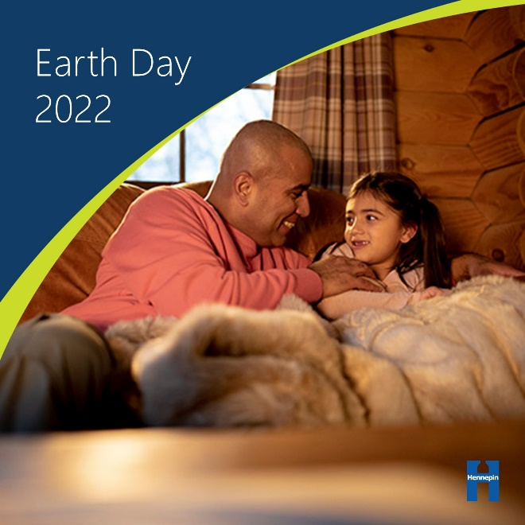
Image alt text: Man and daughter snuggled under blankets on a couch.

Post 6: Avoid wasting food and eat a more plant-based diet – Plan ahead
Facebook: We have the power to significantly reduce the amount of food that goes to waste, save ourselves money, and have a positive impact on climate change by making changes right at home in our kitchens and when we go shopping. Prevent wasted food by practicing meal planning and keeping track of and eating the food you buy. #EarthDay2022
Twitter: We have the power to reduce the amount of food that goes to waste and have a positive impact on climate change by making changes in our kitchens and when we go shopping. Prevent wasted food by meal planning and keeping track of and eating the food you buy. #EarthDay2022
Instagram: We have the power to significantly reduce the amount of food that goes to waste, save ourselves money, and have a positive impact on climate change by making changes right at home in our kitchens and when we go shopping. Prevent wasted food by practicing meal planning and keeping track of and eating the food you buy. #EarthDay2022
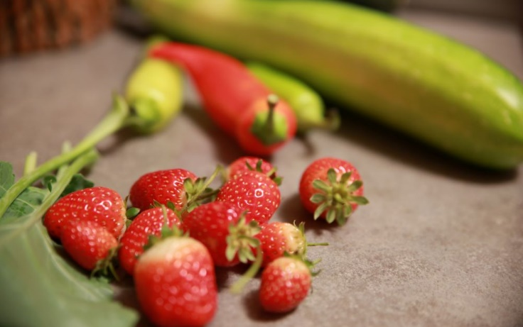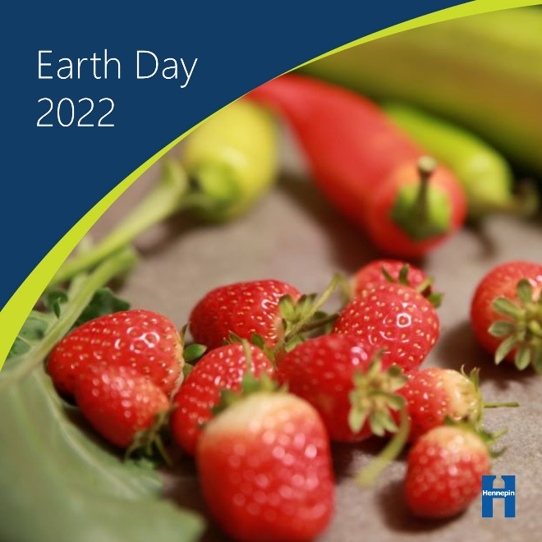
Image alt text: Strawberries and peppers on a counter.

Post 7: Avoid wasting food and eat a more plant-based diet – Store food
Facebook: More than 40 percent of food in America is wasted, which wastes the energy and resources that goes into growing, transporting, and processing that food. Additionally, our food industry, particularly the meat and dairy sector, is a major contributor to climate change, so eating a plant-rich diet can greatly reduce your carbon footprint. Learn how to properly store food so it gets eaten instead of going to waste. #EarthDay2022
Twitter: More than 40% of food in America is wasted, which wastes the energy and resources that goes into growing, transporting, and processing that food. Learn how to properly store food so it gets eaten instead of going to waste. #EarthDay2022
Instagram: More than 40 percent of food in America is wasted, which wastes the energy and resources that goes into growing, transporting, and processing that food. Additionally, our food industry, particularly the meat and dairy sector, is a major contributor to climate change, so eating a plant-rich diet can greatly reduce your carbon footprint. Learn how to properly store food so it gets eaten instead of going to waste. #EarthDay2022
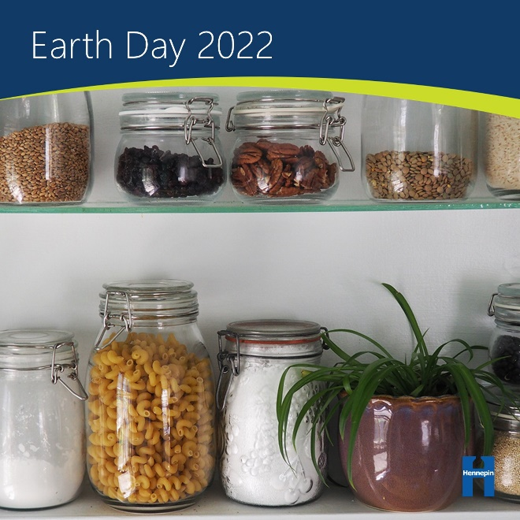
Image alt text: Glass jars of dry foods on a shelf.

Post 8: Avoid wasting food and eat a more plant-based diet – Composting
Facebook: Food scraps that cannot be eaten are great candidates for composting! Participate in an organics recycling program or start backyard composting to put the food waste you can’t avoid to better use. #EarthDay2022
Twitter: Food scraps that cannot be eaten are great candidates for composting! Participate in an organics recycling program or start backyard composting to put the food waste you can’t avoid to better use. #EarthDay2022
Instagram: Food scraps that cannot be eaten are great candidates for composting! Participate in an organics recycling program or start backyard composting to put the food waste you can’t avoid to better use. #EarthDay2022
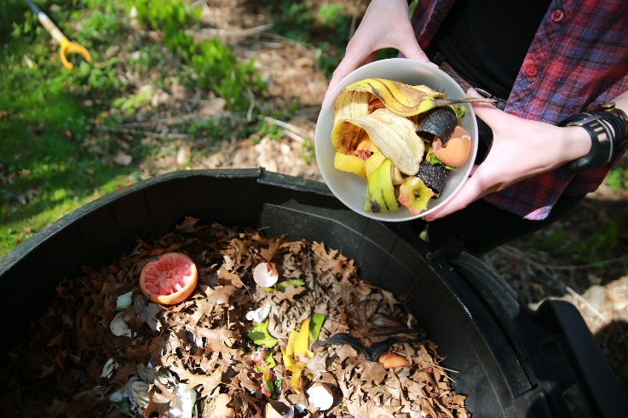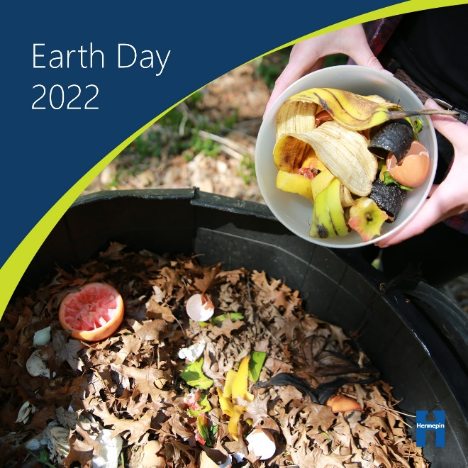
Image alt text: Person holding bowl of food scraps over outdoor compost pile.

Post 9: Live a low-waste lifestyle and practice thoughtful consumption – Low waste
Facebook: From manufacturing and transportation all the way through to disposal, everything we buy has an impact. Producing and transporting goods is associated with 45% of global emissions. Be an intentional consumer by only buying what you need, shopping used, and seeking opportunities to borrow or swap. #EarthDay2022
Twitter: Producing and transporting goods is associated with 45% of global emissions. Be an intentional consumer by only buying what you need, shopping used, and seeking opportunities to borrow or swap. #EarthDay2022
Instagram: From manufacturing and transportation all the way through to disposal, everything we buy has an impact. Producing and transporting goods is associated with 45% of global emissions. Be an intentional consumer by only buying what you need, shopping used, and seeking opportunities to borrow or swap. #EarthDay2022
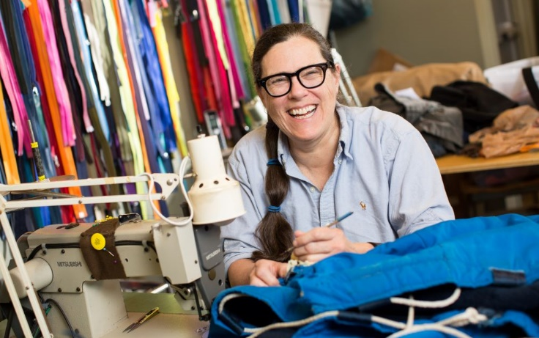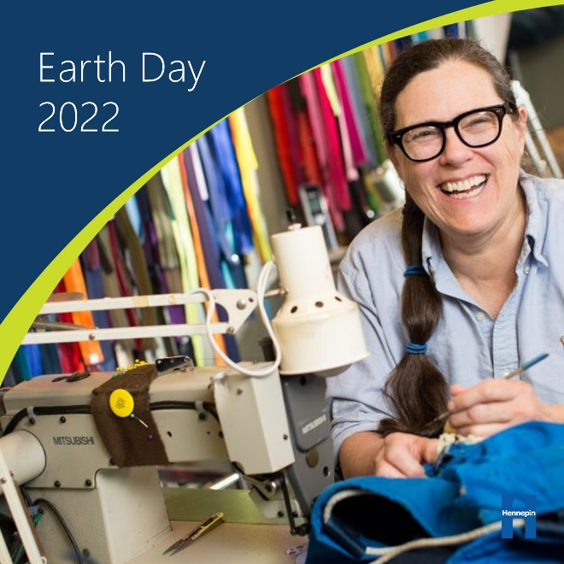
Image alt text: Smiling woman using sewing machine.

Post 10: Live a low-waste lifestyle and practice thoughtful consumption – Plastics
Facebook: Reducing your reliance on plastics will go a long way in reducing your carbon footprint. Most plastics are made from oil and gas – fossil fuels that contribute to climate change. About 4% to 8% of the world's oil production is for plastics, and most plastics are thrown away after a single use. Address climate change by using reusable bags, shopping the bulk bins, avoiding harmful plastics, and buying unpackaged produce. #EarthDay2022
Twitter: Most plastics are made from oil and gas – fossil fuels that contribute to climate change. Address climate change by using reusable bags, shopping the bulk bins, avoiding harmful plastics, and buying unpackaged produce. #EarthDay2022
Instagram: Reducing your reliance on plastics will go a long way in reducing your carbon footprint. Most plastics are made from oil and gas – fossil fuels that contribute to climate change. About 4% to 8% of the world's oil production is for plastics, and most plastics are thrown away after a single use. Address climate change by using reusable bags, shopping the bulk bins, avoiding harmful plastics, and buying unpackaged produce. #EarthDay2022
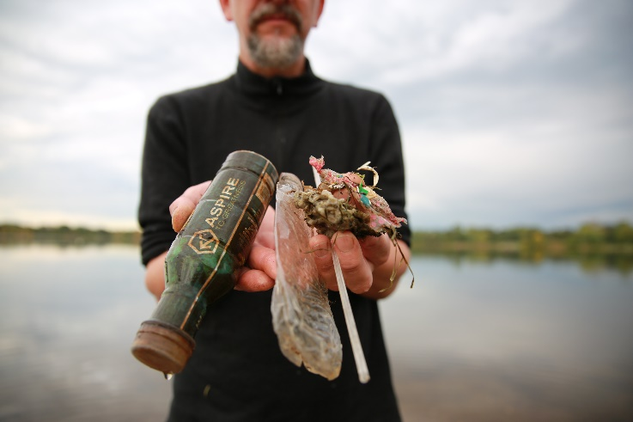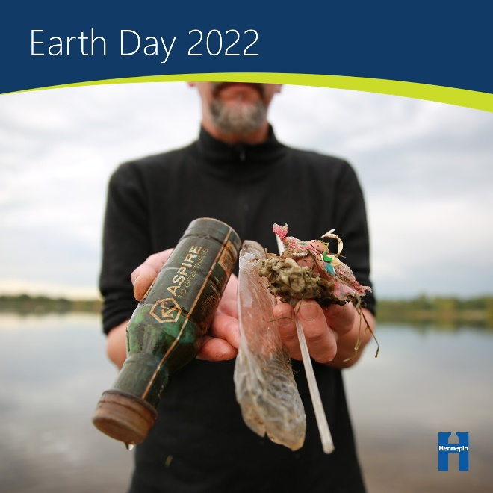
Image alt text: Man holding plastic litter collected from a river clean up.

Post 11: Be a good steward of our natural resources – Trees
Facebook: Trees remove carbon dioxide from the atmosphere through photosynthesis and store carbon in their wood. The older the tree, the more climate benefits it provides. The shade from trees also lessens the need for cooling in buildings. Take care of mature trees on your property, look for opportunities to plant new trees, and get involved with tree care and planting in your community. #EarthDay2022
Twitter: Trees remove carbon dioxide from the atmosphere through photosynthesis and store carbon in their wood. Take care of mature trees on your property, look for opportunities to plant new trees, and get involved with tree care and planting in your community. #EarthDay2022
Instagram: Trees remove carbon dioxide from the atmosphere through photosynthesis and store carbon in their wood. The older the tree, the more climate benefits it provides. The shade from trees also lessens the need for cooling in buildings. Take care of mature trees on your property, look for opportunities to plant new trees, and get involved with tree care and planting in your community. #EarthDay2022
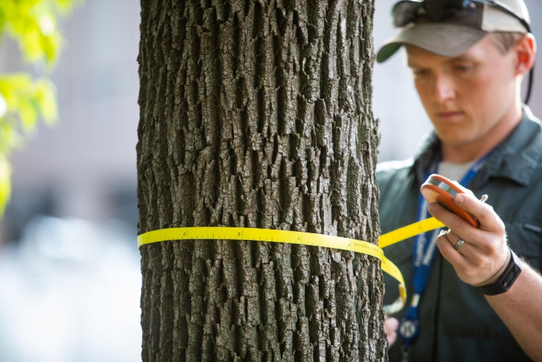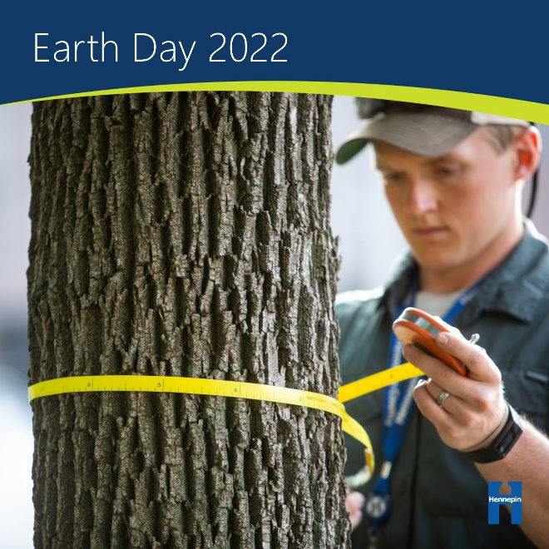
Image alt text: Man measuring diameter of tree trunk.

Post 12: Be a good steward of our natural resources – Pollinators
Facebook: We rely on pollinators including native bees, butterflies, and birds to pollinate fruits and vegetables like apples, tomatoes, pumpkins, and strawberries. Butterflies, bees, and other pollinators are in serious decline from habitat loss, climate change impacts, disease, parasites, and pesticide use. Provide habitat for pollinators by planting native flowers, adding a pollinator friendly seed mix to your lawn, and reducing or eliminating the use of pesticides. #EarthDay2022
Twitter: Pollinators are in serious decline from habitat loss, climate change impacts, and pesticide use. Provide habitat for pollinators by planting native flowers, adding a pollinator friendly seed mix to your lawn, and reducing or eliminating the use of pesticides. #EarthDay2022
Instagram: We rely on pollinators including native bees, butterflies, and birds to pollinate fruits and vegetables like apples, tomatoes, pumpkins, and strawberries. Butterflies, bees, and other pollinators are in serious decline from habitat loss, climate change impacts, disease, parasites, and pesticide use. Provide habitat for pollinators by planting native flowers, adding a pollinator friendly seed mix to your lawn, and reducing or eliminating the use of pesticides. #EarthDay2022
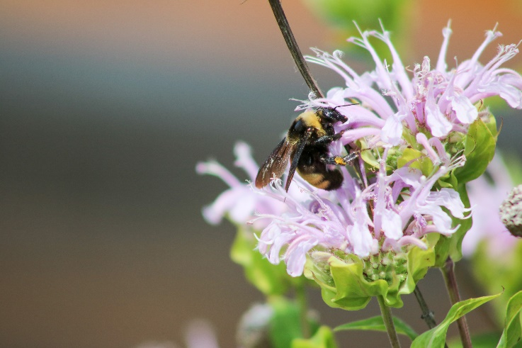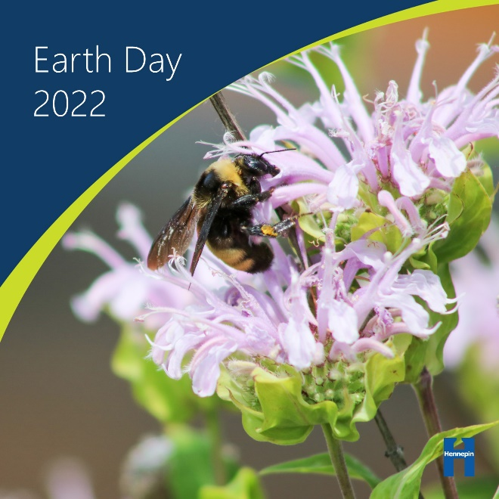
Image alt text: Bee on a purple bee balm flower.

Post 13: Be a good steward of our natural resources – Capture rainwater
Facebook: Keeping rainwater on your yard is a good way to prevent localized flooding and protect water quality. Climate change means more rain in our region, and as we head into the rainiest time of the year, it’s a good time to plan for how you will capture and reuse rainwater at home. Keep water in your yard by installing rain barrels, designing a rain garden or redirecting downspouts, and keeping the storm drains on your street clear of trash, leaves, and other debris. #EarthDay2022
Twitter: As we head into the rainiest time of the year, it’s a good time to plan for how you will capture and reuse rainwater at home. Install rain barrels, design a rain garden or redirect gutter downspouts, and keep storm drains clear of debris. #EarthDay2022
Instagram: Keeping rainwater on your yard is a good way to prevent localized flooding and protect water quality. Climate change means more rain in our region, and as we head into the rainiest time of the year, it’s a good time to plan for how you will capture and reuse rainwater at home. Keep water in your yard by installing rain barrels, designing a rain garden or redirecting downspouts, and keeping the storm drains on your street clear of trash, leaves, and other debris. #EarthDay2022
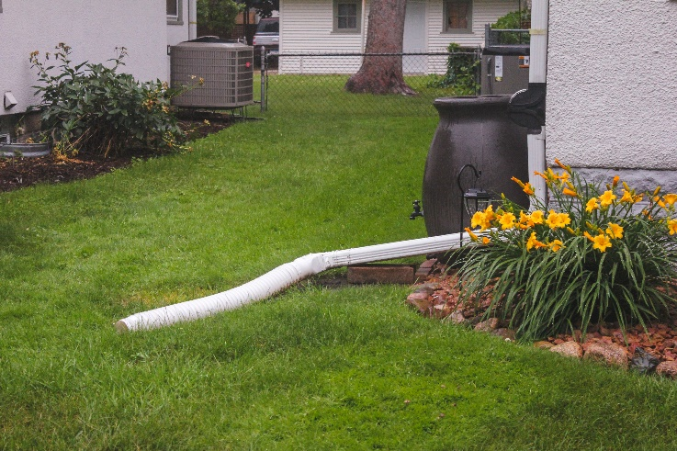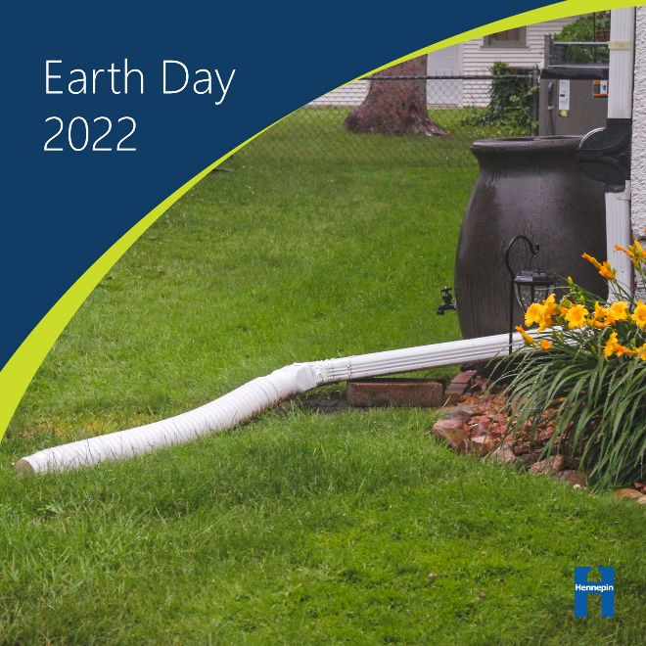
Image alt text: Gutter downspout in yard with rain barrel.

Post 14: Talk about climate change – Climate conversations
Facebook: When starting conversations on climate change, remember that most people are concerned about the issue, and you may find more areas of agreement than you expect. Finding commons interests and areas of concern, speaking to shared values, and connecting to what people care about – hobbies, family, faith, community, jobs, etc. – are the important foundations of effective climate conversations. Share your climate story! #EarthDay2022
Twitter: Finding commons interests and areas of concern, speaking to shared values, and connecting to what people care about are the important foundations of effective climate conversations. Share your climate story! #EarthDay2022
Instagram: When starting conversations on climate change, remember that most people are concerned about the issue, and you may find more areas of agreement than you expect. Finding commons interests and areas of concern, speaking to shared values, and connecting to what people care about – hobbies, family, faith, community, jobs, etc. – are the important foundations of effective climate conversations. Share your climate story! #EarthDay2022
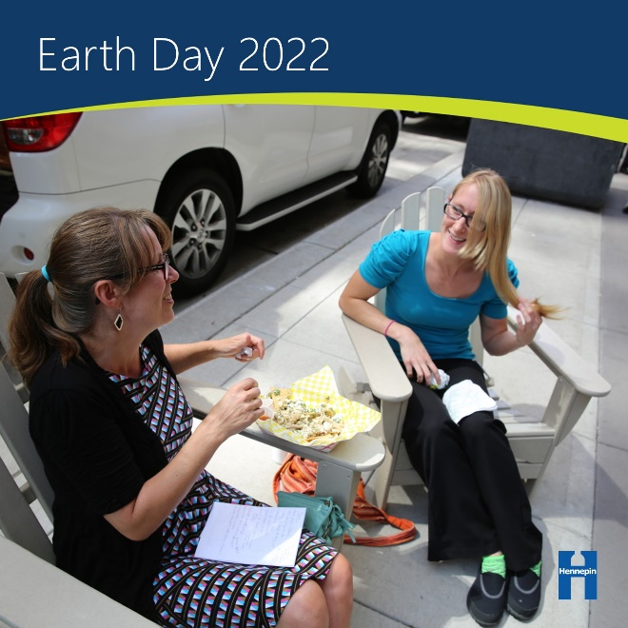
Image alt text: Two women sitting down talking.

Post 15: Talk about climate change – Teaching about climate
Facebook: Understanding the science of climate change makes people more concerned about the issue, more likely to support action, and more confident in talking to others. Teaching about climate change can be complicated, but educators don’t need to generate curriculum themselves. Many educational resources already exist, including full curriculum programs, individual activities, downloadable games, and digital interactive tools: https://www.hennepin.us/climate-action/what-we-can-do/teaching-climate #EarthDay2022
Twitter: Teaching about climate change can be complicated, but many educational resources already exist, including full curriculum programs, individual activities, and games: https://www.hennepin.us/climate-action/what-we-can-do/teaching-climate #EarthDay2022
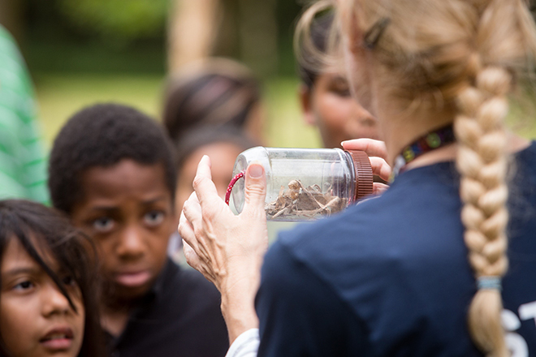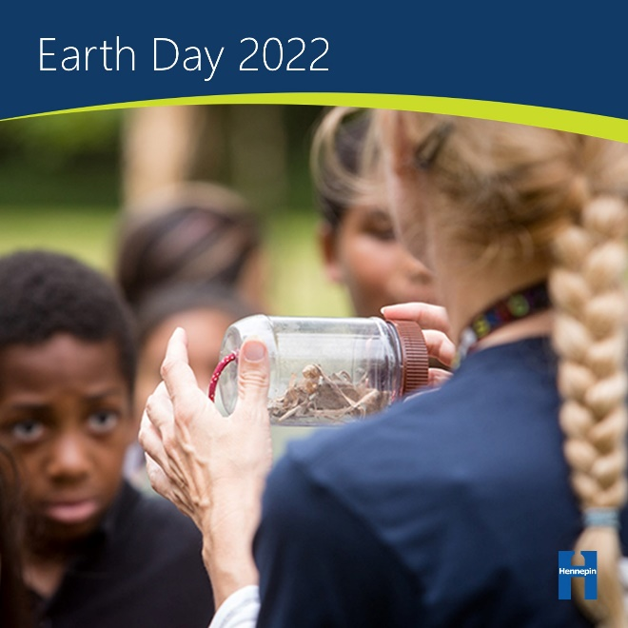
Image alt text: Woman displaying glass jar containing small animal bones to students.

Post 16: Talk about climate change – Focus your climate action
Facebook: Climate change is a big problem that requires big solutions. Acting together can help bring about the changes we need. Remember, climate change is a broad issue, so addressing the climate crisis will require a lot of different people putting their skills and talents to work in a lot of different areas. Learn more about how best to focus your climate action: https://www.hennepin.us/climate-action/what-we-can-do/figuring-out-where-to-focus #EarthDay2022
Twitter: Climate change is a big problem that requires big solutions. Acting together can help bring about the changes we need. Learn more about how best to focus your climate action: https://www.hennepin.us/climate-action/what-we-can-do/figuring-out-where-to-focus #EarthDay2022
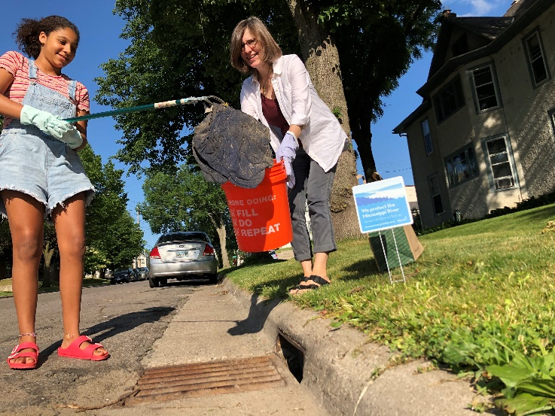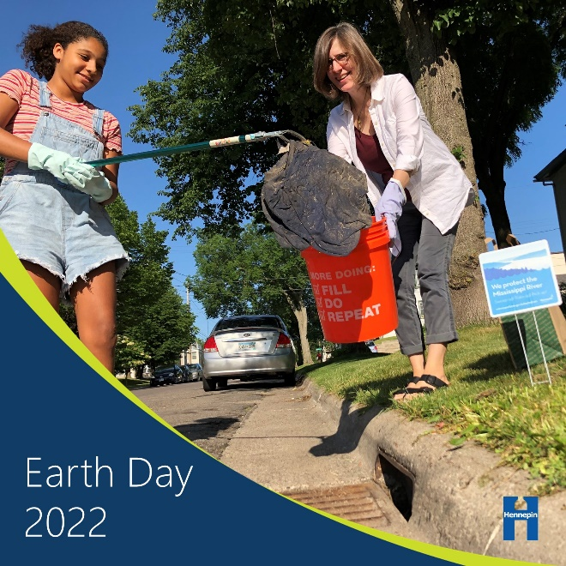
Alt text: Woman and child using trash grabber to pick up litter from a storm drain.

