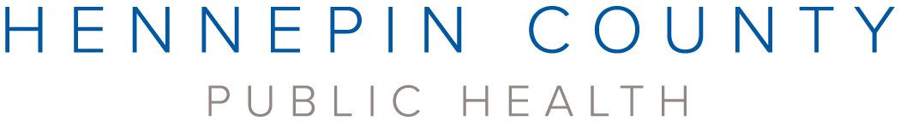

Hennepin County Public Health would like to thank the following organizations for their help informing the 2021-2025 strategic plan. Public Health is grateful for their wisdom and guidance.

2ndChanceProject

African Babies Coalition

Annex Teen Clinic

Archdiocese of Saint Paul and Minneapolis

Between Us, Hennepin Healthcare

Brooklyn Center Community Schools

Community**Emergency Assistance** Programs (CEAP)

City of Brooklyn Center

City of Brooklyn Park

CommonBond Communities

Community Mediation and Restorative Services

District 287

Headway Emotional Health

Hennepin County Medical Center

Hennepin County's Joint Community Police Partnership

Hopkins On Voice and Schools and Community In Partnership (SCIP)

Hopkins Public Schools

Housing Link

Indian Health Board of Minneapolis

Lao Assistance Center of Minnesota

Mad Dads

Medication and Conflict Resolution at HCMC

Minneapolis American Indian Center

Minnesota Council on Latino Affairs

Minnesota Quality Care

Movefwrd MN

MyHealth Teen Clinic, Hopkins

NorthPoint Health and Wellness Center

NorthPoint Foundation

Northwest Hennepin Family Service Collaborative

Pillsbury United Communities

Potter's House of Jesus Christ

Raíces Sagradas Community Mental Health

Robbinsdale Schools

Shiloh Temple North Minneapolis

Statewide Health Improvement Partnership (SHIP) Hmong Diabetes Prevention Community Leadership Team

Stairstep Foundation

Tasks Unlimited

Twin Cities Recovery Project

Ucare

University of Minnesota, School of Public Health

Way to Grow