As we emerge from COVID restrictions, the post-COVID workplace may look different. As you move into new routines, locations, or situations, remember that the basics of a healthy lifestyle stay the same: Eat well, avoid tobacco or nicotine products, get a good night’s rest, and be active!
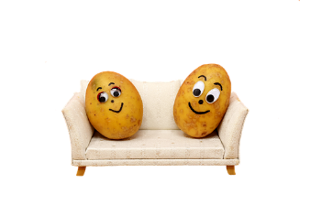
To help with that last one, check the list below for ideas to stay active during the workday. In addition to improved physical health, exercise helps improve mood and decrease feelings of stress!

Working from home:
- Use what would normally be your commute time for morning movement, before starting work. Take a 15-minute stretch, walk, or bike in your neighborhood as a transition time into your workday.
- Keep exercise equipment where you will see it during the workday. Leave hand weights, resistance bands, exercise mats, or a jump rope nearby. For breaks, or even on long calls or in virtual meetings (without video ), take time to do a few repetitions.
- Take an active lunch break. Get away from your screens and do something active — stretching, walking, yoga, anything! You will return to work with more energy and focus.
- Try an under-desk cycle or portable pedal machine. Limited research suggests that these devices may reduce sedentary time at your desk. See reviews here¹ and here.²

Working onsite:
- Walk to a co-worker’s desk to talk instead of connecting by phone or computer (this helps make social connections, too!).
- When possible, walk, bike, or run to work. If you live too far away, park several blocks from your destination and walk into work. Or get off the train or bus several stops early.
- Try walking meetings. These work best with two or three people and can be efficient and energizing.
- Use a stand-up desk, if available. You don’t need to stand all day; alternate with sitting. Move around when standing or do occasional stretching or bending to avoid fatigue.
- Set a timer or app to remind yourself to move. It’s easy to get caught up in work, so help yourself remember to move. Ideas can be found here.³

1 https://www.standingdesk.io/best-desk-cycle/
2 https://www.bestadvisor.com/pedal-exerciser
3 https://www.umsystem.edu/totalrewards/wellness/activity_and_break_apps

